PROFESSIONAL LED EFFECT FIXTURE

AL0460WX
4-HEAD DOUBLE-SIDED CONTINUOUS-ROTATION EFFECT LIGHT
USER MANUAL
English Edition | Translated from the supplied Chinese manual
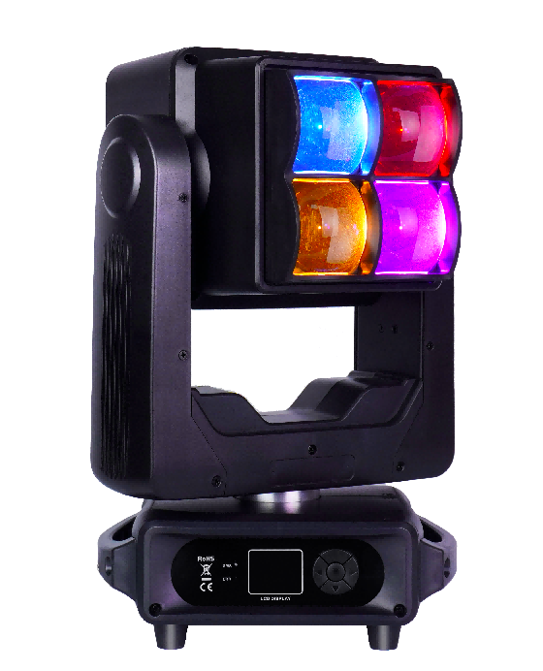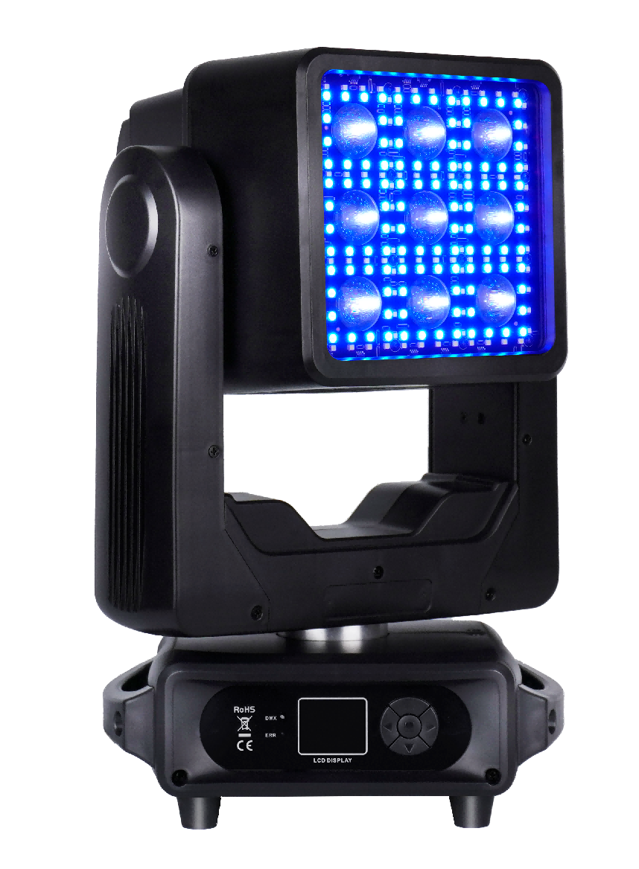
Four 60 W RGBW heads • Nine 10 W white LEDs • 108 RGB auxiliary LEDs
Ingress Protection | Rated Power | Zoom | DMX Modes
IP20 | 400 W | 6°–40° | 20 / 34 / 93 CH

IMPORTANT Read this manual completely before installing, powering, operating, or servicing the fixture. Retain it for future reference.

Contents
1 Unpacking & Product Overview
2 Fixture Dimensions
3 Safety Information
4 Operation, Rigging & Installation
5 DMX-512 Connection
6 Product Features & Specifications
7 DMX Channel Charts
8 Control Menu
9 Photometric Data
10 Maintenance & Cleaning
TRANSLATION NOTE This English edition reorganizes and edits the supplied Chinese source for clarity while preserving its technical values, menu defaults, and DMX channel assignments.

1 Unpacking & Product Overview
Thank you for choosing this LED effect light. Read this manual before installation and use so the fixture can be operated correctly and safely. Follow the procedures in this manual and keep it available for future reference.
The fixture combines a heat-resistant engineering-plastic enclosure with a high-strength metal chassis. It is designed in accordance with CE requirements and supports the international DMX512 protocol. It may be operated as a standalone fixture or linked with other fixtures. Fast movement, low noise, and multiple effect functions make it suitable for concerts, theatres, studios, nightclubs, bars, and similar venues.

1.1 Packing List
Unpack carefully, inspect the fixture for shipping damage, and confirm that all items are present:
Item | Quantity
Moving effect light | 1
3-pin DMX signal cable | 1
User manual | 1
Power cable | 1
Rigging clamp | 2
Safety cable | 1

2 Fixture Dimensions
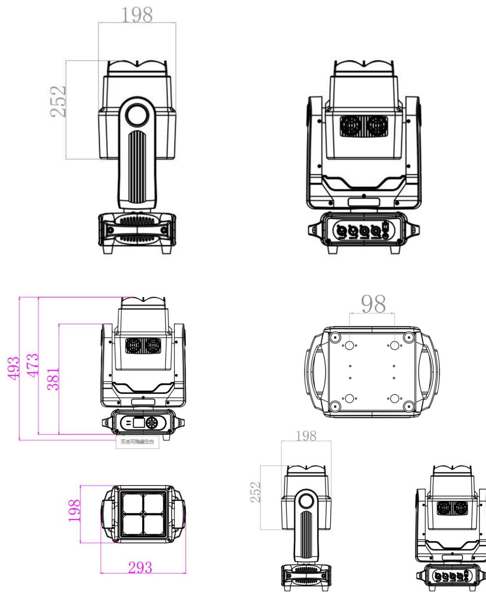
Fixture dimensions shown in millimetres. Overall source drawing: approximately 293 × 198 × 493 mm.

3 Safety Information
The fixture left the factory in good condition. To preserve that condition and ensure safe operation, follow all safety instructions and warnings in this manual.
IMPORTANT Damage caused by failure to follow this manual is not covered by the warranty. The supplier is not responsible for resulting product problems.
- If the fixture has been exposed to a large temperature change, such as after transport, do not connect power immediately. Allow it to reach room temperature so condensation cannot damage internal components.
- Use a properly grounded Class I outlet. The protective-earth conductor must be connected. The technical specification lists an input range of AC 100–240 V, 50/60 Hz; always verify the rating label before connection.
- Inspect the fixture and power cable regularly. Do not use a folded, pinched, abraded, or otherwise damaged cable. Disconnect power when the fixture is not in use and before cleaning or servicing.
- Familiarize yourself with all functions before use. Keep children and untrained persons away from the fixture.
- Do not shake the fixture or apply excessive force during installation or operation.
- There are no user-serviceable parts inside. Maintenance and repair must be carried out by qualified personnel.
- Do not modify the fixture. Unauthorized modifications can cause short circuits, burns, electric shock, fire, equipment damage, or personal injury and will void warranty coverage.

4 Operation, Rigging & Installation

4.1 Operating Precautions
- This fixture is designed to create wash, beam, strobe, and movement effects.
- Protect the fixture from shock and strong impact. Do not lift or carry the entire fixture by the moving head.
- Install only in a location that is not excessively hot, humid, or dusty. Route cables so they cannot create a trip or electric-shock hazard.
- Verify the mounting point before installation. Attach a safety cable and confirm that all screws and fasteners are correctly installed.
- Keep the lenses in good condition. Replace any lens that is damaged or deeply scratched.
- Only trained technicians familiar with the fixture should operate it. Keep the original packing materials for future transport.
- Do not alter the fixture without authorization from the manufacturer or distributor.

4.2 Rigging
SAFETY Do not stand beneath the fixture while it is being installed, removed, or serviced.
- Install the fixture away from walkways, seating areas, and places where people can reach it.
- The mounting point and hardware must support at least 10 times the fixture weight.
- Use an independent secondary attachment, such as a rated safety cable.
- Maintain at least 0.5 m clearance from flammable materials. The source cover also marks a minimum 0.2 m distance from illuminated surfaces.
- Overhead installation must be performed by experienced personnel who can calculate load limits, select suitable hardware, and inspect the installation periodically.

5 DMX-512 Connection
Connect the male XLR plug of the DMX cable to the controller output and the female plug to the fixture DMX input. Multiple fixtures may be connected in a daisy chain. Use a shielded, twisted-pair data cable fitted with 3-pin XLR connectors; 5-pin wiring follows the same signal principle.
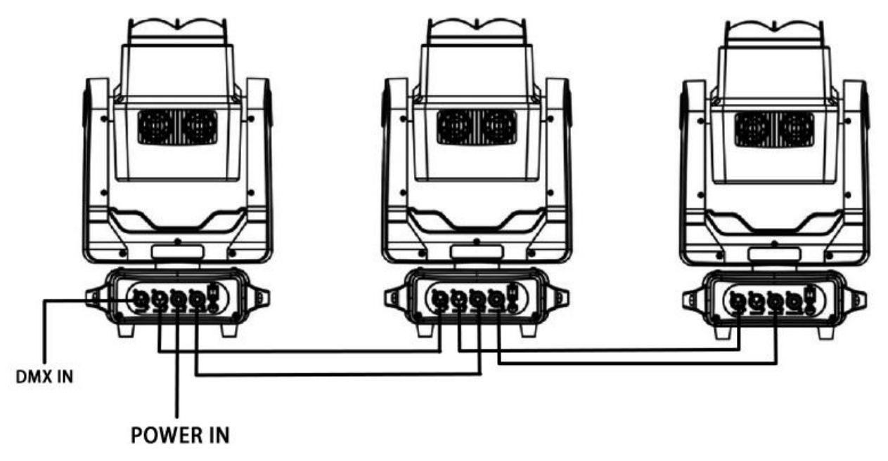
Typical multi-fixture DMX/power daisy chain.
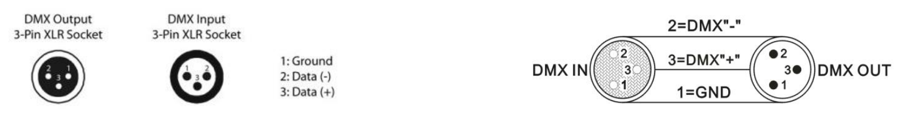
3-pin XLR DMX pin assignment: pin 1 ground, pin 2 Data (-), pin 3 Data (+).

5.1 DMX Termination
For long cable runs or electrically noisy environments, install a DMX terminator at the final fixture to reduce signal reflections and interference. Connect a 120 Ω resistor between pins 2 and 3 of an XLR plug, then insert it into the final DMX output.
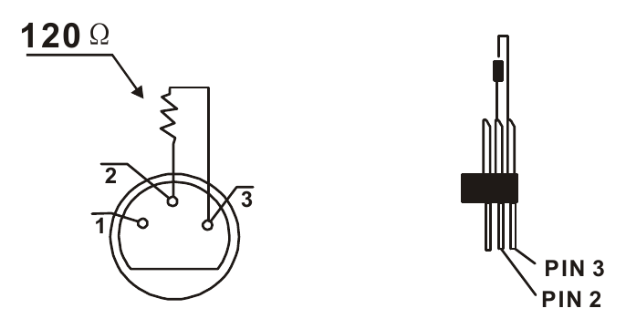
DMX terminator: 120 Ω between pins 2 and 3.

6 Product Features & Specifications
Parameter | Specification
Input voltage | AC 100–240 V, 50/60 Hz
Rated power | 400 W
Light sources | 4 × 60 W high-brightness RGBW LEDs; 9 × 10 W high-brightness white LEDs; 108 RGB LEDs
Control modes | DMX512, standalone/auto, master/slave, sound-active, RDM
DMX modes | 20 CH / 34 CH / 93 CH
Dimming | 32-bit, 0–100% linear dimming
Zoom angle | 6°–40°
Effects | Pan/tilt movement, beam, strobe, continuous pan/tilt rotation, auxiliary lighting
Operating temperature | −10 °C to 50 °C
Strobe frequency | 1–25 Hz
Housing | Black metal
Connections | DMX512 input/output; power input/output
Ingress protection | IP20 — indoor use only
Fixture dimensions | 29 × 20 × 49 cm
Carton dimensions | 52.5 × 35.5 × 27 cm
Net weight | 10.8 kg
4-in-1 flight case | 75 × 67 × 71.5 cm; gross weight 80.6 kg

7 DMX Channel Charts
The following tables reproduce the channel assignments from the supplied Chinese manual. All listed channels use the full 000–255 range in the source.

7.1 20 CH Mode
Channel | DMX Value | Function
1 | 000-255 | Pan
2 | 000-255 | Pan Fine
3 | 000-255 | Pan Continuous Rotation
4 | 000-255 | Tilt
5 | 000-255 | Tilt Fine
6 | 000-255 | Tilt Continuous Rotation
7 | 000-255 | Pan/Tilt Speed
8 | 000-255 | Zoom
9 | 000-255 | Master Dimmer
10 | 000-255 | Strobe
11 | 000-255 | Main Light Red
12 | 000-255 | Main Light Green
13 | 000-255 | Main Light Blue
14 | 000-255 | Main Light White
15 | 000-255 | White LED
16 | 000-255 | Auxiliary Light Red
17 | 000-255 | Auxiliary Light Green
18 | 000-255 | Auxiliary Light Blue
19 | 000-255 | Auxiliary Light White
20 | 000-255 | Reset

7.2 34 CH Mode
Channel | DMX Value | Function
1 | 000-255 | Pan
2 | 000-255 | Pan Fine
3 | 000-255 | Pan Continuous Rotation
4 | 000-255 | Tilt
5 | 000-255 | Tilt Fine
6 | 000-255 | Tilt Continuous Rotation
7 | 000-255 | Pan/Tilt Speed
8 | 000-255 | Zoom
9 | 000-255 | Master Dimmer
10 | 000-255 | Main Light Strobe
11 | 000-255 | Main Light Red
12 | 000-255 | Main Light Green
13 | 000-255 | Main Light Blue
14 | 000-255 | Main Light White
15 | 000-255 | Main Light Effect
16 | 000-255 | Main Light Effect Speed
17 | 000-255 | Main Light Background Color
18 | 000-255 | Main Light Background Dimmer
19 | 000-255 | LED Strobe
20 | 000-255 | White LED
21 | 000-255 | LED Effect
22 | 000-255 | LED Effect Speed
23 | 000-255 | LED Strobe
24 | 000-255 | LED Red
25 | 000-255 | LED Green
26 | 000-255 | LED Blue
27 | 000-255 | White LED
28 | 000-255 | Auxiliary RGB Effect
29 | 000-255 | Auxiliary RGB Effect Speed
30 | 000-255 | Auxiliary White Effect
31 | 000-255 | Auxiliary White Effect Speed
32 | 000-255 | Auxiliary Background Color
33 | 000-255 | Auxiliary Background Dimmer
34 | 000-255 | Reset

7.3 93 CH Mode
Channel | DMX Value | Function
1 | 000-255 | Pan
2 | 000-255 | Pan Fine
3 | 000-255 | Pan Continuous Rotation
4 | 000-255 | Tilt
5 | 000-255 | Tilt Fine
6 | 000-255 | Tilt Continuous Rotation
7 | 000-255 | Pan/Tilt Speed
8 | 000-255 | Zoom
9 | 000-255 | Master Dimmer
10 | 000-255 | Main Light Strobe
11 | 000-255 | Main Light Red 1
12 | 000-255 | Main Light Green 1
13 | 000-255 | Main Light Blue 1
14 | 000-255 | Main Light White 1
15 | 000-255 | Main Light Red 2
16 | 000-255 | Main Light Green 2
17 | 000-255 | Main Light Blue 2
18 | 000-255 | Main Light White 2
19 | 000-255 | Main Light Red 3
20 | 000-255 | Main Light Green 3
21 | 000-255 | Main Light Blue 3
22 | 000-255 | Main Light White 3
23 | 000-255 | Main Light Red 4
24 | 000-255 | Main Light Green 4
25 | 000-255 | Main Light Blue 4
26 | 000-255 | Main Light White 4
27 | 000-255 | Main Light Effect
28 | 000-255 | Main Light Effect Speed
29 | 000-255 | Main Light Background Color
30 | 000-255 | Main Light Background Dimmer
31 | 000-255 | LED Strobe
32 | 000-255 | White LED 1
33 | 000-255 | White LED 2
34 | 000-255 | White LED 3
35 | 000-255 | White LED 4
36 | 000-255 | White LED 5
37 | 000-255 | White LED 6
38 | 000-255 | White LED 7
39 | 000-255 | White LED 8
40 | 000-255 | White LED 9
41 | 000-255 | LED Mode
42 | 000-255 | LED Speed
43 | 000-255 | Auxiliary Light Strobe
44 | 000-255 | Auxiliary Light Red 1
45 | 000-255 | Auxiliary Light Green 1
46 | 000-255 | Auxiliary Light Blue 1
47 | 000-255 | Auxiliary Light Red 2
48 | 000-255 | Auxiliary Light Green 2
49 | 000-255 | Auxiliary Light Blue 2
50 | 000-255 | Auxiliary Light Red 3
51 | 000-255 | Auxiliary Light Green 3
52 | 000-255 | Auxiliary Light Blue 3
53 | 000-255 | Auxiliary Light Red 4
54 | 000-255 | Auxiliary Light Green 4
55 | 000-255 | Auxiliary Light Blue 4
56 | 000-255 | Auxiliary Light Red 5
57 | 000-255 | Auxiliary Light Green 5
58 | 000-255 | Auxiliary Light Blue 5
59 | 000-255 | Auxiliary Light Red 6
60 | 000-255 | Auxiliary Light Green 6
61 | 000-255 | Auxiliary Light Blue 6
62 | 000-255 | Auxiliary Light Red 7
63 | 000-255 | Auxiliary Light Green 7
64 | 000-255 | Auxiliary Light Blue 7
65 | 000-255 | Auxiliary Light Red 8
66 | 000-255 | Auxiliary Light Green 8
67 | 000-255 | Auxiliary Light Blue 8
68 | 000-255 | Auxiliary Light Red 9

Channel | DMX Value | Function
69 | 000-255 | Auxiliary Light Green 9
70 | 000-255 | Auxiliary Light Blue 9
71 | 000-255 | Auxiliary Light White 1
72 | 000-255 | Auxiliary Light White 2
73 | 000-255 | Auxiliary Light White 3
74 | 000-255 | Auxiliary Light White 4
75 | 000-255 | Auxiliary Light White 5
76 | 000-255 | Auxiliary Light White 6
77 | 000-255 | Auxiliary Light White 7
78 | 000-255 | Auxiliary Light White 8
79 | 000-255 | Auxiliary Light White 9
80 | 000-255 | Auxiliary Light White 10
81 | 000-255 | Auxiliary Light White 11
82 | 000-255 | Auxiliary Light White 12
83 | 000-255 | Auxiliary Light White 13
84 | 000-255 | Auxiliary Light White 14
85 | 000-255 | Auxiliary Light White 15
86 | 000-255 | Auxiliary Light White 16
87 | 000-255 | Auxiliary RGB Effect
88 | 000-255 | Auxiliary RGB Effect Speed
89 | 000-255 | Auxiliary White Speed
90 | 000-255 | Auxiliary White Effect Speed
91 | 000-255 | Auxiliary Background Color
92 | 000-255 | Auxiliary Background Dimmer
93 | 000-255 | Reset

8 Control Menu
Use the UP/DOWN controls to change a value and press ENTER to save. The following defaults and ranges are reproduced from the source manual.
Main Menu | Item | Operation / Default
System Settings | DMX Address | Set the DMX start address from 001–512. Default: 001.
System Settings | Encoder | Enable or disable encoder control. Default: On.
System Settings | Pan Invert | Enable or disable X-axis inversion. Default: Off.
System Settings | Tilt Invert | Enable or disable Y-axis inversion. Default: Off.
Operating Mode | Run Mode | Select DMX, Sound-active, or Auto. Default: DMX.
Operating Mode | Channel Mode | Select 20 CH, 34 CH, or 93 CH. Default: 34 CH.
Manual Control | Pan | Range 000–255. Default: 000.
Manual Control | Pan Fine | Range 000–255. Default: 128.
Manual Control | Pan Continuous Rotation | Range 000–255. Default: 000.
Manual Control | Tilt | Range 000–255. Default: 128.
Manual Control | Tilt Fine | Range 000–255. Default: 000.
Manual Control | Tilt Continuous Rotation | Range 000–255. Default: 000.
Manual Control | Other Channels | Continue through the remaining manual-control channels.
Manual Control | Reset (item 34) | To reset from a console, first lower the value below 10, then raise it to 150–255. Values 000–149 do not reset the fixture.
Display Settings | Language | Select Chinese or English. Default: Chinese.
Display Settings | Display Reverse | Enable or disable inverted display orientation. Default: Off.
Display Settings | Screen Saver | Enable or disable the screen saver. Default: On.
Display Settings | Software Version | Program identification code: 06XA. Read-only.

8.1 Factory Settings
ACCESS When prompted for the factory-settings password, change the displayed value to 138 and press ENTER.
Item | Range / Default | Description
Pan Calibration | 000–255 / 128 | Adjust the X-axis calibration value and press ENTER to save.
Tilt Calibration | 000–255 / 128 | Adjust the Y-axis calibration value and press ENTER to save.
Zoom Calibration | 000–255 / 128 | Adjust the zoom calibration value and press ENTER to save.
Zoom Travel | 000–255 / 128 | Adjust the zoom travel value and press ENTER to save.
Items 5–19 | Not detailed | Additional factory parameters are represented by an ellipsis in the source manual.
Temperature | 40–70 / 060 | Adjust the temperature parameter and press ENTER to save.
Temperature/Fan | Off / On; default Off | Enable or disable temperature-based fan control.

9 Photometric Data
Illuminance data for a 6° beam angle:
Color | 2 m | 4 m | 6 m | 8 m | 10 m
Red | 18,010 lux | 5,220 lux | 2,130 lux | 1,160 lux | 735 lux
Green | 36,600 lux | 9,920 lux | 4,240 lux | 2,320 lux | 1,488 lux
Blue | 65,800 lux | 18,300 lux | 7,920 lux | 4,330 lux | 2,750 lux
White | 61,500 lux | 17,120 lux | 7,330 lux | 4,000 lux | 2,540 lux
RGBW | 124,200 lux | 47,200 lux | 20,200 lux | 11,000 lux | 70,000 lux*

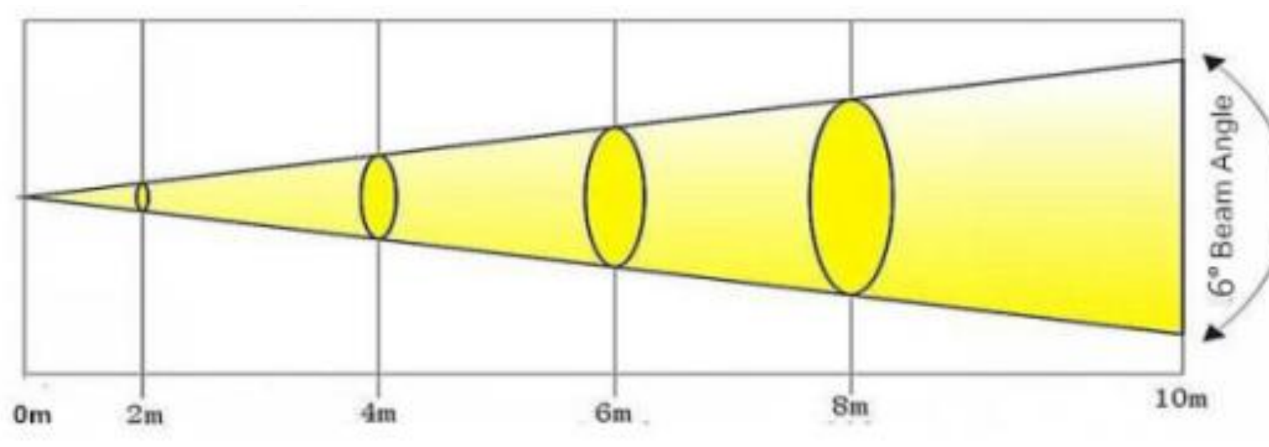
6° beam spread and measurement distances.
SOURCE NOTE The supplied Chinese manual lists the RGBW reading at 10 m as 70,000 lux. This value is reproduced exactly but exceeds the listed 8 m reading; verify it against the product test report before publication.

10 Maintenance & Cleaning
During inspection, confirm the following:
- All mounting screws and components are secure and free of corrosion.
- The housing, lenses, mounting hardware, and supporting structure are not deformed.
- Moving mechanical parts show no excessive wear and rotate smoothly and evenly.
- The power cable has no damage, cuts, abrasions, or exposed material.
- Installation, inspection, and repair are performed by trained technicians and all safety hazards are corrected before use.
To maintain performance and extend service life, clean the fixture regularly:
- Clean the external and internal lenses weekly to prevent dust from reducing light output.
- Clean the fans weekly.
- Every three months, have a qualified electrical technician inspect the circuitry and connections to prevent overheating and contact deterioration.
CLEANING Do not use alcohol or solvents. Do not use wet or lint-producing cloths. Disconnect power and allow the fixture to cool before cleaning.
The fixture does not include user-replaceable service parts. Contact the local distributor when spare parts are required.
END OF MANUAL Retain this document with the fixture. Before operation, verify the current product label, local electrical code, rigging requirements, and venue safety procedures.

