AL1019WR

19 x 15 W LED Bee Eye
Moving Head
RGBW 4-IN-1 - ZOOM - ROTATING HONEYCOMB LENS - USER MANUAL
Beam, wash and individually controlled pixel effects in one moving-head fixture
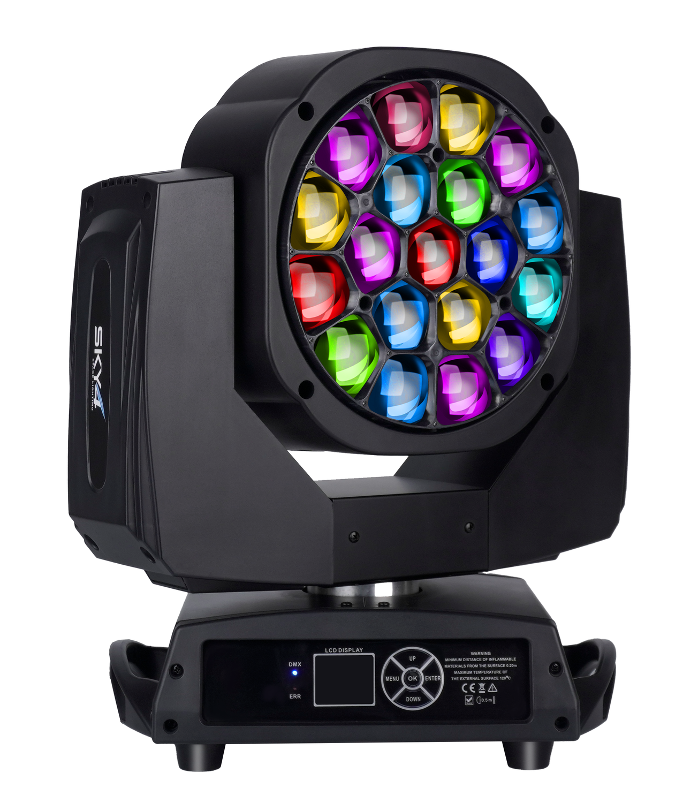
READ BEFORE USE Keep this manual with the fixture. Installation, operation and service must be performed by qualified personnel.
English Edition - Specifications subject to change without notice

Contents
Section | Topic
1 | Safety Information
2 | Product Overview and Specifications
3 | Setup and Installation
4 | Control Panel and Menu
5 | DMX512 Channel Reference
6 | Photometric Data
7 | Routine Maintenance
8 | Troubleshooting and Service

MODEL IDENTIFICATION This manual is for model AL1019WR. Confirm the model, voltage, firmware and product-label ratings before installation or programming.

1 Safety Information
DANGER Disconnect AC power and allow the fixture to cool before opening, cleaning, inspection or service.
- This professional fixture must be installed, operated and serviced by qualified personnel.
- Use only AC 100-240 V, 50/60 Hz. Connect to a protected, correctly grounded Class I supply.
- Do not operate with a damaged housing, lens, connector, cable, mounting point or safety attachment.
- After a large temperature change, keep the fixture disconnected until it reaches ambient temperature and condensation has evaporated.
- Do not look directly into the LEDs at close range. Flashing light may affect susceptible people.
- Keep combustible material at least 0.5 m away and keep every ventilation opening unobstructed.
- For overhead installation, use rated clamps and an independently rated secondary safety cable.
- Carry the fixture by its fixed handles or base. Never lift it by the moving head.
- Do not modify the fixture or bypass protective devices. Refer internal repair to qualified service personnel.
IP20 / PROTECTED INDOOR USE The source specifies IP20. Keep the fixture away from rain, splashing water, condensation and excessive dust.

2 Product Overview and Specifications
The AL1019WR combines nineteen individually controlled 15 W RGBW LEDs with a 4°-60° motorized zoom and a continuously rotating honeycomb lens. It produces narrow beams, broad washes, color mixing and animated kaleidoscopic pixel effects for stages, theatres, clubs, broadcast studios and rental productions.

2.1 Technical Specifications
Parameter | Specification
Input voltage | AC 100-240 V, 50/60 Hz
Rated power | 450 W
Light source | 19 x 15 W high-power RGBW 4-in-1 LEDs; individual LED control
Optics | Motorized 4°-60° zoom; continuously rotating honeycomb lens
Dimming / strobe | 0-100% linear dimming; 0-20 Hz electronic strobe
Control | DMX512 / Auto / Sound-active / Master-slave
DMX personalities | 21CH / 23CH / 35CH / 78CH / 92CH / 97CH / 99CH
Pan / tilt | 540° pan and 270° tilt; 16-bit fine control
Display | Color LCD; English / Chinese; automatic screen inversion
Cooling / protection | Temperature-controlled fan; temperature sensing; position memory and correction
Ingress protection | IP20
Fixture dimensions | 415 x 275 x 425 mm
Carton dimensions | 530 x 420 x 510 mm; 1 fixture per carton
Net / gross weight | 14.95 kg / 18.1 kg
Options | Rechargeable display battery; Art-Net

2.2 Main Functions
- RGBW color mixing with linear color-temperature and macro controls.
- Individual LED pixel control and built-in static/dynamic effects.
- Forward or reverse continuous lens rotation for kaleidoscopic effects.
- Beam, wash and effect-light operation from one fixture.
- Smooth 16-bit pan/tilt, position memory and automatic correction.
- Seven DMX personalities for compact, pattern and full pixel programming.

2.3 Supplied Items
Package contents: AL1019WR fixture x 1; DMX signal cable x 1; hanging brackets x 2; power cable x 1; safety cable x 1; user manual x 1.

3 Setup and Installation

3.1 AC Power
Before connecting power, verify that the product-label voltage and frequency match the local supply. Complete mounting and data connections before applying power. Disconnect by holding the plug, not by pulling the cable.

3.2 Rigging
STRUCTURAL RATING The support, mounting hardware and every attachment must be rated for at least ten times the fixture load or the higher factor required by local regulations.
- Inspect the fixture, Omega brackets, rated clamps, M10 fasteners, mounting points, safety cable and support structure.
- Attach rated clamps to the brackets and lock the brackets securely into the base.
- Attach an independently rated safety cable to the designated point and the supporting structure.
- Confirm unobstructed clearance for complete pan, tilt, zoom and lens-rotation movement.
- Recheck every attachment before applying power and inspect the installation regularly.

3.3 DMX512 Connection
Use shielded twisted-pair cable designed for RS-485/DMX512. Connect the controller to DMX IN, then link DMX OUT to the next fixture. Assign a unique start address to every independently controlled fixture.
3-pin XLR | Signal
Pin 1 | Shield / signal common
Pin 2 | Data -
Pin 3 | Data +

TERMINATION At the final fixture in a long or electrically noisy chain, connect a 120 ohm resistor between pins 2 and 3 of a male XLR plug and insert it into DMX OUT.

4 Control Panel and Menu
Use MENU to move back through the menu, UP/DOWN to change an item or value, and ENTER to open or save it. Menu wording may vary slightly with firmware revision.
Menu | Item | Option / Range | Operation
Address | DMX Address | 001-512 | Set the fixture start address.
Run Mode | Operating Mode | DMX / Sound / Auto 1 / Auto 2 | Select controlled or standalone operation.
System Setup | Channel Mode | 21 / 23 / 35 / 78 / 92 / 97 / 99CH | Select the controller footprint.
System Setup | Invert Pan / Tilt | On / Off | Reverse pan or tilt direction.
System Setup | Hall Correction | On / Off | Enable or disable position-sensor correction.
System Setup | Encoder Correction | On / Off | Enable or disable encoder correction.
System Setup | Signal Keep | On / Off | Hold the last state when DMX is lost.
System Setup | Screen Saver | On / Off | Enable or disable the screen saver.
System Setup | Invert Screen | Auto / On / Off | Set display orientation.
System Setup | Update Slave | On / Off | Firmware/service function.
System Setup | Language | EN / Chinese | Select the display language.
System Setup | Load Default | Confirm | Restore factory settings.
Manual | Channel Control | Per channel | Control each channel manually.
Motor Calibration | Pan / Tilt / Zoom / Rotation / RGBW balance / Power / MIC | Calibration values | Service calibration; change only when necessary.
System Information | Note | Status information | View fixture information.
Reset | Effect / Scan / All | Confirm | Reset a subsystem or the complete fixture.

CALIBRATION CAUTION Do not change motor, color-balance, power or microphone calibration data unless instructed by qualified service personnel.

5 DMX512 Channel Reference
Select the same personality on the fixture and controller. DMX values run from 000 to 255 unless a narrower range is shown. Fine channels provide 16-bit resolution when paired with their coarse channel.

5.1 21-Channel Personality
CH | Function | DMX Value | Description
1 | Red | 000-255 | 0-100%
2 | Red Fine | 000-255 | 16-bit fine
3 | Green | 000-255 | 0-100%
4 | Green Fine | 000-255 | 16-bit fine
5 | Blue | 000-255 | 0-100%
6 | Blue Fine | 000-255 | 16-bit fine
7 | White | 000-255 | 0-100%
8 | White Fine | 000-255 | 16-bit fine
9 | Linear CTO | 000-255 | Linear color-temperature adjustment
10 | Color Macro | 000-255 | Built-in color macro
11 | Strobe | 000-003 / 004-203 / 204-255 | Open / synchronized slow-fast / random
12 | Master Dimmer | 000-255 | 0-100%
13 | Dimmer Fine | 000-255 | 16-bit fine
14 | Pan | 000-255 | Position
15 | Pan Fine | 000-255 | 16-bit fine
16 | Tilt | 000-255 | Position
17 | Tilt Fine | 000-255 | 16-bit fine
18 | Reserved / Function | 000-255 | No source-defined action
19 | Reset | 000-250 / 251-255 | No function / reset; hold 5 seconds
20 | Zoom | 000-255 | 4° to 60°
21 | Lens Rotation | 000-127 / 128-191 / 192-255 | 0°-60° position / CW fast-slow / CCW fast-slow

5.2 23-Channel Personality
CH | Function | DMX Value | Description
1 | Pan | 000-255 | Position
2 | Pan Fine | 000-255 | 16-bit fine
3 | Tilt | 000-255 | Position
4 | Tilt Fine | 000-255 | 16-bit fine
5 | Pan / Tilt Speed | 000-255 | Fast to slow
6 | Zoom | 000-255 | 4° to 60°
7 | Lens Rotation | 000-127 / 128-191 / 192-255 | 0°-60° position / CW fast-slow / CCW fast-slow
8 | Master Dimmer | 000-255 | 0-100%
9 | Strobe | 000-003 / 004-203 / 204-255 | Open / synchronized slow-fast / random
10 | Red | 000-255 | 0-100%
11 | Green | 000-255 | 0-100%
12 | Blue | 000-255 | 0-100%
13 | White | 000-255 | 0-100%
14 | Linear CTO | 000-255 | Linear color-temperature adjustment
15 | Color Macro | 000-255 | Built-in color macro
16 | Static Effect | 000-255 | Each 5-value block selects one static effect
17 | Dynamic Effect | 000-255 | Each 5-value block selects one dynamic effect
18 | Dynamic Speed | 000-255 | Slow to fast
19 | Background Red | 000-255 | 0-100%
20 | Background Green | 000-255 | 0-100%
21 | Background Blue | 000-255 | 0-100%
22 | Background White | 000-255 | 0-100%
23 | Reset | 000-250 / 251-255 | No function / reset; hold 5 seconds

5.3 35-Channel Personality
CH | Function | DMX Value | Description
1 | Red | 000-255 | 0-100%
2 | Red Fine | 000-255 | 16-bit fine
3 | Green | 000-255 | 0-100%
4 | Green Fine | 000-255 | 16-bit fine
5 | Blue | 000-255 | 0-100%
6 | Blue Fine | 000-255 | 16-bit fine
7 | White | 000-255 | 0-100%
8 | White Fine | 000-255 | 16-bit fine
9 | Linear CTO | 000-255 | Linear color-temperature adjustment
10 | Color Macro | 000-255 | Built-in color macro
11 | Strobe | 000-003 / 004-203 / 204-255 | Open / synchronized slow-fast / random
12 | Master Dimmer | 000-255 | 0-100%
13 | Dimmer Fine | 000-255 | 16-bit fine
14 | Pan | 000-255 | Position
15 | Pan Fine | 000-255 | 16-bit fine
16 | Tilt | 000-255 | Position
17 | Tilt Fine | 000-255 | 16-bit fine
18 | Reserved / Function | 000-255 | No source-defined action
19 | Reset | 000-250 / 251-255 | No function / reset; hold 5 seconds
20 | Zoom | 000-255 | 4° to 60°
21 | Lens Rotation | 000-127 / 128-191 / 192-255 | 0°-60° position / CW fast-slow / CCW fast-slow
22 | Shape Selection | 000-255 | Select built-in shape
23 | Shape Speed | 000-255 | Shape speed
24 | Shape Fade | 000-255 | Shape fade
25 | Shape Red | 000-255 | 0-100%
26 | Shape Green | 000-255 | 0-100%
27 | Shape Blue | 000-255 | 0-100%
28 | Shape White | 000-255 | 0-100%
29 | Shape Dimmer | 000-255 | 0-100%
30 | Background Dimmer | 000-255 | 0-100%
31 | Shape Transition | 000-255 | Transition control
32 | Shape Offset | 000-255 | Offset control
33 | Foreground Strobe | 000-255 | Foreground strobe control
34 | Background Strobe | 000-255 | Background strobe control
35 | Background Selection | 000-255 | Background selection

5.4 Pixel Personalities
The expanded personalities retain a complete base personality and then assign direct channels to each of the nineteen LED pixels. LEDs are numbered 1-19 in the fixture's internal order.
Mode | Base channels | Pixel channels | Pixel components
78CH | 1-21 = 21CH | 22-78 | 19 pixels x RGB
92CH | 1-35 = 35CH | 36-92 | 19 pixels x RGB
97CH | 1-21 = 21CH | 22-97 | 19 pixels x RGBW
99CH | 1-23 = 23CH | 24-99 | 19 pixels x RGBW

5.4.1 78CH Pixel Map
CH | Function | DMX Value | Description
22-24 | LED 1 | 000-255 each | R / G / B; 0-100% per component
25-27 | LED 2 | 000-255 each | R / G / B; 0-100% per component
28-30 | LED 3 | 000-255 each | R / G / B; 0-100% per component
31-33 | LED 4 | 000-255 each | R / G / B; 0-100% per component
34-36 | LED 5 | 000-255 each | R / G / B; 0-100% per component
37-39 | LED 6 | 000-255 each | R / G / B; 0-100% per component
40-42 | LED 7 | 000-255 each | R / G / B; 0-100% per component
43-45 | LED 8 | 000-255 each | R / G / B; 0-100% per component
46-48 | LED 9 | 000-255 each | R / G / B; 0-100% per component
49-51 | LED 10 | 000-255 each | R / G / B; 0-100% per component
52-54 | LED 11 | 000-255 each | R / G / B; 0-100% per component
55-57 | LED 12 | 000-255 each | R / G / B; 0-100% per component
58-60 | LED 13 | 000-255 each | R / G / B; 0-100% per component
61-63 | LED 14 | 000-255 each | R / G / B; 0-100% per component
64-66 | LED 15 | 000-255 each | R / G / B; 0-100% per component
67-69 | LED 16 | 000-255 each | R / G / B; 0-100% per component
70-72 | LED 17 | 000-255 each | R / G / B; 0-100% per component
73-75 | LED 18 | 000-255 each | R / G / B; 0-100% per component
76-78 | LED 19 | 000-255 each | R / G / B; 0-100% per component

5.4.2 92CH Pixel Map
CH | Function | DMX Value | Description
36-38 | LED 1 | 000-255 each | R / G / B; 0-100% per component
39-41 | LED 2 | 000-255 each | R / G / B; 0-100% per component
42-44 | LED 3 | 000-255 each | R / G / B; 0-100% per component
45-47 | LED 4 | 000-255 each | R / G / B; 0-100% per component
48-50 | LED 5 | 000-255 each | R / G / B; 0-100% per component
51-53 | LED 6 | 000-255 each | R / G / B; 0-100% per component
54-56 | LED 7 | 000-255 each | R / G / B; 0-100% per component
57-59 | LED 8 | 000-255 each | R / G / B; 0-100% per component
60-62 | LED 9 | 000-255 each | R / G / B; 0-100% per component
63-65 | LED 10 | 000-255 each | R / G / B; 0-100% per component
66-68 | LED 11 | 000-255 each | R / G / B; 0-100% per component
69-71 | LED 12 | 000-255 each | R / G / B; 0-100% per component
72-74 | LED 13 | 000-255 each | R / G / B; 0-100% per component
75-77 | LED 14 | 000-255 each | R / G / B; 0-100% per component
78-80 | LED 15 | 000-255 each | R / G / B; 0-100% per component
81-83 | LED 16 | 000-255 each | R / G / B; 0-100% per component
84-86 | LED 17 | 000-255 each | R / G / B; 0-100% per component
87-89 | LED 18 | 000-255 each | R / G / B; 0-100% per component
90-92 | LED 19 | 000-255 each | R / G / B; 0-100% per component

5.4.3 97CH Pixel Map
CH | Function | DMX Value | Description
22-25 | LED 1 | 000-255 each | R / G / B / W; 0-100% per component
26-29 | LED 2 | 000-255 each | R / G / B / W; 0-100% per component
30-33 | LED 3 | 000-255 each | R / G / B / W; 0-100% per component
34-37 | LED 4 | 000-255 each | R / G / B / W; 0-100% per component
38-41 | LED 5 | 000-255 each | R / G / B / W; 0-100% per component
42-45 | LED 6 | 000-255 each | R / G / B / W; 0-100% per component
46-49 | LED 7 | 000-255 each | R / G / B / W; 0-100% per component
50-53 | LED 8 | 000-255 each | R / G / B / W; 0-100% per component
54-57 | LED 9 | 000-255 each | R / G / B / W; 0-100% per component
58-61 | LED 10 | 000-255 each | R / G / B / W; 0-100% per component
62-65 | LED 11 | 000-255 each | R / G / B / W; 0-100% per component
66-69 | LED 12 | 000-255 each | R / G / B / W; 0-100% per component
70-73 | LED 13 | 000-255 each | R / G / B / W; 0-100% per component
74-77 | LED 14 | 000-255 each | R / G / B / W; 0-100% per component
78-81 | LED 15 | 000-255 each | R / G / B / W; 0-100% per component
82-85 | LED 16 | 000-255 each | R / G / B / W; 0-100% per component
86-89 | LED 17 | 000-255 each | R / G / B / W; 0-100% per component
90-93 | LED 18 | 000-255 each | R / G / B / W; 0-100% per component
94-97 | LED 19 | 000-255 each | R / G / B / W; 0-100% per component

5.4.4 99CH Pixel Map
CH | Function | DMX Value | Description
24-27 | LED 1 | 000-255 each | R / G / B / W; 0-100% per component
28-31 | LED 2 | 000-255 each | R / G / B / W; 0-100% per component
32-35 | LED 3 | 000-255 each | R / G / B / W; 0-100% per component
36-39 | LED 4 | 000-255 each | R / G / B / W; 0-100% per component
40-43 | LED 5 | 000-255 each | R / G / B / W; 0-100% per component
44-47 | LED 6 | 000-255 each | R / G / B / W; 0-100% per component
48-51 | LED 7 | 000-255 each | R / G / B / W; 0-100% per component
52-55 | LED 8 | 000-255 each | R / G / B / W; 0-100% per component
56-59 | LED 9 | 000-255 each | R / G / B / W; 0-100% per component
60-63 | LED 10 | 000-255 each | R / G / B / W; 0-100% per component
64-67 | LED 11 | 000-255 each | R / G / B / W; 0-100% per component
68-71 | LED 12 | 000-255 each | R / G / B / W; 0-100% per component
72-75 | LED 13 | 000-255 each | R / G / B / W; 0-100% per component
76-79 | LED 14 | 000-255 each | R / G / B / W; 0-100% per component
80-83 | LED 15 | 000-255 each | R / G / B / W; 0-100% per component
84-87 | LED 16 | 000-255 each | R / G / B / W; 0-100% per component
88-91 | LED 17 | 000-255 each | R / G / B / W; 0-100% per component
92-95 | LED 18 | 000-255 each | R / G / B / W; 0-100% per component
96-99 | LED 19 | 000-255 each | R / G / B / W; 0-100% per component

6 Photometric Data
Source illuminance measurements at the 4° beam angle:
Color | 2.5 m | 5 m | 7.5 m
Red | 83,700 lx | 2,550 lx | 1,150 lx
Green | 13,800 lx | 3,800 lx | 1,780 lx
Blue | 15,300 lx | 4,460 lx | 1,970 lx
White | 18,000 lx | 5,300 lx | 2,320 lx
RGBW | 50,400 lx | 15,500 lx | 6,680 lx

MEASUREMENT NOTE Photometric values are source measurements and may vary with LED binning, calibration, mains conditions, optical cleanliness and measurement method.

7 Routine Maintenance
DISCONNECT POWER Allow the fixture to cool before inspection or cleaning. There are no user-serviceable parts inside.
- Inspect mounting screws, clamps, brackets, safety cable, housing, lenses and installation points for corrosion, wear, deformation or looseness.
- Inspect moving parts for unusual wear, imbalance, noise or restricted movement.
- Inspect power and data cables for damage, fatigue, overheating or contamination.
- Clean internal and external optical surfaces regularly with a soft, lint-free cloth. Never use alcohol or solvents.
- Keep fans, air inlets and outlets clean. Cleaning frequency must suit the dust level and operating environment.
- Have the electrical system and internal connections inspected periodically by a qualified technician.

8 Troubleshooting and Service
Symptom | Checks / corrective action
No power or display | Verify the supply, breaker, cable, connector and product-label voltage. Disconnect power before inspecting.
No DMX response | Confirm DMX mode and start address, cable pinout, controller output and chain termination.
Unexpected movement | Check pan/tilt inversion, free movement, Hall/encoder correction and reset the fixture.
Low or uneven output | Check dimmer/color channels, lens cleanliness, temperature status and airflow.
Fixture stops when hot | Disconnect power, clear airflow, clean the fans and allow the fixture to cool. Refer persistent temperature faults to service.
Lens rotation or zoom fault | Remove obstructions, reset the fixture and check calibration only if qualified to do so.

SERVICE Use genuine replacement parts. Refer internal repair, calibration and persistent faults to the dealer or a qualified service technician.

