AL1019WZ

19 x 15 W LED Moving Head
Aura
  - RGBW 4-IN-1 - MOTORIZED ZOOM - USER MANUAL
Three-zone RGBW wash, beam and circular-effect moving-head fixture
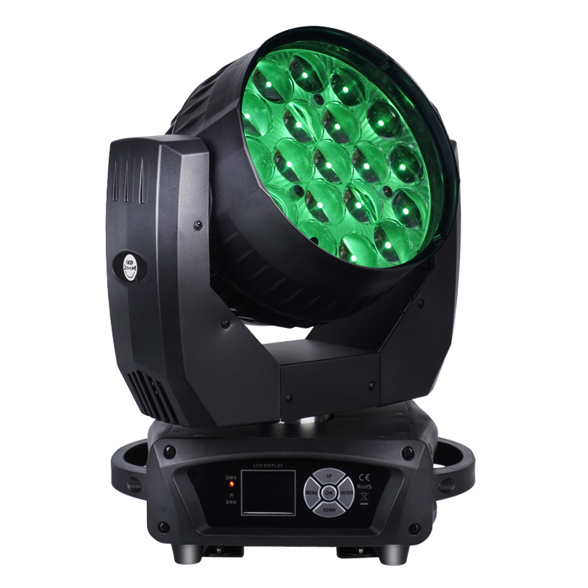
READ BEFORE USE Keep this manual with the fixture. Installation, operation, rigging and service must be performed by qualified personnel.
English Edition | Professionally translated and technically standardized

Contents
Section | Topic
1 | Safety Information
2 | Product Overview and Confirmed Specifications
3 | Setup, Rigging and Data Connections
4 | Control Panel and Menu
5 | DMX512 Channel Reference
6 | Photometric Data
7 | Inspection, Maintenance and Cleaning
8 | Troubleshooting and Service

MODEL IDENTIFICATION This edition is organized for model AL1019WZ, as specified by the product owner. Confirm the model, electrical rating and firmware shown on the actual fixture before installation or programming.
SOURCE LIMITS The source manual does not state rated input voltage, total power consumption or fixture dimensions. Use the fixture rating label for electrical data; do not estimate total power from LED wattage. The source also contains conflicting maximum-ambient-temperature values, so no single value is published here.
The product name Aura describes this model/effect family. The source confirms nineteen RGBW emitters and three RGBW control zones; it does not identify a separate aura-ring light source.

1 Safety Information
DANGER Disconnect AC power and allow the fixture to cool completely before cleaning, inspection, opening the housing or service.
- This professional fixture must be installed, operated and serviced by qualified personnel.
- Use only the voltage and frequency marked on the product label. Connect the Class I fixture to a protected, properly grounded supply.
- Do not operate the fixture with a damaged housing, lens, connector, mounting point, power cable or data cable.
- After a large temperature change, leave the fixture disconnected until it reaches ambient temperature and all condensation has evaporated.
- Do not look directly into the LEDs at close range. Intense or flashing light may affect photosensitive people; follow local restrictions.
- Keep at least 0.5 m clearance from walls and obstructions. Keep fans and ventilation openings clear and do not operate in excessive dust.
- Keep combustible materials away from the beam and fixture. Never leave the fixture operating unattended in an unsafe condition.
- Carry the fixture by the fixed base or designated handles only. Never lift or suspend it by the moving head.
- Stop use immediately if there is smoke, a burning odor, abnormal noise, severe vibration or unexpected overheating; disconnect power and arrange qualified inspection.
IP20 / INDOOR USE Protect the fixture from rain, splashing water, condensation, moisture and conductive dust. Do not use it outdoors or in a wet location without a correctly rated enclosure.

2 Product Overview and Confirmed Specifications
The AL1019WZ is an RGBW moving-head fixture with nineteen 15 W four-in-one LEDs, motorized zoom and two DMX personalities. Its 24-channel personality divides the RGBW array into three control zones for layered color and circular effects. It is intended for stages, theatres, studios, clubs, mobile productions and rental applications.

2.1 Confirmed Technical Specifications
Parameter | Confirmed source specification
Light source | 19 x 15 W high-brightness RGBW 4-in-1 LEDs
Expected LED life | 50,000 hours (source nominal value)
Control modes | DMX512 / Master-Slave / Auto / Sound-active
DMX personalities | 16CH / 24CH
Pan | 540 degrees, 16-bit
Tilt | 270 degrees, 16-bit
Zoom / beam angle | 8-63 degrees motorized zoom
Dimming | 0-100% linear dimming
Strobe | Electronic strobe, 1-25 Hz nominal
Color / effects | RGBW mixing, color-temperature control, rainbow/circular and built-in macro effects
Positioning | Position memory and automatic repositioning
Cooling | Temperature-controlled fan cooling
Display / menu | Onboard display; Chinese and English menu options; 180-degree inversion
Data connection | 3-pin XLR DMX input/output
Ingress protection | IP20 / indoor use
Packing dimensions | 360 x 260 x 460 mm; one fixture per carton
Net / gross weight | 7.5 kg / 9.3 kg

2.2 Package Contents
Item | Quantity
AL1019WZ fixture | 1
Power cable | 1
DMX signal cable | 1
Omega brackets | 2
Safety cable | 1
User manual | 1

BEFORE INSTALLATION Inspect the carton and every item for shipping damage. Do not energize a damaged fixture; retain the packaging and contact the supplier.

3 Setup, Rigging and Data Connections

3.1 AC Power
Before connecting power, verify that the voltage and frequency on the product label match the local supply. Complete mounting and data connections before applying power. Disconnect by holding the plug or connector body, never by pulling the cable.

3.2 Rigging
STRUCTURAL RATING The support and every attachment must be rated for at least ten times the fixture load, or the higher factor required by local regulations. Keep people clear of the area below during installation and service.
- Inspect the fixture, two omega brackets, rated clamps, M10 clamp hardware, quarter-turn fasteners, safety cable, mounting points and support structure.
- Attach one rated clamp to each omega bracket, then lock both brackets into the base with all quarter-turn fasteners fully engaged.
- Attach an independently rated safety cable to the designated safety point. Do not attach it to a carrying handle.
- Confirm clearance for the complete 540-degree pan, 270-degree tilt and zoom range, with no cable tension or obstruction.
- Recheck every attachment before applying power and inspect the installation at intervals required by local regulations.

3.3 DMX512 Connection
Use shielded, twisted-pair cable intended for RS-485/DMX512. Connect the controller to DMX IN, then daisy-chain DMX OUT to the next fixture. Assign a unique start address to every independently controlled fixture.
3-pin XLR | Signal
Pin 1 | Shield / signal common
Pin 2 | Data -
Pin 3 | Data +

TERMINATION At the last fixture in a long or electrically noisy DMX chain, install a 120 ohm resistor between pins 2 and 3 of a male XLR plug and insert it into DMX OUT.

4 Control Panel and Menu
Use the menu and confirmation keys to open or save a setting, and the arrow keys to select or change values. Labels may vary slightly with firmware revision.
Main Menu | Item | Option / Range | Operation
System | DMX Address | 001-512 | Set the fixture start address.
System | Position Encoder | Off / On | Enable or disable the documented encoder setting.
Movement | Pan Reverse | Off / On | Reverse the pan direction.
Movement | Tilt Reverse | Off / On | Reverse the tilt direction.
Run Mode | Operating Mode | DMX / Auto / Sound | Select controller, automatic or sound-active operation.
Run Mode | Channel Mode | 16CH / 24CH | Select the DMX personality.
Display | Language | Chinese / English | Select the menu language.
Display | Display Reverse | Off / On | Rotate the display by 180 degrees.
System | ECO Output | 50% / 75% / 100% | Source setting preserved; exact firmware behavior is not defined.
Factory | Protected Menu | Not documented | Service-only menu; do not change undocumented values.

UNDOCUMENTED FUNCTIONS The source lists Master/Slave control but does not provide its setup workflow. It also does not define the detailed behavior of Position Encoder or ECO Output. Confirm these items on the installed firmware before show programming.

5 DMX512 Channel Reference
Select the same personality on the fixture and controller. Values increase from 000 to 255 unless a narrower range is shown. Macro, strobe, zoom-direction and color-temperature subranges are not defined in the source and are therefore not invented here.

5.1 16-Channel Personality
Channel | Function | DMX Value | Description
1 | Pan | 000-255 | 0-540 degrees
2 | Pan Fine | 000-255 | 16-bit fine adjustment
3 | Tilt | 000-255 | 0-270 degrees
4 | Tilt Fine | 000-255 | 16-bit fine adjustment
5 | Pan / Tilt Speed | 000-255 | Fast to slow
6 | Master Dimmer | 000-255 | Blackout to full output
7 | Strobe | 000-255 | Electronic strobe; detailed value bands not supplied
8 | Red | 000-255 | 0-100%
9 | Green | 000-255 | 0-100%
10 | Blue | 000-255 | 0-100%
11 | White | 000-255 | 0-100%
12 | Zoom | 000-255 | Motorized zoom; value direction not supplied
13 | Macro Effect | 000-255 | Built-in macro selection; map not supplied
14 | Macro Speed | 000-255 | Fast to slow
15 | Color Temperature | 000-255 | Linear adjustment; endpoints not supplied
16 | Reset | 000-249 | No function
16 | Reset | 250-255 | Reset after value is held for 5 seconds

5.2 24-Channel Personality
Channel | Function | DMX Value | Description
1 | Pan | 000-255 | 0-540 degrees
2 | Pan Fine | 000-255 | 16-bit fine adjustment
3 | Tilt | 000-255 | 0-270 degrees
4 | Tilt Fine | 000-255 | 16-bit fine adjustment
5 | Pan / Tilt Speed | 000-255 | Fast to slow
6 | Zoom | 000-255 | Motorized zoom; value direction not supplied
7 | Master Dimmer | 000-255 | Blackout to full output
8 | Strobe | 000-255 | Electronic strobe; detailed value bands not supplied
9 | Zone 1 Red | 000-255 | 0-100%
10 | Zone 1 Green | 000-255 | 0-100%
11 | Zone 1 Blue | 000-255 | 0-100%
12 | Zone 1 White | 000-255 | 0-100%
13 | Zone 2 Red | 000-255 | 0-100%
14 | Zone 2 Green | 000-255 | 0-100%
15 | Zone 2 Blue | 000-255 | 0-100%
16 | Zone 2 White | 000-255 | 0-100%
17 | Zone 3 Red | 000-255 | 0-100%
18 | Zone 3 Green | 000-255 | 0-100%
19 | Zone 3 Blue | 000-255 | 0-100%
20 | Zone 3 White | 000-255 | 0-100%
21 | Macro Effect | 000-255 | Built-in macro selection; map not supplied
22 | Macro Speed | 000-255 | Fast to slow
23 | Color Temperature | 000-255 | Linear adjustment; endpoints not supplied
24 | Reset | 000-249 | No function
24 | Reset | 250-255 | Reset after value is held for 5 seconds

ZONE MAP The source defines three RGBW control zones but does not show which lenses belong to Zones 1, 2 and 3. Build a low-intensity RGBW test scene and document the physical mapping before programming production cues.

6 Photometric Data
The 8-degree illuminance values below are copied from the source test data. Actual output varies with production tolerance, optical condition, mains quality, fixture temperature and measurement method.

6.1 8-Degree Beam
Color | 2 m | 4 m | 6 m | 8 m
Red | 7,200 lux | 1,900 lux | 1,000 lux | 620 lux
Green | 14,800 lux | 3,900 lux | 1,900 lux | 1,200 lux
Blue | 14,800 lux | 3,950 lux | 1,950 lux | 1,200 lux
White | 15,200 lux | 3,850 lux | 1,950 lux | 1,200 lux
RGBW | 41,100 lux | 10,000 lux | 4,600 lux | 2,550 lux

DATA-QUALITY NOTE The source also contains a 50-degree table, but one color row is internally non-monotonic. That table is withheld pending a verified remeasurement; the omission does not change the documented 8-63 degree motorized zoom range.

6.2 Application Guidance
- Use the narrow end of the zoom range for higher center intensity and beam effects.
- Use wider zoom settings for wash coverage; confirm uniformity and overlap in the actual venue.
- Photometric data is nominal and is not a substitute for an on-site lighting test.

7 Inspection, Maintenance and Cleaning
ATTENTION Disconnect AC power and allow the fixture to cool completely before inspection or cleaning.
- Before each use, inspect the housing, lens, screws, brackets, clamps, safety cable and mounting points for looseness, corrosion, cracks or deformation.
- Inspect pan, tilt and zoom movement for obstruction, imbalance, excessive resistance, unusual noise or vibration.
- Inspect power and data cables and connectors for cuts, fatigue, exposed conductors, bent contacts or heat damage.
- Clean the exterior lens and housing with a soft, lint-free cloth lightly dampened with clean water. Do not use alcohol, solvents, abrasives or strong detergent.
- Keep fans and ventilation openings free of dust. Cleaning frequency depends on duty cycle, haze-fluid residue and the operating environment.
- Internal cleaning, fan service, electrical inspection, LED-module replacement and calibration must be performed by a qualified technician.
NO USER-SERVICEABLE PARTS Do not open or modify the fixture unless you are qualified and authorized to service professional stage-lighting equipment.

8 Troubleshooting and Service
Symptom | Check
Fixture does not power on | Verify the product-label supply requirement, power connection, circuit protection and cable condition. Refer internal inspection to qualified service.
No light output | Check master dimmer, strobe/blackout, RGBW values, ECO setting, macro values, controller output and fixture temperature.
No DMX response | Confirm DMX mode, start address, 16CH/24CH personality, controller patch, 3-pin polarity, cable continuity and connector condition.
Intermittent or unstable DMX | Use shielded twisted-pair cable, inspect connectors, separate data from high-voltage cables and terminate the final fixture with 120 ohms.
Unexpected zone colors | Confirm the 24CH patch and identify the physical Zone 1-3 mapping with a low-intensity RGBW test scene.
Abnormal pan or tilt | Remove obstructions, check reverse/encoder settings, run a reset and refer mechanical or encoder faults to qualified service.
Zoom does not respond | Check Channel 12 in 16CH mode or Channel 6 in 24CH mode, reset the fixture and refer mechanism faults to qualified service.
Reduced or unstable output | Check ventilation, fan operation, optical cleanliness, ECO setting, mains quality and operating temperature.

SERVICE Disconnect the fixture and refer it to the manufacturer, its service agent or similarly qualified personnel if damage, liquid ingress, burning odor, smoke, abnormal heat or persistent mechanical/electrical faults are found.

8.1 Support Information
When requesting support, provide the model, serial number, active channel personality, start address, firmware/menu version if available, supply conditions and a clear description of the fault. Include photographs or a short video when they help demonstrate the issue.
End of manual

