AL1036WZ

36 x 12 W LED Wash
Moving Head
  - RGBW ZOOM - USER MANUAL
Professional indoor LED wash moving-head fixture
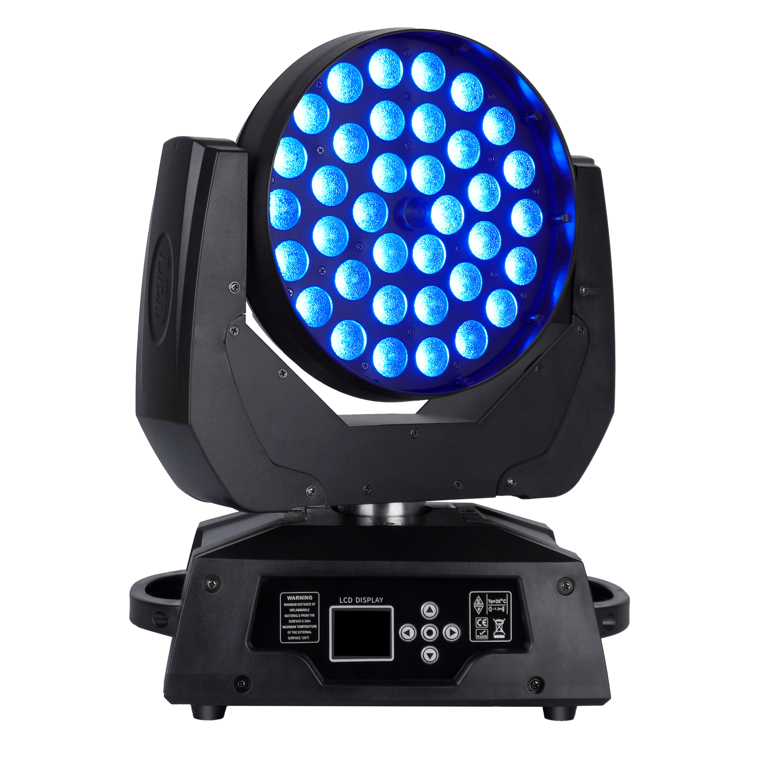
READ BEFORE USE Keep this manual with the fixture. Installation, operation and service must be performed by qualified personnel.
English Edition - Specifications subject to change without notice

Contents
Section | Topic
1 | Safety Information
2 | Product Overview
3 | Installation, DMX and Menu
4 | DMX Channel Reference
5 | Routine Maintenance
6 | Troubleshooting and Service

MODEL AND FIRMWARE This manual is organized for AL1036WZ. Confirm the model, supply rating and channel mode shown on the actual fixture before use.
The archived AL1036WZ manual and the user-supplied PDF describe different firmware profiles. This edition preserves both complete channel charts and identifies their sources clearly.

1 Safety Information
DANGER Disconnect AC power and allow the fixture to cool completely before opening the housing, cleaning, inspection or service.
- Use indoors in dry locations only. The fixture is rated IP20 and is not protected against rain or water jets.
- Connect only to the supply range marked on the product label and to a properly grounded Protection Class I circuit.
- Protect power and DMX cables from heat, sharp edges, crushing, heavy traffic and damaged insulation.
- Keep ventilation openings clear and maintain free airflow around the base and head.
- Do not look directly into the light output at close range. The LED array can produce intense visible light and rapid strobe effects.
- Do not carry the fixture by the moving head. Lift it by the base or designated handles.
- For suspended installation, use correctly rated clamps and an independent safety cable attached to the designated safety point.
- Do not modify the fixture. Internal repair, adjustment and calibration must be performed by qualified personnel.
CONDENSATION After transport or a severe temperature change, leave the fixture disconnected until it reaches room temperature and all condensation has evaporated.
MINIMUM CLEARANCE Keep the light output away from combustible materials and maintain the clearances required by the fixture label, venue rules and local regulations.

2 Product Overview
The AL1036WZ is an indoor RGBW LED wash moving head with 36 four-color emitters, motorized zoom, smooth dimming and automated movement. It supports DMX512 control together with stand-alone automatic and sound-active operation.

2.1 Technical Specifications
Parameter | Specification
Model | AL1036WZ
Product type | 36 x 12 W LED Wash Moving Head
Input voltage | AC 90-240 V, 50/60 Hz - verify the fixture label
Rated input power | 400 W in the archived AL1036WZ product manual
Light source | 36 x 12 W high-brightness RGBW 4-in-1 LEDs
Color system | RGBW additive color mixing
Zoom | Motorized focus/zoom, DMX controlled
Pan / tilt | Pan 540 degrees; tilt 270 degrees; fine control
Dimming | 0-100% continuous linear dimming
Strobe | 1-25 Hz in the archived 14CH profile; firmware may vary
Control modes | DMX512 / Master-Slave / Auto / Sound
Documented DMX profiles | 14CH archived profile / 15CH supplied-PDF profile
Display | LCD control display
Application / protection | Indoor use / IP20
Listed dimensions | 425 x 295 x 390 mm
Listed net weight | 10 kg

SOURCE NORMALIZATION The user-supplied PDF contains legacy discharge-lamp wording and lists 450 W / 15CH, while archived AL1036WZ product material lists 400 W / 14CH. This edition corrects all lamp references to LED and includes both documented channel charts. The fixture label and installed firmware take priority.

2.2 Package Contents
Item | Quantity
AL1036WZ fixture | 1
Hanging bracket | 1
Power cable | 1
3-pin DMX signal cable | 1
User manual | 1

2.3 Main Functions
- RGBW color mixing with smooth 0-100% master dimming.
- Motorized zoom/focus for wash coverage adjustment.
- 540-degree pan and 270-degree tilt with fine-position channels.
- Electronic strobe and built-in automatic and sound-active operation.
- Pan/tilt inversion, position calibration and RGBW balance settings.
- Fan-assisted cooling with thermal protection.

3 Installation, DMX and Menu

3.1 Rigging and Placement
- Place the fixture on a stable, level surface or suspend it from a structure rated for the fixture and all applied loads.
- Use correctly rated clamps and fasteners. Fully tighten all hardware before connecting power.
- Attach an independent safety cable to the designated base safety point. Never attach the safety cable to a carrying handle.
- Keep the fixture outside normal walking and seating areas and beyond unauthorized reach.
- Inspect clamps, fasteners, the bracket, the safety cable and the supporting structure before every use.

3.2 DMX512 Data Connection
Use shielded twisted-pair DMX cable. Connect the controller output to the fixture DMX input, then link each fixture output to the next fixture input.
3-pin XLR | Signal
Pin 1 | Ground / shield
Pin 2 | Data -
Pin 3 | Data +

TERMINATION For long cable runs or electrically noisy environments, connect a 120 ohm resistor between pins 2 and 3 in a male XLR plug and fit it to the DMX output of the final fixture.
ADDRESS EXAMPLES For consecutive addressing: 14CH fixtures may start at 001, 015 and 029; 15CH fixtures may start at 001, 016 and 031. Leave additional address space when required by the controller profile.

3.3 Control Panel and Menu
Use MENU or RETURN to leave the current item, ENTER to open or confirm, and UP/DOWN to change the selected option or value. Menu wording may vary with firmware.
Menu | Range / Options | Operation
Run Mode | DMX512 / Auto / Sound | Select console, automatic or sound-active operation.
DMX Address | 001-512 | Set the DMX start address and press ENTER to save.
Channel Mode | 14CH / 15CH / firmware options | Select the controller profile that matches the fixture display.
Invert Pan | No / Yes | Reverse pan direction for the installation.
Invert Tilt | No / Yes | Reverse tilt direction for the installation.
Pan Adjust | 000-255 | Fine-adjust the pan home position.
Tilt Adjust | 000-255 | Fine-adjust the tilt home position.
Focus / Zoom Adjust | 000-255 | Fine-adjust the zoom home position.
Balance R / G / B / W | 100-255 | Set the maximum level used for white balance.
Backlight | On / 30 s | Keep the LCD on or switch it off after inactivity.
Sound Sense | 0-100% | Adjust sound-active sensitivity.
Language / Orientation | Firmware dependent | Choose language or rotate the display when available.
Factory Default | Confirm / Cancel | Restore stored factory values.
Reset | Confirm / Cancel | Reinitialize the fixture and wait for movement to stop.

CALIBRATION Record original values before changing pan, tilt, zoom or RGBW balance. Incorrect settings can cause uneven color or abnormal mechanical positioning.

4 DMX Channel Reference
Select the profile shown by the fixture display and configure the controller with the matching channel layout. Do not use a profile only because it has the same channel count; compare the function order.
FIRMWARE PROFILES The archived AL1036WZ manual provides a complete 14CH chart. The user-supplied PDF provides a complete 15CH chart and separately mentions 16CH in menu text without a 16-channel chart. No undocumented 16CH functions are invented here.
Profile | Source | Use
14CH | Archived AL1036WZ manual | Dimmer/strobe, RGBW, zoom, movement fine control and mode/reset
15CH | User-supplied PDF | Movement speed first, dimmer, RGBW, strobe, zoom, function mode/speed and reset

4.1 14-Channel Profile - Archived AL1036WZ Manual
Channel | Function | DMX Value | Description
1 | Pan | 000-255 | 0-540 degrees
2 | Tilt | 000-255 | 0-270 degrees
3 | Master Dimmer | 000-255 | 0-100% linear dimming
4 | Strobe | 000-003 | No function / open
4 | Strobe | 004-255 | Synchronized strobe, slow to fast, approximately 1-25 Hz
5 | Red | 000-255 | 0-100% red
6 | Green | 000-255 | 0-100% green
7 | Blue | 000-255 | 0-100% blue
8 | White | 000-255 | 0-100% white
9 | Zoom / Focus | 000-255 | Linear motorized zoom/focus
10 | Macro / Run Mode | 000-155 | DMX512 control
10 | Macro / Run Mode | 156-199 | Automatic program
10 | Macro / Run Mode | 200-255 | Sound-active program
11 | Pan Fine | 000-255 | Fine pan adjustment
12 | Tilt Fine | 000-255 | Fine tilt adjustment
13 | Pan/Tilt Speed | 000-255 | Fast to slow
14 | Reset | 000-250 | No function
14 | Reset | 251-255 | Fixture reset after value is held for approximately 3 seconds

4.2 15-Channel Profile - User-Supplied PDF
The supplied chart gives full-channel ranges for channels 1-14 but does not provide internal boundaries for strobe or function macros. These are retained as continuous selectors without invented sub-ranges.
Channel | Function | DMX Value | Description
1 | Pan | 000-255 | Pan movement
2 | Tilt | 000-255 | Tilt movement
3 | Pan/Tilt Speed | 000-255 | Movement speed control
4 | Master Dimmer | 000-255 | 0-100% linear dimming
5 | Red | 000-255 | Area/group 1 red
6 | Green | 000-255 | Area/group 1 green
7 | Blue | 000-255 | Area/group 1 blue
8 | White | 000-255 | Area/group 1 white
9 | Strobe | 000-255 | Strobe control; exact sub-ranges not supplied
10 | Zoom / Focus | 000-255 | Motorized zoom/focus
11 | Function Mode | 000-255 | Built-in function mode; sub-ranges not supplied
12 | Function Mode Speed | 000-255 | Built-in function speed
13 | Pan Fine | 000-255 | Fine pan adjustment
14 | Tilt Fine | 000-255 | Fine tilt adjustment
15 | Reset | 000-249 | No function
15 | Reset | 250-255 | Fixture reset

5 Routine Maintenance
Cleaning frequency depends on operating conditions. Inspect the fixture after approximately 100 hours in demanding environments, then establish a suitable recurring interval.
- Frequent use of smoke or fog machines.
- Operation near an air inlet, outlet or other high-airflow location.
- Dust from stage effects, building work or simulated outdoor environments.
ATTENTION Disconnect AC power and allow the fixture to cool completely before opening the housing or cleaning any component.

5.1 Cleaning Optical Components
- Disconnect power, allow the fixture to cool completely and open the housing only if qualified to do so.
- Use clean, dry compressed air to remove loose dust.
- For marks on the front lens, use lint-free optical tissue lightly moistened with purified water or a suitable optical cleaner.
- Wipe gently from the center outward. Do not scratch the lens or colored coatings.
- Dry with a clean, soft cloth or clean compressed air before reconnecting power.

5.2 Fans and Vents
Remove dust from fans and ventilation openings with a soft brush, lint-free cloth, vacuum cleaner or clean compressed air. Do not force debris deeper into the fixture.

5.3 Inspection
- Check the power cable, plug, DMX connectors and strain relief for damage.
- Check the lens, yoke, base, bracket, clamps and safety attachment for cracks or looseness.
- Run a pan/tilt reset and listen for unusual noise or repeated position errors.

6 Troubleshooting and Service
Symptom | Check
Fixture does not power on | Verify the supply, product-label voltage, power cable, plug and fuse/service protection.
Fixture does not respond to DMX | Confirm DMX mode, start address, controller profile, data polarity and cable connections.
Unexpected channel behavior | Verify that the controller chart matches the selected 14CH or 15CH firmware profile.
Pan or tilt is reversed | Change the Invert Pan or Invert Tilt setting.
Movement does not return accurately | Run Reset; if permitted, check Pan/Tilt Adjust values and encoder settings.
Zoom position is incorrect | Run Reset and check Focus/Zoom Adjust without overwriting the original value.
Sound mode is unresponsive | Increase Sound Sense and confirm that Run Mode is set to Sound.
Reduced output or overheating | Allow the fixture to cool, then clean fans, vents and optical components.

SERVICE All repairs not described in this manual must be referred to a qualified technician. Do not operate a fixture with damaged wiring, abnormal movement, persistent errors or signs of overheating.
END OF MANUAL Retain this manual with the fixture and verify the product label, controller profile, local electrical requirements and rigging procedures before each installation.

