PROFESSIONAL LED EFFECT FIXTURE

AL120T

120W Tornado Moving Head

SINGLE-HEAD TORNADO EFFECT LIGHT
USER MANUAL
English Edition | Translated from the supplied Chinese manual
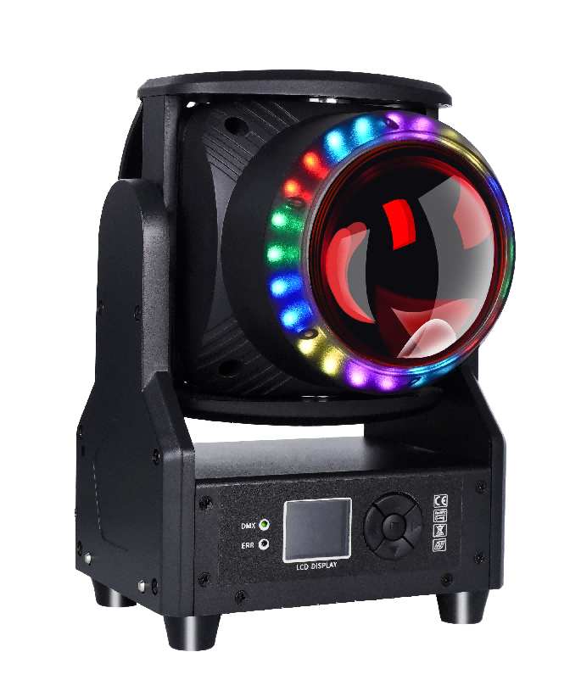
120 W RGBL main LED • 24-zone RGB halo • Zoom, beam and wash effects
Ingress Protection | Rated Power | Input | DMX Modes
IP20 | 142 W | DC 36 V | 22 / 24 / 94 CH

IMPORTANT Read this manual completely before installing, powering, operating, or servicing the fixture. Retain it for future reference.

Contents
1 Safety, Maintenance & Product Information
2 Display Panel & Menu Operation
3 Master/Slave Control
4 DMX512 Control & Channel Charts
5 Troubleshooting
TRANSLATION NOTE This English edition reorganizes the supplied Chinese source for clarity while preserving its specifications, menu defaults, DMX values, and safety instructions.

1 Safety, Maintenance & Product Information

1.1 Statement
Thank you for choosing this product. It left the factory in good condition and with complete packaging. Read this manual fully before use. It contains important installation and operating information; follow all instructions and retain the manual for future reference.
Technical changes may be made without prior notice.

1.2 Maintenance & Safety
- This fixture is intended for professional use only.
- If the external flexible cable is damaged, replace it only with the dedicated cable supplied by the manufacturer or its service agent.
- The light source may be replaced only by the manufacturer, its service agent, or similarly qualified personnel.
- Connect the product to a protected circuit fitted with a circuit breaker or fuse and ensure proper protective grounding to reduce the risk of electric shock or fire.
- Disconnect power completely at the breaker or plug when the fixture is not in use.
- The enclosure may become hot during operation. Install the fixture in a well-ventilated location.
- After moving the product between extreme temperatures, allow it to acclimatize before applying power so internal condensation cannot cause a malfunction.
- Strobe lighting may trigger epileptic seizures. Comply with all local regulations and warning requirements for strobe use.

1.3 Product Precautions
- Disconnect power before cleaning the product or replacing a fuse.
- When ports are not in use, reinstall and secure the protective covers for power, data, USB, and other connections so the specified IP protection is maintained.
- Use a rated safety cable for overhead installation.
- Connect the product only to a grounded and protected circuit.
- Do not look directly into the light source while the product is operating.
- Keep flammable materials at least 20 cm from the product during operation and while power is connected.
- Do not operate the product if the enclosure, lens, or cable is damaged.
- Carry the product only by its handle or rigging/mounting bracket.
- Stop using the product immediately if a serious operating problem occurs.

1.4 Product Specifications
Parameter | Specification
Input voltage | DC 36 V
Rated power | 142 W
Light sources | 1 × 120 W RGBL (red, green, blue, lime) 1212 LED; 24 × RGB 5050 auxiliary LEDs
Control modes | DMX512, standalone/auto, master/slave, sound-active, RDM
DMX modes | 22 CH / 24 CH / 94 CH
Dimming | 32-bit, 0–100% linear dimming
Effects | Single moving head, wash, beam
Operating temperature | −30 °C to 50 °C
Strobe frequency | 1–30 Hz
Housing | Black metal
Connections | DMX512 input/output; power input/output
Ingress protection | IP20 — indoor use only
Fixture dimensions | 200 × 184 × 328 mm
Fixture weight | 5.1 kg

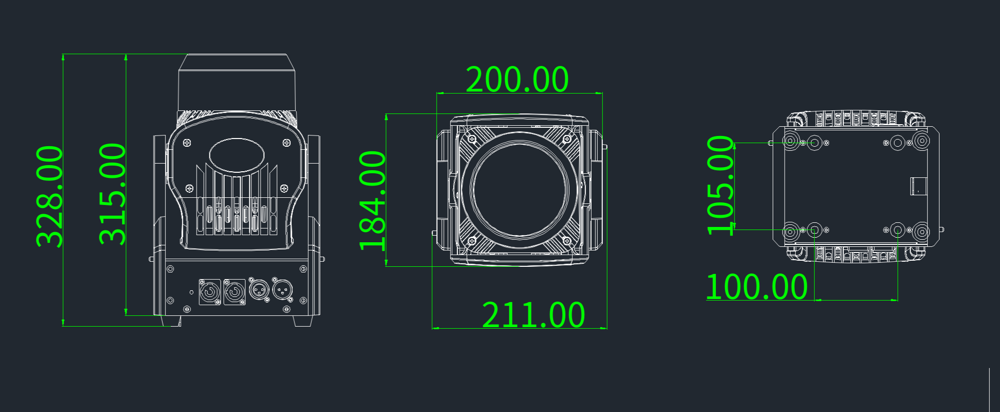
Source dimension drawing; all dimensions are in millimetres.

2 Display Panel & Menu Operation

2.1 Control Panel
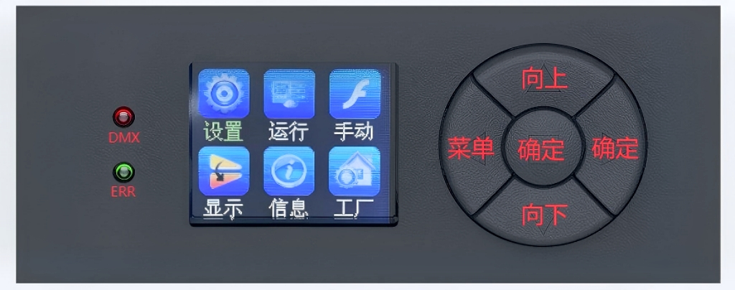
Control panel. The source image shows the Chinese user interface; key functions are translated below.
Control | Function
MENU | Open the main menu or return to the previous menu.
UP | Move upward through menu items or increase a parameter value.
DOWN | Move downward through menu items or decrease a parameter value.
ENTER | Select a menu function; confirm and save a modified parameter.

2.2 Menu Operation
After power-on and the automatic reset, press MENU to open the main menu. The main menu exits after 30 seconds without input. Use UP/DOWN to select an item, press ENTER to edit it, then press ENTER again to save. Saved values are retained after power loss.
Menu | Option | Setting / Default
System Settings | DMX Address | 001–512; default 001.
System Settings | Encoder | On / Off; default On.
System Settings | Pan Invert | On / Off; default Off.
System Settings | Tilt Invert | On / Off; default Off.
System Settings | Zoom Invert | On / Off; default Off.
System Settings | No Signal | Blackout / Hold; default Blackout.
System Settings | Reset | Yes / No; default No.
System Settings | Factory Reset | Yes / No; default No.
System Settings | Advanced Settings | Open the advanced-settings submenu.
Operating Mode | Run Mode | DMX / Sound-active / Auto; default DMX.
Operating Mode | Channel Mode | 22 CH / 24 CH / 94 CH; default 24 CH.

2.3 Manual Control
Item | Range | Default
Pan | 000–255 | 000
Pan Fine | 000–255 | 000
Tilt | 000–255 | 000
Tilt Fine | 000–255 | 000
Zoom | 000–255 | 000
Pan/Tilt Speed | 000–255 | 000
Dimmer | 000–255 | 000
Dimmer Fine | 000–255 | 000
Main Strobe | 000–255 | 000
Color Temperature | 000–255 | 000
Color Macro | 000–255 | 000
Red | 000–255 | 000
Green | 000–255 | 000
Blue | 000–255 | 000
Lime | 000–255 | 000
Halo Strobe | 000–255 | 000
Halo Red | 000–255 | 000
Halo Green | 000–255 | 000
Halo Blue | 000–255 | 000
Halo Mode | 000–255 | 000
Halo Mode Speed | 000–255 | 000
Halo Background Color | 000–255 | 000
Halo Background Dimmer | 000–255 | 000
Function | 000–255 | 000

2.4 Display & Information
Menu | Option | Setting / Function
Display Settings | Language | Chinese / English; default Chinese.
Display Settings | Display Reverse | Off / On; default Off.
Display Settings | Screen Saver | Off / On; default On.
Display Settings | Software Version | Program identification code D1TF; read-only.
Information | Sensors | View Hall-sensor and temperature-communication status.
Information | Error Information | View stored error information.
Information | Channel Information | View live DMX channel data.
Information | Time Information | View power-on time and total fixture operating time.

2.5 Factory Settings
ACCESS When prompted for the factory-settings password, change the value to 138 and press ENTER.
Item | Range / Options | Default
Pan Calibration | 000–255 | 128
Tilt Calibration | 000–255 | 128
Focus/Zoom Axis Calibration | 000–255 | 128
Pan Travel | 000–255 | 128
Tilt Travel | 000–255 | 128
Focus/Zoom Travel | 000–255 | 128
Red | 032–255 | 252
Green | 032–255 | 252
Blue | 032–255 | 252
Lime | 032–255 | 252
Current | 032–255 | 240
Temperature | 040–070 | 065
Temperature / Fan | Auto / Standard / Quiet | Auto
LED Selection | LEDA / LEDB / LEDC / LEDD | LEDA
LED PWM Frequency | 900, 1000, 1100, 1200, 1300, 1400, 1500, 2500, 4000, 5000, 6000, 10000, 15000, 20000, 25000 Hz | 4000 Hz
Dimmer Curve | Linear / Square / Inverse Square / S-Curve | Linear
Dimmer Mode | Fast / Smooth | Fast
Logo | 000 / 001 | 000
Clear Time | Yes / No | No

3 Master/Slave Control
Connect two or more identical fixtures with a 3-pin DMX cable. Set each fixture to any address from 001–512. Configure one fixture as the master and all others as slaves. The slave displays should remain steady. When gradient, pulse, jump, sound-active, or auto effects are selected on the master, all slave fixtures run the same effect in synchronization.
IMPORTANT Use only one master in each fixture group. Multiple masters will cause unsynchronized flashing. Master/slave control operates only when the DMX512 console is disconnected or switched off.

4 DMX512 Control

4.1 DMX Address
Set the address of every fixture, then connect the fixtures to the DMX512 console using 3-pin DMX cables. When the address display stops flashing, the fixture is receiving a DMX signal. Use the channel charts below to control each function.
OUTPUT NOTE To produce light output, set the applicable strobe channel to its full-open value.

4.2 22 CH Mode
Channel | DMX Value | Function
1 | 000–255 | Pan
2 | 000–255 | Pan Fine
3 | 000–255 | Tilt
4 | 000–255 | Tilt Fine
5 | 000–255 | Zoom
6 | 000–255 | Main Light Red
7 | 000–255 | Main Light Green
8 | 000–255 | Main Light Blue
9 | 000–255 | Main Light Lime
10 | 000–255 | Main Light Color Temperature
11 | 000–255 | Main Light Color Macro
12 | 000–255 | Halo Red
13 | 000–255 | Halo Green
14 | 000–255 | Halo Blue
15 | 000–255 | Halo Mode
16 | 000–255 | Halo Mode Speed
17 | 000–255 | Master Dimmer
18 | 000–255 | Master Dimmer Fine
19 | 000–255 | Main Light Strobe
20 | 000–255 | Halo Strobe
21 | 000–255 | Pan/Tilt Speed
22 | 000–255 | Function

4.3 24 CH Mode
Channel | DMX Value | Function
1 | 000–255 | Pan
2 | 000–255 | Pan Fine
3 | 000–255 | Tilt
4 | 000–255 | Tilt Fine
5 | 000–255 | Zoom
6 | 000–255 | Pan/Tilt Speed
7 | 000–255 | Master Dimmer
8 | 000–255 | Master Dimmer Fine
9 | 000–255 | Main Light Strobe
10 | 000–255 | Main Light Color Temperature
11 | 000–255 | Main Light Color Macro
12 | 000–255 | Main Light Red
13 | 000–255 | Main Light Green
14 | 000–255 | Main Light Blue
15 | 000–255 | Main Light Lime
16 | 000–255 | Halo Strobe
17 | 000–255 | Halo Red
18 | 000–255 | Halo Green
19 | 000–255 | Halo Blue
20 | 000–255 | Halo Mode
21 | 000–255 | Halo Mode Speed
22 | 000–255 | Halo Background Color
23 | 000–255 | Halo Background Dimmer
24 | 000–255 | Function

4.4 94 CH Mode
EXPANDED SEQUENCE The source chart shows channels 22–24 for halo zone 1 and channels 91–93 for zone 24 with an arrow between them. The repeating RGB sequence for zones 2–23 is expanded below for easier programming.
Channel | DMX Value | Function
1 | 000–255 | Pan
2 | 000–255 | Pan Fine
3 | 000–255 | Tilt
4 | 000–255 | Tilt Fine
5 | 000–255 | Zoom
6 | 000–255 | Pan/Tilt Speed
7 | 000–255 | Main Light Dimmer
8 | 000–255 | Main Light Dimmer Fine
9 | 000–255 | Main Light Strobe
10 | 000–255 | Main Light Color Temperature
11 | 000–255 | Main Light Color Macro
12 | 000–255 | Main Light Red
13 | 000–255 | Main Light Green
14 | 000–255 | Main Light Blue
15 | 000–255 | Main Light Lime
16 | 000–255 | Halo Dimmer
17 | 000–255 | Halo Strobe
18 | 000–255 | Halo Mode
19 | 000–255 | Halo Mode Speed
20 | 000–255 | Halo Background Color
21 | 000–255 | Halo Background Dimmer
22 | 000–255 | Halo Red 1
23 | 000–255 | Halo Green 1
24 | 000–255 | Halo Blue 1
25 | 000–255 | Halo Red 2
26 | 000–255 | Halo Green 2
27 | 000–255 | Halo Blue 2
28 | 000–255 | Halo Red 3
29 | 000–255 | Halo Green 3
30 | 000–255 | Halo Blue 3
31 | 000–255 | Halo Red 4
32 | 000–255 | Halo Green 4
33 | 000–255 | Halo Blue 4
34 | 000–255 | Halo Red 5
35 | 000–255 | Halo Green 5
36 | 000–255 | Halo Blue 5
37 | 000–255 | Halo Red 6
38 | 000–255 | Halo Green 6
39 | 000–255 | Halo Blue 6
40 | 000–255 | Halo Red 7
41 | 000–255 | Halo Green 7
42 | 000–255 | Halo Blue 7
43 | 000–255 | Halo Red 8
44 | 000–255 | Halo Green 8
45 | 000–255 | Halo Blue 8
46 | 000–255 | Halo Red 9
47 | 000–255 | Halo Green 9
48 | 000–255 | Halo Blue 9
49 | 000–255 | Halo Red 10
50 | 000–255 | Halo Green 10
51 | 000–255 | Halo Blue 10
52 | 000–255 | Halo Red 11
53 | 000–255 | Halo Green 11
54 | 000–255 | Halo Blue 11
55 | 000–255 | Halo Red 12
56 | 000–255 | Halo Green 12
57 | 000–255 | Halo Blue 12
58 | 000–255 | Halo Red 13
59 | 000–255 | Halo Green 13
60 | 000–255 | Halo Blue 13
61 | 000–255 | Halo Red 14
62 | 000–255 | Halo Green 14
63 | 000–255 | Halo Blue 14
64 | 000–255 | Halo Red 15
65 | 000–255 | Halo Green 15
66 | 000–255 | Halo Blue 15
67 | 000–255 | Halo Red 16
68 | 000–255 | Halo Green 16

Channel | DMX Value | Function
69 | 000–255 | Halo Blue 16
70 | 000–255 | Halo Red 17
71 | 000–255 | Halo Green 17
72 | 000–255 | Halo Blue 17
73 | 000–255 | Halo Red 18
74 | 000–255 | Halo Green 18
75 | 000–255 | Halo Blue 18
76 | 000–255 | Halo Red 19
77 | 000–255 | Halo Green 19
78 | 000–255 | Halo Blue 19
79 | 000–255 | Halo Red 20
80 | 000–255 | Halo Green 20
81 | 000–255 | Halo Blue 20
82 | 000–255 | Halo Red 21
83 | 000–255 | Halo Green 21
84 | 000–255 | Halo Blue 21
85 | 000–255 | Halo Red 22
86 | 000–255 | Halo Green 22
87 | 000–255 | Halo Blue 22
88 | 000–255 | Halo Red 23
89 | 000–255 | Halo Green 23
90 | 000–255 | Halo Blue 23
91 | 000–255 | Halo Red 24
92 | 000–255 | Halo Green 24
93 | 000–255 | Halo Blue 24
94 | 000–255 | Function

4.5 Function Channel Values
Index | DMX Value | Function
1 | 000–005 | No function
2 | 006–007 | No function
3 | 008–009 | No function
4 | 010–029 | No function
5 | 030–039 | Dimmer curve: Linear
6 | 040–049 | Dimmer curve: Square
7 | 050–059 | Dimmer curve: Inverse Square
8 | 060–069 | Dimmer curve: S-Curve
9 | 070–079 | Fan mode: Auto
10 | 080–089 | Fan mode: Standard
11 | 090–099 | Fan mode: Quiet
12 | 100–109 | No function
13 | 110–119 | No function
14 | 120–122 | No function
15 | 123 | PWM frequency: 900 Hz
16 | 124 | PWM frequency: 1000 Hz
17 | 125 | PWM frequency: 1100 Hz
18 | 126 | PWM frequency: 1200 Hz
19 | 127 | PWM frequency: 1300 Hz
20 | 128 | PWM frequency: 1400 Hz
21 | 129 | PWM frequency: 1500 Hz
22 | 130 | PWM frequency: 2500 Hz
23 | 131 | PWM frequency: 4000 Hz
24 | 132 | PWM frequency: 5000 Hz
25 | 133 | PWM frequency: 6000 Hz
26 | 134 | PWM frequency: 10 kHz
27 | 135 | PWM frequency: 15 kHz
28 | 136 | PWM frequency: 20 kHz
29 | 137 | PWM frequency: 25 kHz
30 | 138–139 | No function
31 | 140–149 | Pan/Tilt reset
32 | 150–159 | Head reset
33 | 160–169 | No function
34 | 170–179 | No function
35 | 180–199 | No function
36 | 200–209 | Reset all (MA fixture-library reset value: 80–82)
37 | 210–219 | Dimmer speed: Fast
38 | 220–229 | Dimmer speed: Smooth
39 | 230–255 | No function

5 Troubleshooting
The following remedies cover common faults. Disconnect power before maintenance. Any problem that cannot be resolved must be handled by qualified service personnel.

5.1 Light Source Does Not Illuminate
- Verify that the supplied voltage matches the fixture rating.
- Check the power connection and control switch for poor contact.
- Confirm that the power supply has sufficient capacity.
- Confirm that the DMX512 controller is transmitting the required command.

5.2 Fixture Resets but Does Not Respond to the Console
- Verify the DMX start address and selected operating options.
- Check the control-cable connections and look for an open circuit or excessive cable length.
- Check the controller and any signal amplifier connected in series.
- Reduce cable length, separate high- and low-voltage wiring, and improve cable routing.
- Use a high-quality shielded twisted-pair data cable and add a signal amplifier when required.
- Install a 120 Ω terminator at the final fixture.

5.3 Fixture Does Not Start
- Verify that the power-supply parameters match the fixture.
- Inspect for shipping deformation, vibration damage, moisture, loose parts, or disconnected internal components.
- Check internal wiring and connectors for looseness or disconnection.
- Have qualified personnel inspect electronic components, including the transformer, PCB, and motor-control board, for looseness, short circuits, or burn damage.

5.4 Abnormal Pan or Tilt Movement
- Carry out the checks listed above.
- Inspect the corresponding pan and tilt drive belts for detachment or breakage.
- Inspect the pan/tilt position-feedback Hall sensors for damage.
- Restart the fixture and allow it to reset again.
END OF MANUAL Retain this manual with the fixture. Before operation, verify the product label, local electrical code, rigging requirements, and venue safety procedures.

