PROFESSIONAL LED PIXEL MOVING BAR

AL1240WB
12 x 40 W LED MOVING BAR
USER MANUAL
English Edition | Professionally translated and edited
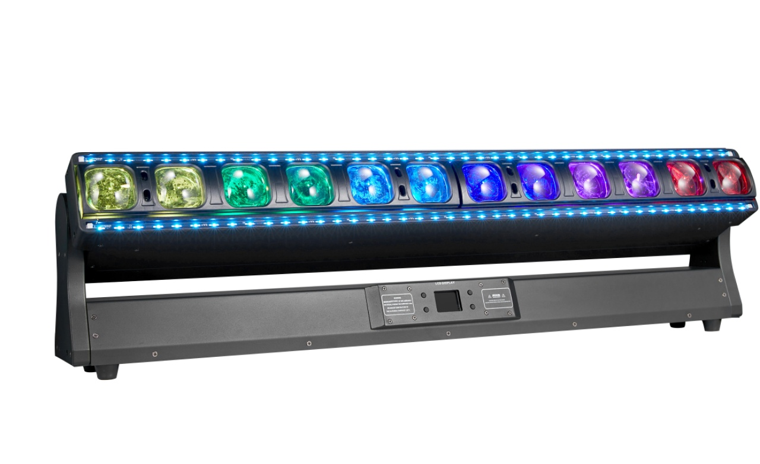
12 x 40 W RGBW main LEDs | Dual motorized zoom | Independent pixel control
Application | Input Voltage | Tilt | DMX Modes
Indoor | AC 90-240 V | 270 degrees + fine | 29 / 68 CH

IMPORTANT Read this manual completely before installing, powering, operating, or servicing the fixture. Retain it for future reference.

Contents
1 Product Information & Safety
2 Installation & DMX Connections
3 Display Menu & Operation
4 DMX512 Control & Channel Charts
5 Inspection, Maintenance & Cleaning
EDITORIAL NOTE The supplied Chinese legacy manual has been translated and professionally standardized. Confirmed source values are retained; specifications that are not present in the source have not been invented.

1 Product Information & Safety

1.1 Intended Use
The AL1240WB is a professional indoor moving LED pixel bar with twelve 40 W RGBW main emitters, dual motorized zoom control, integrated cool-white/warm-white and RGB effect strips, and two DMX personalities. It supports DMX512/RDM, automatic programs, sound-active operation, and independent RGBW control of all twelve main pixels in 68 CH mode. Typical applications include concerts, theatres, studios, clubs, bars, and entertainment venues.
Inspect the fixture and accessories immediately after unpacking. Do not operate a product that appears damaged in transit.

1.2 Package Contents
Item | Quantity
AL1240WB fixture | 1
Power cable | 1
DMX signal cable | 1
User manual | 1

1.3 Safety Instructions
- Installation, operation, and service must be performed by trained, qualified personnel.
- This is an indoor fixture. Keep it away from rain, moisture, excessive dust, and corrosive environments.
- Connect only to the rated AC supply and a properly grounded Protection Class I circuit.
- Disconnect mains power before cleaning, servicing, connecting, or when the fixture is not in use. Pull the plug, never the cable.
- After a severe temperature change, allow the fixture to reach room temperature before applying power so condensation can evaporate.
- Do not operate the fixture if the power cable, housing, lens, bracket, or safety attachment is damaged.
- Do not lift or carry the fixture by the moving light bar. Protect the mechanism from impact and excessive vibration.
- Strobe lighting may trigger photosensitive seizures. Follow venue and local warning requirements.
WARNING Damage caused by installation or operation that does not follow this manual may not be covered by warranty. Never stand below the fixture during installation, removal, or service.

1.4 Confirmed Technical Specifications
Parameter | Specification
Input voltage | AC 90-240 V
Main light source | 12 x 40 W RGBW LEDs
Effect-strip sources | Cool-white / warm-white strip and RGB strip; individual emitter quantities not specified
Tilt | 0-270 degrees with 16-bit fine control
Zoom | Dual motorized Zoom 1 / Zoom 2 control
Dimming | 0-100% continuous linear dimming
Color functions | RGBW mixing; main CTO 8000-2500 K; white-strip CTO 6500-2600 K
Control modes | DMX512/RDM, Auto 1, Auto 2, sound-active
DMX personalities | 29 CH / 68 CH
Pixel control | 12 independent RGBW main pixels in 68 CH mode
Application | Indoor use

SOURCE LIMITATION The supplied manual does not specify input frequency, rated fixture power, dimensions, weight, beam angle, LED lifetime, or effect-strip emitter quantities. These fields are intentionally omitted rather than estimated.

2 Installation & DMX Connections

2.1 Rigging
The fixture may be placed on a stable level surface or installed in an approved suspended orientation. Before mounting, verify that the supporting structure and every rigging component are suitable for the full fixture load. Complete all rigging before connecting mains power.
- Install outside normal walking and seating areas and beyond unauthorized reach.
- Use correctly rated clamps and fully tighten all mounting fasteners.
- Attach a correctly rated secondary safety cable to the designated fixture safety point.
- Never attach the safety cable to the moving light bar or use a moving section as a carrying handle.
- Inspect clamps, fasteners, the safety cable, and the supporting structure before every use.

2.2 DMX512 Data Connection
Connect the controller DMX output to the fixture DMX input with a shielded twisted-pair DMX cable. Connect the fixture output to the next fixture input. Assign a unique start address to every independently controlled fixture.
3-pin XLR | Signal
Pin 1 | Ground / shield
Pin 2 | Data -
Pin 3 | Data +

TERMINATION For long cable runs or electrically noisy environments, connect a 120 ohm, 1 W resistor between pins 2 and 3 in a male XLR plug and install it at the DMX output of the final fixture.

2.3 DMX Addressing
For consecutive fixtures using the same personality, the next start address equals the previous start address plus the selected channel count. Examples: 29 CH fixtures may start at 001, 030, 059; 68 CH fixtures may start at 001, 069, 137. Verify that the controller provides enough channels for the complete installation.

3 Display Menu & Operation

3.1 Menu Map
Menu | Option | Range / Function
DMX Address | Address | 001-512
System | Run Mode | DMX / Auto 1 / Auto 2 / Sound Active
System | Channel Mode | 29 CH / 68 CH
System | Pixel Reverse | Off / On
System | Tilt Invert | Off / On
System | Reserved Function | Off / On; no current function
System | Optical-Sensor Correction | Off / On
System | Hold on DMX Loss | Off / On
Display | Screen Saver | Off / On
Display | Display Orientation | Auto / Normal / Inverted
System | Synchronize Settings | Off / On
Display | Language | Chinese / English
System | Factory Reset | Confirm / Cancel
Manual | Manual Channel Control | 000-255 per channel
Calibration | Password | Default source password: 6688
Calibration | Initial Position | Tilt / Zoom 1 / Zoom 2; 000-255, 127 = no offset
Calibration | Maximum Output Limit | 000-255, 255 = no adjustment
Calibration | White Balance | LED 1-12 RGBW; 000-255, 255 = no adjustment
Calibration | Microphone Sensitivity | Adjust sound-active sensitivity
Reset | Effect Motors | Reset zoom/effect motors
Reset | Tilt Motor | Reset tilt only
Reset | All Motors | Reset fixture
Information | Error / DMX / Sensors | View diagnostic data
Information | Hardware / Software Version | View version information

SYNCHRONIZATION NOTE When synchronizing settings or calibration between fixtures, link the fixtures with DMX cable and disconnect the controller signal as instructed by the source manual.

3.2 Operating Notes
- Select the 29 CH or 68 CH personality before programming the controller; changing personality changes the complete DMX footprint.
- Use DMX Address to assign a valid start address from 001 to 512. RDM is available for compatible controller workflows.
- Auto 1, Auto 2, and Sound Active are stand-alone run selections; DMX is the external-control selection.
- Calibration is password protected. The source default is 6688; 127 is the neutral initial-position offset and 255 means no output reduction.

4 DMX512 Control
Select the required personality and set a valid start address. The 29 CH mode provides global main and strip control with built-in effects; the 68 CH mode provides independent RGBW control of all twelve main pixels.
OUTPUT NOTE Set the Master Dimmer above zero and place the applicable strobe channel in an Open range to obtain steady output.

4.1 29 CH Mode
Channel | DMX Value | Function
1 | 000-255 | Tilt, 0-270 degrees
2 | 000-255 | Tilt Fine (16-bit)
3 | 000-255 | Zoom 1 Position
4 | 000-255 | Zoom 2 Position
5 | 000-255 | Tilt Speed, fast to slow
6 | 000-255 | Master Dimmer, 0-100%
7 | 000-255 | Main LED Strobe; see 4.4
8 | 000-255 | White-Strip Strobe; see 4.4
9 | 000-255 | RGB-Strip Strobe; see 4.4
10 | 000-255 | Main Red, 0-100%
11 | 000-255 | Main Green, 0-100%
12 | 000-255 | Main Blue, 0-100%
13 | 000-255 | Main White, 0-100%
14 | 000-255 | Main CTO; see 4.5
15 | 000-255 | Main Color Macro; see 4.5
16 | 000-255 | Main Effect Macro; see 4.5
17 | 000-255 | Main Effect Direction / Speed; see 4.5
18 | 000-255 | White Strip: Cool White, 0-100%
19 | 000-255 | White Strip: Warm White, 0-100%
20 | 000-255 | White-Strip CTO; see 4.5
21 | 000-255 | White-Strip Effect Macro; see 4.5
22 | 000-255 | White-Strip Effect Speed / Fade; see 4.5
23 | 000-255 | RGB Strip: Red, 0-100%
24 | 000-255 | RGB Strip: Green, 0-100%
25 | 000-255 | RGB Strip: Blue, 0-100%
26 | 000-255 | RGB-Strip Color Macro; see 4.5
27 | 000-255 | RGB-Strip Effect Macro; see 4.5
28 | 000-255 | RGB-Strip Effect Speed / Fade; see 4.5
29 | 000-255 | Reset; see 4.5

4.2 68 CH Pixel Mode
Channel | DMX Value | Function
1 | 000-255 | Tilt, 0-270 degrees
2 | 000-255 | Tilt Fine (16-bit)
3 | 000-255 | Tilt Speed, fast to slow
4 | 000-255 | Zoom 1 Position
5 | 000-255 | Zoom 2 Position
6 | 000-255 | Master Dimmer, 0-100%
7 | 000-255 | Main LED Strobe; see 4.4
8 | 000-255 | White-Strip Strobe; see 4.4
9 | 000-255 | RGB-Strip Strobe; see 4.4

Main RGBW Pixel Mapping
Channels 10-57 provide individual RGBW intensity for pixels 1-12. Every channel uses 000-255 for 0-100% output.
Pixel n | Red | Green | Blue | White
n = 1-12 | 10 + 4(n-1) | 11 + 4(n-1) | 12 + 4(n-1) | 13 + 4(n-1)
Pixel 1 | 10 | 11 | 12 | 13
Pixel 12 | 54 | 55 | 56 | 57

68 CH Tail Channels
Channel | DMX Value | Function
58 | 000-255 | White Strip: Cool White, 0-100%
59 | 000-255 | White Strip: Warm White, 0-100%
60 | 000-255 | White-Strip CTO; see 4.5
61 | 000-255 | White-Strip Effect Macro; see 4.5
62 | 000-255 | White-Strip Effect Speed / Fade; see 4.5
63 | 000-255 | RGB Strip: Red, 0-100%
64 | 000-255 | RGB Strip: Green, 0-100%
65 | 000-255 | RGB Strip: Blue, 0-100%
66 | 000-255 | RGB-Strip Color Macro; see 4.5
67 | 000-255 | RGB-Strip Effect Macro; see 4.5
68 | 000-255 | RGB-Strip Effect Speed / Fade; see 4.5

MODE DIFFERENCE The 68 CH source chart ends with RGB-Strip Effect Speed at channel 68 and does not include the reset channel used by 29 CH mode.

4.3 Personality Summary
Mode | Control Resolution
29 CH | Global main RGBW with CTO/color/effect macros, dual zoom, white-strip effects, RGB-strip effects, and reset.
68 CH | Independent RGBW for twelve main pixels, dual zoom, shared white-strip and RGB-strip macro systems.

4.4 Shared Strobe Behavior
Channels 7, 8, and 9 use the same strobe ranges for the main LEDs, white strip, and RGB strip respectively.
DMX Value | Function
000-007 | Closed / Blackout
008-015 | Open
016-131 | Standard Strobe, slow to fast
132-139 | Open
140-181 | Pulse: slow open / fast close, slow to fast
182-189 | Open
190-231 | Pulse: fast open / slow close, slow to fast
232-239 | Open
240-247 | Random Strobe, slow to fast
248-255 | Open

4.5 Shared CTO, Macro & Reset Behavior
Parameter | DMX Value | Function
Main CTO | 000 | No CTO correction
Main CTO | 001-255 | Linear color temperature adjustment, 8000-2500 K
Main / RGB-Strip Color Macro | 000-007 | No color macro
Main / RGB-Strip Color Macro | 008-255 | Built-in color selection; individual colors not named in source
Main Effect Macro | 000-004 | No effect
Main Effect Macro | 005-249 | Effects 1-49 in consecutive 5-value bands
Main Effect Macro | 250-255 | Effect 50
Main Effect Direction / Speed | 000-127 | Forward, slow to fast
Main Effect Direction / Speed | 128-255 | Reverse, slow to fast
White-Strip CTO | 000-067 | No CTO
White-Strip CTO | 068-247 | Linear color temperature adjustment, 6500-2600 K
White-Strip CTO | 248-255 | No CTO
White / RGB-Strip Effect Macro | 000-007 | No effect
White / RGB-Strip Effect Macro | 008-191 | Effects 1-23 in consecutive 8-value bands
White / RGB-Strip Effect Macro | 192-255 | No effect
White / RGB-Strip Effect Speed | 000-127 | Slow to fast, without fade
White / RGB-Strip Effect Speed | 128-255 | Slow to fast, with fade
Reset (29 CH only) | 000-239 | No Function
Reset (29 CH only) | 240-255 | Reset All

MACRO NOTE The source defines macro numbers and ranges but does not identify their colors or visual patterns. No unsupported macro names are introduced here.

5 Inspection, Maintenance & Cleaning
Disconnect mains power and allow the fixture to cool before inspection or cleaning. There are no user-serviceable parts inside. Internal service must be performed by qualified personnel using genuine replacement parts.

5.1 Inspection
- Confirm that installation screws, clamps, and safety attachments are tight and free from corrosion.
- Inspect the housing, lenses, mounting points, and rigging hardware for damage or deformation.
- Check moving parts for excessive wear, imbalance, abnormal noise, or restricted tilt travel.
- Inspect the power and data cables for cuts, crushing, heat damage, fatigue, or contamination.
- Correct every safety issue before returning the fixture to service.

5.2 Cleaning
- Clean external and internal lens surfaces regularly to prevent output loss caused by dust accumulation.
- Remove dust from fans and ventilation paths regularly; cleaning frequency depends on the environment.
- Use a dry, soft, lint-free cloth. Do not use alcohol, solvents, abrasives, or a wet cloth.
- Arrange a detailed electrical inspection by a qualified technician at least every three months.
END OF MANUAL Retain this manual with the fixture. Before operation, verify the product label, local electrical code, rigging requirements, and venue safety procedures.

