AL1240WZ

12 x 40 W RGBW Zoom Wash
Moving Head
INDIVIDUAL PIXELS - 5° TO 60° ZOOM - USER MANUAL
Professional RGBW wash fixture with independent LED control
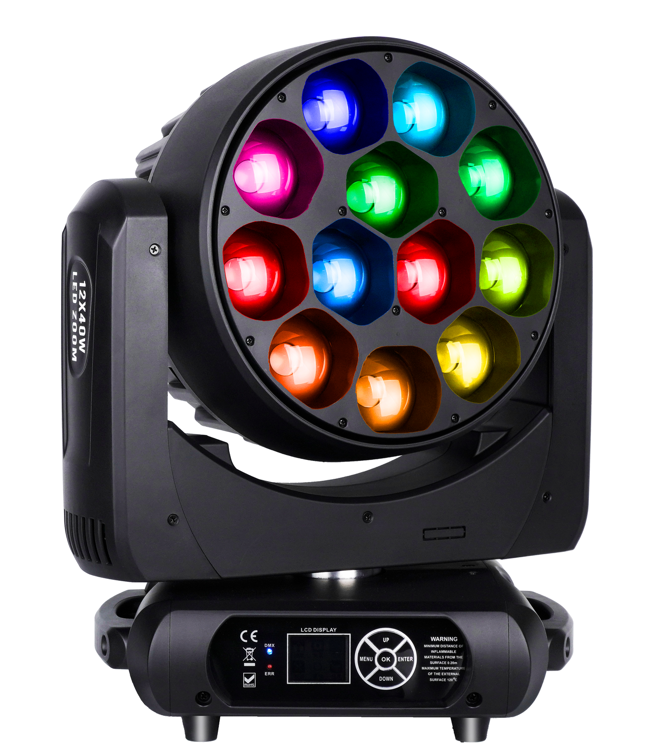
READ BEFORE USE Keep this manual with the fixture. Installation, operation and service must be performed by qualified personnel.
English Edition - Specifications subject to change without notice

Contents
Section | Topic
1 | Safety Information
2 | Product Overview
3 | Setup and Installation
4 | Control Panel and Menu
5 | Photometric Data
6 | DMX Channel Reference
7 | Routine Maintenance
8 | Troubleshooting and Service

MODEL IDENTIFICATION This manual is organized for model AL1240WZ. Confirm the model, voltage rating and firmware shown on the actual fixture before installation or programming.
The source PDF identifies the product as a 12 x 40 W RGBW zoom wash. This edition uses the complete model designation AL1240WZ supplied with the product files.

1 Safety Information
DANGER Disconnect AC power and allow the fixture to cool completely before opening the housing, cleaning, inspection or service.
- Use the fixture only with the voltage and frequency marked on its product label. Connect it to a properly grounded supply; this is a Class I appliance.
- Protect the power cable from crushing, sharp edges, heat and other damage. A damaged flexible cable must be replaced by the manufacturer, an authorized service agent or similarly qualified personnel.
- If the fixture has been exposed to a large temperature change, leave it disconnected until it reaches room temperature and all condensation has evaporated.
- Keep at least 0.5 m clearance from walls and combustible materials, and keep fans and ventilation openings unobstructed.
- Do not look directly into the light output at close range. The LEDs can produce intense visible light.
- Do not lift or carry the fixture by the moving head. Protect it from shock, moisture, excessive heat and heavy dust.
- Installation, operation and service must be performed by trained personnel. Do not modify the fixture.
- For suspended installation, use rated clamps, omega brackets and an independently rated safety cable attached only to the designated safety point.
SOURCE OPERATING LIMIT The source manual advises against operating all RGBW emitters at full output continuously for more than 10 minutes. Follow this limit unless the current product label or manufacturer documentation states otherwise.
INITIAL OPERATION A slight odor or trace of smoke may occur during the first warm-up. It should decrease gradually. Disconnect the fixture and inspect it if the condition persists or appears abnormal.

2 Product Overview
The AL1240WZ is a professional RGBW wash moving head with twelve 40 W four-in-one LEDs, motorized zoom and independent pixel control. Built-in color and dynamic effects support stage, theater, studio, club and live-event applications.

2.1 Package Contents
Item | Quantity
AL1240WZ fixture | 1
Power cable | 1
3-pin DMX signal cable | 1
Safety cable | 1
Omega bracket | 2
User manual | 1

2.2 Technical Specifications
Parameter | Specification
Input voltage | AC 90-240 V, 50/60 Hz
Maximum power | 550 W
Light source | 12 x 40 W RGBW 4-in-1 LEDs
LED lifetime | 20,000 hours average (source specification)
Dimmer | 0-100% linear dimming
Strobe | 1-25 flashes per second
Zoom | 5°-60°, motorized
Pan / tilt | 540° / 270°, both with 16-bit fine control
DMX personalities | 19CH / 67CH
Control modes | DMX512 / Master-Slave / Auto / Sound
Display | LCD; English/Chinese menu
Ingress protection | IP20 - indoor use
Dimensions | 338 x 264 x 470 mm
Net weight | 14.2 kg
Cooling | Temperature-controlled forced-air cooling

2.3 Main Functions
- Smooth RGBW color mixing with linear master dimming and color-temperature control.
- Motorized 5°-60° zoom for beam-to-wash coverage.
- Built-in color macros, dynamic effects and independently dimmable background color.
- Independent RGBW control of all twelve LEDs in the 67-channel personality.
- Three-phase pan and tilt motors for fast movement.

3 Setup and Installation

3.1 AC Power
Before connecting power, verify that the product-label rating matches the local supply. Complete all rigging and installation work before connecting the mains cable. Always disconnect by holding the plug, not by pulling the cable.

3.2 Rigging
STRUCTURAL RATING The mounting structure and attachment point must support at least 10 times the fixture weight. Keep people clear of the area below the fixture during installation and service.
- Inspect the fixture, omega brackets, clamps, fasteners, safety cable and support structure.
- Attach an appropriately rated clamp to an omega bracket using a correctly fitted M10 fastener.
- Lock the omega bracket into the fixture base and secure all fasteners.
- Attach an independently rated safety cable to the designated safety point; never attach it to a carrying handle.
- Confirm adequate clearance for the complete pan, tilt and zoom range, then recheck all hardware before applying power.

3.3 DMX Data Connection
Use shielded, two-conductor twisted-pair cable intended for RS-485/DMX512. Connect the controller to DMX IN, then link DMX OUT to the next fixture. Five-pin wiring follows the same data-pair principle when fitted.
3-pin XLR | Signal
Pin 1 | Shield / signal common
Pin 2 | Data -
Pin 3 | Data +

TERMINATION At the last fixture in a long or electrically noisy DMX chain, connect a 120 ohm resistor between pins 2 and 3 of a male XLR plug and insert it into DMX OUT.

4 Control Panel and Menu
Use MENU to move through the menu, ENTER/OK to open or save an item, and UP/DOWN to change a value. Menu wording may vary slightly with firmware revision.
Menu | Options | Operation
Address | 001-512 | Set the DMX start address.
Run Mode | DMX / Sound / Auto 1 / Auto 2 | Select console, sound-active or automatic operation.
Channel Mode | 19CH / 67CH | Select the controller personality.
Invert Pan / Tilt | On / Off | Reverse movement direction for the installation.
Hall Correction | On / Off | Enable Hall-sensor position correction.
Encoder Correction | On / Off | Enable encoder-based movement correction.
Signal Keep | On / Off | Choose whether the last DMX state is retained after signal loss.
Screen Saver | On / Off | Control automatic display blanking.
Invert Screen | Auto / On / Off | Set automatic, inverted or normal display orientation.
Update Slave | On / Off | Enable or disable synchronized slave updating.
Language | EN / 中文 | Choose the menu language.
Load Default | Confirm | Restore factory-default settings.

4.1 Manual Control and Calibration
Manual mode provides local control of each channel. Motor Calibration contains pan, tilt, focus/zoom, rotation, individual LED color-balance, power and microphone parameters, plus password management.
Calibration group | Purpose
Pan / Tilt | Movement home and position calibration
Focus / Zoom | Zoom-motor calibration
Rotation | Effect-motor calibration
Balance Red/Green/Blue/White 1...12 | Individual LED color-balance calibration
Power / MIC | Output-power and sound-sensitivity parameters
Change password | Update access password for protected calibration

CALIBRATION Do not change protected calibration or balance values unless adjustment is necessary. Record every original value before editing.

4.2 Reset and System Information
Item | Action
Reset Effect | Reset effect motors.
Reset Scan | Reset pan and tilt movement.
Reset All | Perform a complete fixture reset.
System Information | View fixture status and version information.

5 Photometric Data
The following illuminance values are reproduced from the source manual. Measurements are nominal and can vary with LED binning, optical condition, supply voltage and measurement method.

5.1 5° Beam Angle
Color | 4 m | 6 m | 8 m
Red | 7,650 lx | 3,500 lx | 2,100 lx
Green | 19,200 lx | 8,500 lx | 5,050 lx
Blue | 2,450 lx | 758 lx | 465 lx
White | 21,150 lx | 9,250 lx | 5,380 lx
RGBW | 47,250 lx | 20,500 lx | 12,350 lx

5.2 60° Beam Angle
Color | 4 m | 6 m | 8 m
Red | 351 lx | 156 lx | 95 lx
Green | 965 lx | 425 lx | 250 lx
Blue | 118 lx | 50 lx | 30 lx
White | 1,020 lx | 445 lx | 270 lx
RGBW | 2,300 lx | 1,040 lx | 630 lx

MEASUREMENT USE Use these values for comparison and planning only. Verify critical installations with a calibrated meter under the actual operating conditions.

6 DMX Channel Reference
Select 19CH or 67CH on the fixture and use the matching controller personality. Channels 1-19 are common to both modes. The 67CH personality adds four channels for each of the twelve RGBW LEDs.
Mode | Channel map
19CH | 1-19 common movement, zoom, color and effects
67CH | 1-19 common + 20-67 individual RGBW pixels

6.1 Common Channels 1-19 - 19CH and 67CH
Channel | Function | DMX Value | Description
1 | Pan | 0-255 | Pan movement
2 | Pan Fine | 0-255 | 16-bit pan fine adjustment
3 | Tilt | 0-255 | Tilt movement
4 | Tilt Fine | 0-255 | 16-bit tilt fine adjustment
5 | Pan/Tilt Speed | 0-255 | Movement speed
6 | Zoom | 0-255 | Narrow to wide
7 | Master Dimmer | 0-255 | Linear dimming, dark to full
8 | Strobe | 0-255 | 0-84 standard strobe slow to fast; 85-170 random strobe slow to fast; 171-255 thunder strobe at normal speed
9 | Red | 0-255 | Main red dimmer
10 | Green | 0-255 | Main green dimmer
11 | Blue | 0-255 | Main blue dimmer
12 | White | 0-255 | Main white dimmer
13 | CTO | 0-255 | Color-temperature adjustment
14 | Color Macro | 0-255 | 0-127 gradual color change; 128-255 jump color change
15 | Dynamic Effect | 0-255 | 0-20 no function; 21-27 effect 1; 28-227 effects 2-26 in 8-value steps; 228-255 effect 27
16 | Macro Speed | 0-255 | Fast to slow
17 | Background Dimmer | 0-255 | Background master dimmer
18 | Background Color | 0-255 | 0-30 red; 31-60 green; 61-92 blue; 93-123 white; 124-154 yellow; 155-185 purple; 186-216 light blue; 217-255 RGBW full on
19 | Reset | 0-255 | 0-249 no function; 250-255 fixture reset

6.2 67CH Pixel Extension - Channels 20-67
Channel | Function | DMX Value | Description
20 | LED 1 Red | 0-255 | LED 1 red dimmer
21 | LED 1 Green | 0-255 | LED 1 green dimmer
22 | LED 1 Blue | 0-255 | LED 1 blue dimmer
23 | LED 1 White | 0-255 | LED 1 white dimmer
24 | LED 2 Red | 0-255 | LED 2 red dimmer
25 | LED 2 Green | 0-255 | LED 2 green dimmer
26 | LED 2 Blue | 0-255 | LED 2 blue dimmer
27 | LED 2 White | 0-255 | LED 2 white dimmer
28 | LED 3 Red | 0-255 | LED 3 red dimmer
29 | LED 3 Green | 0-255 | LED 3 green dimmer
30 | LED 3 Blue | 0-255 | LED 3 blue dimmer
31 | LED 3 White | 0-255 | LED 3 white dimmer
32 | LED 4 Red | 0-255 | LED 4 red dimmer
33 | LED 4 Green | 0-255 | LED 4 green dimmer
34 | LED 4 Blue | 0-255 | LED 4 blue dimmer
35 | LED 4 White | 0-255 | LED 4 white dimmer
36 | LED 5 Red | 0-255 | LED 5 red dimmer
37 | LED 5 Green | 0-255 | LED 5 green dimmer
38 | LED 5 Blue | 0-255 | LED 5 blue dimmer
39 | LED 5 White | 0-255 | LED 5 white dimmer
40 | LED 6 Red | 0-255 | LED 6 red dimmer
41 | LED 6 Green | 0-255 | LED 6 green dimmer
42 | LED 6 Blue | 0-255 | LED 6 blue dimmer
43 | LED 6 White | 0-255 | LED 6 white dimmer
44 | LED 7 Red | 0-255 | LED 7 red dimmer
45 | LED 7 Green | 0-255 | LED 7 green dimmer
46 | LED 7 Blue | 0-255 | LED 7 blue dimmer
47 | LED 7 White | 0-255 | LED 7 white dimmer
48 | LED 8 Red | 0-255 | LED 8 red dimmer
49 | LED 8 Green | 0-255 | LED 8 green dimmer
50 | LED 8 Blue | 0-255 | LED 8 blue dimmer
51 | LED 8 White | 0-255 | LED 8 white dimmer
52 | LED 9 Red | 0-255 | LED 9 red dimmer
53 | LED 9 Green | 0-255 | LED 9 green dimmer
54 | LED 9 Blue | 0-255 | LED 9 blue dimmer
55 | LED 9 White | 0-255 | LED 9 white dimmer
56 | LED 10 Red | 0-255 | LED 10 red dimmer
57 | LED 10 Green | 0-255 | LED 10 green dimmer
58 | LED 10 Blue | 0-255 | LED 10 blue dimmer
59 | LED 10 White | 0-255 | LED 10 white dimmer
60 | LED 11 Red | 0-255 | LED 11 red dimmer
61 | LED 11 Green | 0-255 | LED 11 green dimmer
62 | LED 11 Blue | 0-255 | LED 11 blue dimmer
63 | LED 11 White | 0-255 | LED 11 white dimmer
64 | LED 12 Red | 0-255 | LED 12 red dimmer
65 | LED 12 Green | 0-255 | LED 12 green dimmer
66 | LED 12 Blue | 0-255 | LED 12 blue dimmer
67 | LED 12 White | 0-255 | LED 12 white dimmer

7 Routine Maintenance
ATTENTION Disconnect AC power and allow the fixture to cool completely before inspection or cleaning.
- Inspect all mounting screws, brackets, clamps and safety attachments for tightness, corrosion or deformation.
- Inspect the housing, lenses, suspension points and mechanically moving parts for damage, wear or imbalance.
- Inspect power cables and connectors for damage, fatigue, overheating or contamination.
- Clean internal and external optical surfaces regularly with a moist, lint-free cloth suitable for the surface. Never use alcohol or aggressive solvents.
- Remove dust from fans and ventilation openings. The source recommends weekly cleaning in demanding environments.
- Arrange a detailed electrical inspection by a qualified engineer approximately every three months, adjusted to usage and local requirements.
Maintenance frequency must reflect operating hours, dust, fog-fluid residue, airflow and the installation environment. Correct every safety issue before returning the fixture to service.

8 Troubleshooting and Service
Symptom | Check
Fixture does not power on | Verify the supply, protective earth, circuit protection, cable, connector and product-label rating.
No DMX response | Confirm DMX mode, start address, 19CH/67CH personality, controller patch, cable polarity and termination.
Unexpected channel behavior | Confirm that the controller profile matches the selected personality and installed firmware.
Movement or position error | Remove obstructions, run Reset Scan and inspect Hall/encoder correction settings.
Reduced or unstable output | Check the full-output operating limit, temperature, ventilation, fan operation, optical cleanliness and power quality.
Uneven pixel color | Check manual channel values and protected RGBW balance parameters; restore recorded values if necessary.

SERVICE There are no user-serviceable high-voltage parts inside. Refer internal repair, calibration and component replacement to qualified personnel, and use genuine replacement parts.

8.1 Warranty and Support
Damage caused by misuse, unauthorized modification, incorrect installation, impact, short circuit or operation outside the specified conditions may be excluded from warranty coverage. Include the model, serial number, firmware version and a clear fault description when requesting service.
End of manual

