AL150WX

150 W LED Wash ONE-effect
Moving Head
RGBL 4-IN-1 - DYNAMIC ZOOM - USER MANUAL
High-output wash fixture with a 24-pixel RGB auxiliary effect array
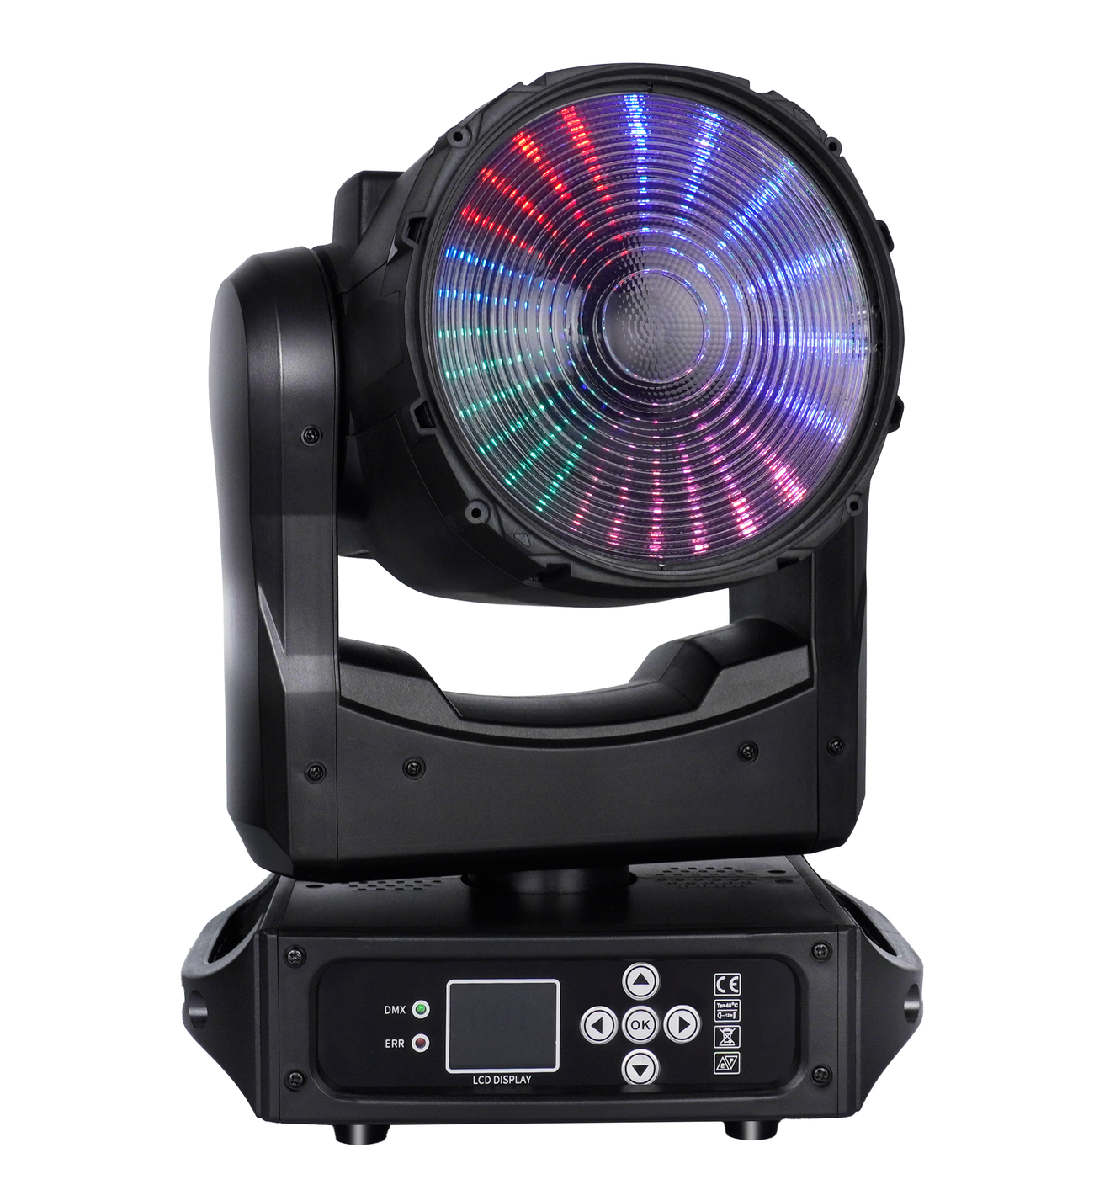
READ BEFORE USE Keep this manual with the fixture. Installation, operation and service must be performed by qualified personnel.
English Edition - Specifications subject to change without notice

Contents
Section | Topic
1 | Safety Information
2 | Product Overview and Specifications
3 | Setup and Installation
4 | Control Panel and Menu
5 | DMX512 Channel Reference
6 | Routine Maintenance
7 | Troubleshooting and Service

MODEL IDENTIFICATION This manual is for model AL150WX. Confirm the model, voltage, firmware and product-label ratings before installation or programming.

1 Safety Information
DANGER Disconnect AC power and allow the fixture to cool before opening, cleaning, inspection, fuse replacement or service.
- This professional fixture must be installed, operated and serviced by qualified personnel.
- Use only AC 100-240 V, 50/60 Hz. Connect the yellow/green conductor to protective earth.
- The maximum ambient temperature is 40°C. Stop operation if the environment exceeds this limit.
- Do not connect the fixture to an external dimmer. Do not operate it with damaged cables, housing, lens, mounting points or protective parts.
- Keep the fixture dry and indoors. Prevent liquids, flammable substances and metal objects from entering the housing.
- Keep at least 0.5 m clearance around the fixture and never block ventilation openings.
- For overhead installation, use rated clamps and an independently rated safety cable. Never lift the fixture by its moving head.
- Do not touch wiring during operation. Keep power and data cables separated and free from tangles.
- If a serious fault occurs, disconnect power immediately. Do not repeatedly cycle power or attempt unauthorized repairs.
- Use only a replacement fuse of the same type and rating. Internal service must be performed by qualified personnel.
FIRST USE A small amount of smoke or odor may occur during the first few minutes of operation and should disappear. Disconnect power if the condition persists or appears abnormal.

2 Product Overview and Specifications
The AL150WX is a compact moving-head wash built around a 150 W RGBL four-in-one source. Its red, green, blue and lemon emitters provide broad color mixing, while twenty-four individually controlled RGB auxiliary pixels create animated ONE-effect looks around the main optic. A motorized 19°-27° zoom includes continuous dynamic pulse effects.

2.1 Technical Specifications
Parameter | Specification
Input voltage | AC 100-240 V, 50/60 Hz
Main light source | 150 W RGBL 4-in-1 LED: red, green, blue and lemon
Auxiliary source | 24 high-brightness RGB LEDs; individual pixel control in 108CH mode
Total power | 200 W
Dimming | 16-bit, 0-100% smooth linear dimming
Zoom | Motorized 19°-27°; continuous forward/reverse zoom-pulse effect
Control | DMX512 / Auto / Sound-active / Master-Slave / RDM
DMX personalities | 20CH / 36CH / 108CH / 20aCH / 24CH
Pan | 540°
Tilt | 200°
Maximum ambient | 40°C
Net weight | 4.4 kg
Fixture dimensions | 252.85 x 188.1 x 358.4 mm
Environment | Indoor use; dry location

2.2 Main Functions
- RGBL main wash with 16-bit dimmer and 16-bit color control in compact modes.
- Motorized zoom with narrow-to-wide positioning and forward/reverse pulse animation.
- Twenty-four RGB auxiliary pixels with strobe, dimmer, macro and speed controls.
- Color-temperature, green/magenta tint and virtual LEE filter functions in supported modes.
- DMX512, automatic, sound-active, master-slave and RDM operation.

2.3 Supplied Items
Package contents: AL150WX fixture x 1; 3-pin DMX signal cable x 1; power cable x 1; mounting clamps x 2; user manual x 1.

3 Setup and Installation

3.1 AC Power
Before connecting power, verify that the product-label voltage and frequency match the local supply. Complete mounting and data connections before applying power. Disconnect by holding the plug, not by pulling the cable.

3.2 Rigging
STRUCTURAL RATING The support, clamps, hardware and safety attachment must meet local load and safety requirements. Keep people clear of the area below during installation and service.
- Inspect the fixture, clamps, fasteners, mounting points, safety cable and supporting structure.
- Attach two correctly rated clamps to the fixture mounting points and secure them to the structure.
- Attach an independently rated safety cable to the designated point and the supporting structure.
- Confirm at least 0.5 m ventilation clearance and unobstructed pan, tilt and zoom movement.
- Recheck every attachment before applying power. Inspect the installation regularly.

3.3 DMX512 Connection
Use shielded twisted-pair cable designed for RS-485/DMX512. Connect the controller to DMX IN, then link DMX OUT to the next fixture. Assign a unique start address to each independently controlled fixture.
3-pin XLR | Signal
Pin 1 | Shield / signal common
Pin 2 | Data -
Pin 3 | Data +

TERMINATION At the final fixture in a long or electrically noisy DMX chain, connect a 120 ohm resistor between pins 2 and 3 of a male XLR plug and insert it into DMX OUT.

4 Control Panel and Menu
Use the arrow keys to move or change a value and OK to open or save a setting. Menu labels may vary slightly with firmware revision.
Menu | Item | Option / Range | Operation
Address | DMX Address | 001-512 | Set the fixture start address.
Settings | Channel Mode | 20CH / 36CH / 108CH / 20aCH / 24CH | Select the DMX personality.
Settings | XY Correction | Off / On | Enable pan/tilt position correction.
Settings | Pan Reverse | Off / On | Reverse pan direction.
Settings | Tilt Reverse | Off / On | Reverse tilt direction.
Settings | XY Swap | Off / On | Exchange pan and tilt control.
Settings | Sound Sensitivity | 01-99 | Adjust sound-active sensitivity.
Display | Language | Chinese / English | Select the menu language.
Display | Display Reverse | Off / On | Rotate the display.
Display | Backlight | 30 s | Set the backlight timeout.
Settings | Factory Reset | Yes / No | Restore factory defaults.
Settings | Signal Hold | Yes / No; default No | Choose behavior after DMX loss.
Settings | Dimmer Curve | Linear / Square / Inverse Square / S Curve | Select the dimmer curve.
Settings | LEE Mode | Mode 1 / Mode 2 | Select virtual-filter behavior; Mode 1 default.
Manual | Manual Channels | Strobe through auxiliary blue | Test individual functions.
Reset | Reset | Yes / No | Reset the fixture.
Motor Calibration | Calibration | Service values | Qualified service only.
Standalone | Run Mode | DMX / Auto / Sound | Select the operating mode.
Information | Status | LED hours / Fixture hours / Software / RDM UID / Diagnostics | View fixture and diagnostic information.

SERVICE SETTINGS Motor calibration and diagnostic items are intended for qualified service personnel. Record original values before making any service adjustment.

5 DMX512 Channel Reference
Select the same personality on the fixture and controller. A 16-bit function uses two adjacent channels and a combined value from 00000 to 65535. Fine channels provide the lower eight bits of resolution.

5.1 Compact DMX Mode - 20CH
CH | Function | DMX Value | Description
1 | Main Strobe | 000-255 | 000-019 blackout; 020-049 open; 050-200 synchronized slow-fast; 201-210 open; 211-255 random slow-fast
2-3 | Master Dimmer | 00000-65535 | 0-100%; 16-bit
4-5 | Red | 00000-65535 | 0-100%; 16-bit
6-7 | Green | 00000-65535 | 0-100%; 16-bit
8-9 | Blue | 00000-65535 | 0-100%; 16-bit
10 | Color Temperature | 000-255 | 000-010 none; 011-255 about 2000-12850 K in 50 K steps; 128 = 6500 K
11 | Tint | 000-255 | 000 = Δuv -0.05; 001-126 to neutral; 127-128 neutral; 129-254 to +0.05; 255 = +0.05
12 | Virtual LEE Filter | 000-010 / 011-106 / 107-255 | Off / LEE virtual filters / off
13-14 | Zoom | 00000-65535 | 00000-51400 narrow-wide; 51401-57825 forward pulse fast-slow; 57826-59110 stop; 59111-65535 reverse pulse slow-fast
15-16 | Pan | 00000-65535 | 0-540°; 16-bit
17-18 | Tilt | 00000-65535 | 0-200°; 16-bit
19 | Fixture Control | 000-255 | 000-009 none; 010-014 full reset (hold 5 s); 015-016 none; 017 zoom reset (hold 5 s); 018 pan/tilt reset (hold 5 s); 019-022 none; 023 linear curve (hold 1 s); 024 square; 025 inverse square; 026 S curve; 027-255 none
20 | LED Frequency | 000-255 | Reserved / no function in source firmware

5.2 Base DMX Mode - 36CH
CH | Function | DMX Value | Description
1-20 | Compact Base | See 20CH | Same functions and values as Compact 20CH mode
21 | Reserved | 000-255 | No function
22 | Aux Macro / Source | 000-051 / 052-255 | No function / auxiliary macro effect
23 | Aux Macro Speed | 000-255 | Slow to fast
24-26 | Reserved | 000-255 | No function
27 | Aux Strobe | 000-019 / 020-049 / 050-255 | Blackout / open / strobe slow-fast
28-29 | Aux Dimmer | 00000-65535 | 0-100%; 16-bit
30 | Aux Red | 000-255 | 0-100%
31 | Aux Green | 000-255 | 0-100%
32 | Aux Blue | 000-255 | 0-100%
33 | Aux Color Temperature | 000-255 | 000-010 none; 011-255 about 2000-12850 K in 50 K steps; 128 = 6500 K
34 | Aux Tint | 000-255 | 000 = Δuv -0.05; 001-126 to neutral; 127-128 neutral; 129-254 to +0.05; 255 = +0.05
35 | Aux Virtual LEE Filter | 000-010 / 011-255 | Off / LEE virtual filters
36 | Reserved | 000-255 | No function

5.3 Base DMX Mode - 108CH
Channels 1-36 are identical to Base 36CH mode. Channels 37-108 provide direct RGB control of all twenty-four auxiliary pixels.
CH | Function | DMX Value | Description
37-39 | Aux Pixel 1 | 000-255 each | Red / Green / Blue; 0-100% per component
40-42 | Aux Pixel 2 | 000-255 each | Red / Green / Blue; 0-100% per component
43-45 | Aux Pixel 3 | 000-255 each | Red / Green / Blue; 0-100% per component
46-48 | Aux Pixel 4 | 000-255 each | Red / Green / Blue; 0-100% per component
49-51 | Aux Pixel 5 | 000-255 each | Red / Green / Blue; 0-100% per component
52-54 | Aux Pixel 6 | 000-255 each | Red / Green / Blue; 0-100% per component
55-57 | Aux Pixel 7 | 000-255 each | Red / Green / Blue; 0-100% per component
58-60 | Aux Pixel 8 | 000-255 each | Red / Green / Blue; 0-100% per component
61-63 | Aux Pixel 9 | 000-255 each | Red / Green / Blue; 0-100% per component
64-66 | Aux Pixel 10 | 000-255 each | Red / Green / Blue; 0-100% per component
67-69 | Aux Pixel 11 | 000-255 each | Red / Green / Blue; 0-100% per component
70-72 | Aux Pixel 12 | 000-255 each | Red / Green / Blue; 0-100% per component
73-75 | Aux Pixel 13 | 000-255 each | Red / Green / Blue; 0-100% per component
76-78 | Aux Pixel 14 | 000-255 each | Red / Green / Blue; 0-100% per component
79-81 | Aux Pixel 15 | 000-255 each | Red / Green / Blue; 0-100% per component
82-84 | Aux Pixel 16 | 000-255 each | Red / Green / Blue; 0-100% per component
85-87 | Aux Pixel 17 | 000-255 each | Red / Green / Blue; 0-100% per component
88-90 | Aux Pixel 18 | 000-255 each | Red / Green / Blue; 0-100% per component
91-93 | Aux Pixel 19 | 000-255 each | Red / Green / Blue; 0-100% per component
94-96 | Aux Pixel 20 | 000-255 each | Red / Green / Blue; 0-100% per component
97-99 | Aux Pixel 21 | 000-255 each | Red / Green / Blue; 0-100% per component
100-102 | Aux Pixel 22 | 000-255 each | Red / Green / Blue; 0-100% per component
103-105 | Aux Pixel 23 | 000-255 each | Red / Green / Blue; 0-100% per component
106-108 | Aux Pixel 24 | 000-255 each | Red / Green / Blue; 0-100% per component

NORMALIZED ENDPOINT The source prints 0-126 for Auxiliary Pixel 1 Blue, while every adjacent RGB pixel component uses 0-255. The table above normalizes this isolated typographical endpoint to 0-255.

5.4 Compact Direct DMX Mode - 20aCH
CH | Function | DMX Value | Description
1 | Main Strobe | 000-255 | 000-019 blackout; 020-049 open; 050-200 synchronized slow-fast; 201-210 open; 211-255 random slow-fast
2-3 | Master Dimmer | 00000-65535 | 0-100%; 16-bit
4-5 | Red | 00000-65535 | 0-100%; 16-bit
6-7 | Green | 00000-65535 | 0-100%; 16-bit
8-9 | Blue | 00000-65535 | 0-100%; 16-bit
10-11 | Lemon | 00000-65535 | 0-100%; 16-bit
12 | Main Virtual LEE Filter | 000-010 / 011-106 / 107-255 | Off / LEE virtual filters / off
13-14 | Zoom | 00000-65535 | 00000-51400 narrow-wide; 51401-57825 forward pulse fast-slow; 57826-59110 stop; 59111-65535 reverse pulse slow-fast
15-16 | Pan | 00000-65535 | 0-540°; 16-bit
17-18 | Tilt | 00000-65535 | 0-200°; 16-bit
19 | Fixture Control | 000-255 | 000-009 none; 010-014 full reset (hold 5 s); 015-016 none; 017 zoom reset (hold 5 s); 018 pan/tilt reset (hold 5 s); 019-022 none; 023 linear curve (hold 1 s); 024 square; 025 inverse square; 026 S curve; 027-255 none
20 | Reserved | 000-255 | No function

5.5 Custom DMX Mode - 24CH
CH | Function | DMX Value | Description
1-2 | Pan | 00000-65535 | 0-540°; 16-bit
3-4 | Tilt | 00000-65535 | 0-200°; 16-bit
5 | Pan / Tilt Speed | 000-255 | Fast to slow
6 | Main Strobe | 000-255 | 000-019 blackout; 020-049 open; 050-200 synchronized slow-fast; 201-210 open; 211-255 random slow-fast
7 | Master Dimmer | 000-255 | 0-100%
8 | Red | 000-255 | 0-100%
9 | Green | 000-255 | 0-100%
10 | Blue | 000-255 | 0-100%
11 | Lemon | 000-255 | 0-100%
12-13 | Zoom | 00000-65535 | 00000-51400 narrow-wide; 51401-57825 forward pulse fast-slow; 57826-59110 stop; 59111-65535 reverse pulse slow-fast
14 | Color Temperature | 000-255 | 000-010 none; 011-255 about 2000-12850 K in 50 K steps; 128 = 6500 K
15 | Tint | 000-255 | 000 = Δuv -0.05; 001-126 to neutral; 127-128 neutral; 129-254 to +0.05; 255 = +0.05
16 | Virtual LEE Filter | 000-010 / 011-106 / 107-255 | Off / LEE virtual filters / off
17 | Aux Strobe | 000-019 / 020-049 / 050-255 | Blackout / open / strobe slow-fast
18 | Aux Dimmer | 000-255 | 0-100%
19 | Aux Red | 000-255 | 0-100%
20 | Aux Green | 000-255 | 0-100%
21 | Aux Blue | 000-255 | 0-100%
22 | Aux Macro / Source | 000-051 / 052-255 | No function / auxiliary macro effect
23 | Aux Macro Speed | 000-255 | Slow to fast
24 | Fixture Control | 000-255 | 000-009 none; 010-014 full reset (hold 5 s); 015-016 none; 017 zoom reset (hold 5 s); 018 pan/tilt reset (hold 5 s); 019-022 none; 023 linear curve (hold 1 s); 024 square; 025 inverse square; 026 S curve; 027-255 none

6 Routine Maintenance
ATTENTION Disconnect AC power and allow the fixture to cool completely before inspection or cleaning.
Dust, smoke particles, haze-fluid residue and other contamination reduce light output and cooling performance. Cleaning frequency depends on the operating environment. Inspect the fixture within its first operating hours in dusty, smoky or high-airflow locations, then establish a suitable routine.
- Clean only in a dry, well-lit area.
- Wipe gently with a soft, lint-free cloth dampened with water or a mild detergent solution.
- Never use alcohol, solvents or abrasive cleaners. Optical surfaces are fragile and scratch easily.
- Remove dust from ventilation openings and inspect fans, cables, connectors, lenses and mounting hardware.
- Refer internal electrical, thermal, motor and LED service to qualified personnel.

7 Troubleshooting and Service
Symptom | Check
No light output | Verify AC supply, circuit protection, master/aux dimmer, strobe/blackout values, active mode and controller output.
No DMX response | Confirm the start address, selected personality, controller patch, cable polarity, connectors and signal-hold setting.
Unstable DMX | Use shielded twisted-pair cable, separate data from power wiring, inspect connectors and terminate the final fixture with 120 ohms.
Abnormal pan or tilt | Remove obstructions, check correction/reverse/swap settings, reset the fixture and refer persistent motor or encoder faults to service.
Zoom does not move | Check coarse/fine channel pairing and values, remove obstructions, run zoom reset and refer persistent faults to service.
Auxiliary pixels do not respond | Confirm aux dimmer and strobe values, macro/source settings, selected 36/108/24CH mode and controller patch.
Reduced or unstable output | Check ambient temperature, ventilation, fans, optical cleanliness, mains quality and dimmer settings.

SERVICE There are no user-serviceable high-voltage parts inside. Refer internal repair, LED replacement, motor service and calibration to the manufacturer, its service agent or similarly qualified personnel.

7.1 Warranty and Support
Damage caused by misuse, ignored warnings, unauthorized repair, incorrect installation or operation outside the specified conditions may be excluded from warranty coverage. Include the model, serial number, firmware, active personality and a clear fault description when requesting support.
End of manual

