Use manual

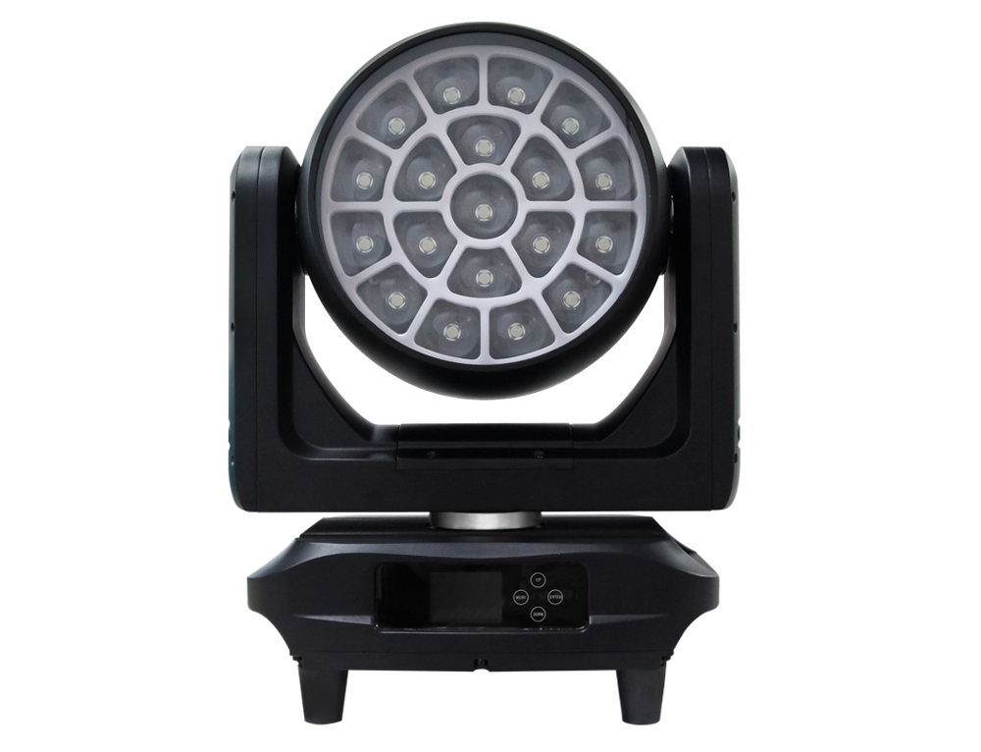

Keep this manual for future needs.

Errors and omissions for all information given in this user manual are possible.
All information is subject to change without prior notice.

CONTENTS

1. Safety Instructions 1
2. Technical Specifications 3
3. Drawing 4
4. Installation Instructions 5
5. DMX-512 Control Connection 6
6. Menu Description 7
7. Error Messages 12
8. DMX Channel Table & Description 13
9. Cleaning & Maintenance 20

Safety Instructions

Important Safety Warnings
This device has left the factory in perfect condition. In order to maintain this condition and to ensure safe operation, it is absolutely necessary for the user to follow the safety instructions and warning notes written in this user manual.

In order to install, operate and maintain the lighting fixture safely and correctly we suggest that the installation and operation be carried out by qualified technicians and these instructions be carefully followed.





Caution
High voltage. Risk of severe or fatal electric shock.
Always disconnect the main power supply before removing the cover of any fixture covers.
Never look directly into the light source.Sensitive persons may suffer an epileptic shock.
Blue light hazard: Risk Group 2
Never touch the device cover, as it may be hot during use.
This fixture is not designed for permanent use in a marine / corrosive environment. Following temporary use in such environments, clean fixture with fresh water and dry before storage.
Warning: Changes or modifications to this unit not expressly approved by the party responsible for compliance could void the user's authority to operate the equipment.

Note: This equipment has been tested and found to comply with the limits for a Class A digital device, pursuant to Part 15 of the FCC Rules. These limits are designed to provide reasonable protection against harmful interference when the equipment is operated in a commercial environment. This equipment generates, uses, and can radiate radio frequency energy and, if not installed and used in accordance with the instruction manual, may cause harmful interference to radio communications. Operation of this equipment in a residential area is likely to cause harmful interference, in which case the user will be required to correct the interference at their own expense.

■
Damage caused by the disregard of this user manual is not subject to warranty. The dealer and manufacturer will not accept liability for any resulting defects or problems.

- If the device is exposed to temperature changes due to environmental conditions, do not immediately power it on. The resulting condensation may damage the device. Keep the device powered off until it reaches room temperature.
- Ensure the sealing rubber covers of powerCON and XLR connectors are fitted properly when the device is not in used to
- avoid water ingress.
- This device falls under protection-class I. Therefore, it is essential that the device be earthed.
- If either lenses or display are damaged (damage may include cracks or gashes in the material) they must be replaced.
- Electrical connections, such as replacing the power plug, must be performed by a qualified person.
- Make sure the available voltage is not higher than that specified in this manual.
- Make sure the power cable is not crushed or damaged by sharp edges. If this happens, the cable must be replaced by an authorized dealer.
- If the external flexible power cord of this device is damaged, it shall be exclusively replaced by the manufacturer or their service agent or a similar qualified person in order to avoid injury.
- When the device is not in use or before performing maintenance, always disconnect the device from the mains. Only handle the power cord from the plug. Never pull the plug out of a socket by tugging the power cord.
- When powered on for the first time, some smoke or smell may occur. This is caused by coating on metal parts when heated and is normal. If you are concerned, please contact your distributor.
- Do not focus the beam onto flammable surfaces. The minimum distance between the device's exit lens and the illuminated surface must be greater than 0.5 meters.

Please be aware that damage caused by any modifications to the device are not subject to warranty. Keep away from children and non-professionals.

Guidelines
This device is a professional lighting effects device used in stages, discos, theaters, etc. This device is designed for indoor use.
This device is intended for operation only within the maximum AC power range specified in Section 2, Technical Specifications of this manual.
- When installing or maintaining the device, please handle the device with care and avoid shaking or applying force.
- If you use the quick lock cam when rigging the device, make sure the quick lock fasteners are located in the quick lock holes correctly and securely.
- Operate the device only after having familiarized yourself with its functions Do not permit operation by persons not qualified for operating the device. Most damage is the result of unprofessional operation..
- If you need to transport the device, please use the original packaging.
- The operating temperature range of the device is -18°C to 45°C. Do not use the device outside this temperature range.
- The light source contained in this luminaire shall only be replaced by the manufacturer or his service agent or a similar qualified person.

For safety reasons, please note that all modifications to the device are prohibited. If you operate this device in any manner different from that described in this manual, the product may be damaged and the warranty will be void. In addition, any other operation may result in a short circuit, burns, electric shock, and other dangerous situations.

Technical Specifications
Power Supply
- Input Voltage: AC 100 ~ 240V, 50/60Hz
- Power Consumption: 950 W maximum
Optics
- Beam Angle：6° to 55°
Light Source:
- LED：19x50W RGBL 4-in-1 LED
- Backlight LED：210 pcs RGB 3-in-1 LED
- LED Lifetime: < 40,000h
Movement
- Pan movement：540°（16bit）
- Tilt movement：270°（16bit）
- Advanced moving system: fast, stable and quite, auto X-Y repositioning
Color
- Advanced 4-color RGB-L mixing technology with high color rendering index and wide color temperature range of 2400-10000K. Uniform light beam with no colour shadows, and rich saturated and pastel colour-hues. Supports 4.29 billion colors (8-bit resolution)
- Virtual color wheel, including the most commonly used white color temperature presets
Effects
- 2D & 3D graphical effects capabilities
- Effects can be coupled with beam, wash or matrix applications
- Built-in pattern effects with speed and fade controls, suitable for scene applications
- Individual control of each pixels
- LiquidEffect™
Dimmer/Strobe
- Electronic dimmer from 0-100%
- Strobe effect: 1 to 20 flashes per second
Hardware Features
- Graphic LCD display with flip function
- 4 menu buttons to set functions
- P65 XLR 3-pin connectors
- IP65 etherCON RJ45 connectors
- IP65 powerCON TRUE1 connector
Control
- DMX 512 protocol.
- DMX-RDM compatible
- Stand-alone mode, local control panel
- ArtNet™& sACN protocol
- 4 DMX modes：26/50/50/127 channels

Cooling System
- Advanced liquid cooling system
- Selectable ventilation user modes
- Excess temperature protection
Housing
- Skeleton made of magnesium-aluminum alloy metal plates
- Base in die-cast composite alloy
- Heatsinks in aluminium
- Molded housing
- 2-side handles for transportation
- 4 heavy-duty feet for better stability
- IP66 protection rating
Installation
- 2 Omega ¼ turn brackets
- 4 ¼ turn mounting points
- Safety cable attachment point
Operation Parameters
- Maximum permitted: 45°C (113°F)
- Minimum permitted: -18°C (-4°F)
- Minimum usage distance: 2 m (6.56 ft)
Compliance
- CE、Certification
Size
- Product：349 x 216.5x 350mm（L x H x D）
Weight
- Net weight：17kg

Drawing

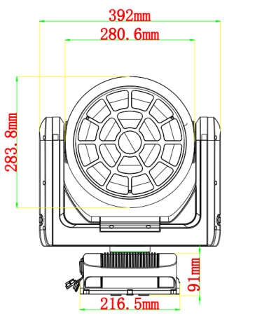
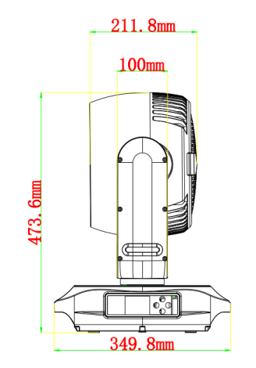
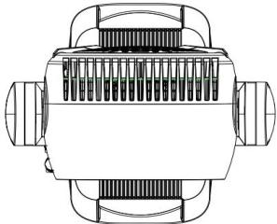
Fixture Dimension

Installation Instructions

Rigging The Device

Please consider the respective national norms during the installation. The installation must only be carried out by a qualified person.
- The installation of the support structure has to be built and constructed in a way that it can hold 10 times the weight for 1 hour without any harming deformation.
- The installation must always be secured with a secondary safety attachment, e.g. an appropriate safety rope.Never stand directly below the device when mounting, removing or servicing the fixture.
- The operator has to make sure the safety relating and machine technical installations are approved by an expert before taking the device into operation for the first time.
- These installations have to be approved by a skilled person once a year.
- Overhead mounting requires extensive experience, including amongst others calculating working load limits, installation material being used, and periodic safety inspection of all installation material and the device. If you lack these qualifications,do not attempt the installation yourself. Improper installation can result in bodily injury.

Rigging Using The OMEGA Brackets

This step is very important to ensure safe rigging of the fixture.
- Fix the clamp to the bracket by tightening the M12 nut and bolt to the bracket through the Ф13 hole in the middle of the bracket.
- Insert the quick-lock fasteners of the first Omega holder into the respective holes on the bottom of the device. Tighten the quick lock fasteners fully clockwise.
- Install the second Omega holder.
- Pull the safety cable through the holes on the bottom of the base and over the trussing system or another suitable rigging point.Insert the end into the carabiner and tighten the safety screw.

Rigging Installation
Caution
Overhead rigging requires extensive experience, including (but not limited to) calculating working load limits, specifying installation/ rigging materials, and periodic safety inspection of all installation material as well as the device.If you lack these qualifications, do not attempt the rigging of this device yourself. Improper installation/ rigging can result in serious bodily injury.
- Be sure this fixture is kept at least 0.1 m away from any flammable materials (decoration etc.).
- Always use and install a safety cable as a safety measure to prevent accidental damage and/or injury in the event the clamp fails.
- Rig the projector high enough to provide clearance for people who may walk beneath the beam path or establishing a restricted access area that extends beyond the beam hazard distance.
WARNING! Please DO NOT let other external intense lights to shine through the fixture front lens, it may cause significant internal damages!
- When install fixture outdoor at day time (with power off), please make sure that the fixture front lens is NOT facing the sun.
- When use fixture outdoor at day time (with power on), please avoid fixture front lens facing the sun.
- When fixture is on standby outdoor at day time (with power ON and no DMX signal), please make sure the “sun protection” mode is ON (default).

DMX-512 Control Connection
Connect the provided male side of the XLR cable to the female XLR output of your controller and the female side of the XLR cable to the male XLR input of the device. You can connect multiple devices together in a serial fashion. The cable needed should be two core, screened cable with XLR input and output connectors. Please refer to the diagram below.
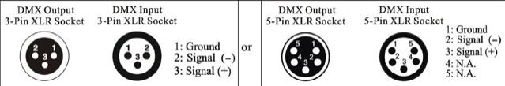

DMX-512 Connection With DMX Terminal
For installations where the DMX cable has to run over a long distance or is in an electrically noisy environment, such as in a discotheque, it is recommended to use a DMX terminator. This helps in preventing corruption of the digital control signal caused by electrical noise. The DMX terminator is an XLR plug with a 120 Ω resistor connected between pins 2 and 3, which is then plugged into the output (female) XLR socket of the last fixture in the chain. Please see illustrations below.。
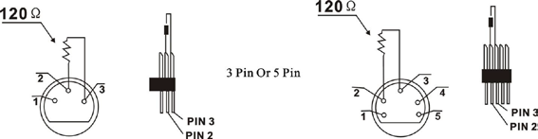

Device DMX Start Address Selection
All fixtures should be given a DMX starting address when using a DMX signal, so that the correct fixture responds to the correct control signals.This digital starting address is the channel number from which the fixture starts to “listen” to the digital control information sent out from the DMX controller. The allocation of this starting address is achieved by setting the correct address number on the display located on the base of the device.

You can set the same starting address for all fixtures or a group of fixtures, or set different addresses for each fixture individually.

If you set the same address on all devices, all the devices will start to "listen to" the same control signal from the same channel number .In other words, changing the settings of one channel will affect all the fixtures simultaneously.

If you set a different address, each unit will start to "listen to" the channel number you have set, based on the quantity of control channels of the unit. That means changing the settings of one channel will affect only the selected device.

In the case of the LED moving head, in 50 channel mode, you should set the starting address of the first unit to 1, the second unit to 51(50 + 1), the third unit to 101 (50 + 51), and so on.

Menu Description
Press the MENU button to enter the menu. Confirm the selected function with the ENTER button. Use the UP/DOWN buttons to select a mode. Once a mode is selected, press the ENTER button to confirm. To return to the main menu, press the MENU button. If no button is pressed for 15 seconds, the menu function will automatically exit.

System Setting |  |  |  | Description
DMX Address | 1-512 |  |  | DMX address setting
LED DMX Address | 1-512 |  |  | LED DMX address
DMX Channel Mode | 26CH |  |  | DMX channel mode selection
DMX Channel Mode | 50CH1 |  |  | DMX channel mode selection
DMX Channel Mode | 50CH2 |  |  | DMX channel mode selection
DMX Channel Mode | 127CH |  |  | DMX channel mode selection
Operation Mode | DMX |  |  | DMX512
Operation Mode | Artnet |  |  | Artnet
Operation Mode | Artnet+DMX |  |  | Artnet+DMX512
Operation Mode | Effect 1 |  |  | Auto mode1
Operation Mode | Effect 2 |  |  | Auto mode2
Network Setting | DHCH | Off/On |  | DHCP
Network Setting | IP Setting | IP address | xxx.xxx.xxx.xxx | IP address setting
Network Setting | IP Setting | Sub-Net Mask | 255.000.000.000 | Sub-Net mask
Network Setting | IP Setting | Sub-Net Mask | 255.255.000.000 | Sub-Net mask
Network Setting | IP Setting | Sub-Net Mask | 255.255.255.000 | Sub-Net mask
Network Setting | Artnet Setting | Network | 0-127
Network Setting | Artnet Setting | Sub-Net | 0-15
Network Setting | Artnet Setting | Data packet | 0-15
Network Setting | sACN Setting | Data Packet | 1-32000
Network Setting | sACN Setting | Priority | 0-200
Network Setting | Protocol selection | Auto
Network Setting | Protocol selection | Artnet
Network Setting | Protocol selection | sACN
Pan Reverse | No/Yes |  |  | Pan Reverse movement
Tilt Reverse | No/Yes |  |  | Tilt Reverse movement
Encoder Calibration | No/Yes |  |  | Calibrate and adjust the effects to standard/right position
Fan Mode | Auto |  |  | Fan mode selection
Fan Mode | Low speed |  |  | Fan mode selection
Fan Mode | High speed |  |  | Fan mode selection
Signal Hold | Clear/Hold |  |  | Signal hold selection
Dimmer | Slow/Fast |  |  | Dimmer speed selection
Dimmer Curve | Linear |  |  | Dimmer Curve
Dimmer Curve | Square Law |  |  | Dimmer Curve
Dimmer Curve | Inverse Square Law |  |  | Dimmer Curve
Dimmer Curve | S-Curve |  |  | Dimmer Curve
Dimmer Frequency | 1.2kHz |  |  | Dimmer frequency
Dimmer Frequency | 2.4kHz |  |  | Dimmer frequency
Dimmer Frequency | 16kHz |  |  | Dimmer frequency
Dimmer Frequency | 20kHz |  |  | Dimmer frequency
Flip Display | Off/On |  |  | Screen flip
Backlight Control | Off/On |  |  | Backlight control
Auto Key Lock | Off/On |  |  | Auto key lock
Language Selection | Chinese/English |  |  | Language selection
Temperature | ℃/℉ |  |  | Temp Unit (℃/℉)
Reset Default | Off/On |  |  | Restore factory set
Manual Control
Control | 26CH |  |  | Channel-Based display
Control | 50CH1 |  |  | Channel-Based display
Control | 50CH2 |  |  | Channel-Based display
Control | 127CH |  |  | Channel-Based display
White Balance Setting
Red | 0-255
Green | 0-255
Blue | 0-255
White | 0-255
System Test
Effect 1 |  |  |  | Test effect
Effect 2 |  |  |  | Test effect
System Reset
All | No/Yes |  |  | Reset All
Pan&Tilt | No/Yes |  |  | Reset Pan&Tilt
Zoom | No/Yes |  |  | Reset Zoom
System Information
Software Ver | Display： | Vxx.xx |  | Display version
Software Ver | Motor： | Vxx.xx |  | Motor version
Software Ver | LED board： | Vxx.xx |  | LED board version
RDM Info | 0Xxxxxxxxxxxxx |  |  | RDM UID
Humidity | x% |  |  | Humidity
Temp. Info | LED | xx℃/xx℉ |  | LED board temperature
Temp. Info | Base | xx℃/xx℉ |  | Base temperature
Channel Test |  |  |  | DMX channel value testing
Error Info |  |  |  | Error Info display

System Setting

DMX Address
Select the DMX address, press the ENTER button to confirm, use the UP/DOWN button to adjust the address 1-512, press the ENTER button to setup.

LED DMX Address
Select the LED DMX address, press the ENTER button to confirm, use the UP/DOWN button to adjust the address 1-512, press the ENTER button to setup.

DMX Channel Mode
With this function, you can select the DMX channel mode you need.

Operation Mode
With this function, you can select the operation mode you need.
(When you need to use auxiliary lighting effects to connect to sACN or Artnet, please adjust the mode to Artnet+DMX mode).

Network Setting

DHCP
This function allows you to enable or disable the DHCP.

IP Setting
This function allows you to set the IP and the IP Sub-Net Mask of the Unit.

Artnet Setting
This function allows you to set the Network, Sub-Net and data packets that receive Artnet.

sACN Setting
This function allows you to set the data packets and priority for receiving sACN.

Protocol Selection
This function allows you to select the protocol from Auto, Artnet, sACN.

Pan Reverse
With this function you can reverse the Pan-movement.

Tilt Reverse
With this function, you can reverse the Tilt-movement.

Encoder Calibration
Using this function, the encoder will automatically correct.

Fan Mode
Auto：The fan rises and falls according to the ambient temperature and the temperature of the LED module itself.
Low speed：When the light dimming is on, the fan speed is stable at low speed.
High speed：Fans maintain full speed when light dimming is on.

Signal Hold
When this function is turned on, you can use the manual control settings in the menu when there is no external signal. When there is an external signal, the state when the signal is interrupted will be maintained after the signal is interrupted.

Dimmer
With this function, you can select slow/fast dimmer speed.

Dimmer Curve
With this function, you can select dimmer curve.
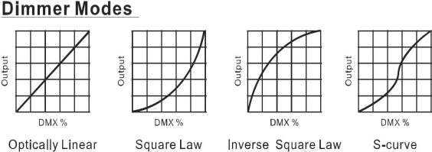

Dimmer Frequency
With this function, you can select the frequency of dimmer output.

Flip Display
With this function, you can flip the display 180°.

Backlight Control
With this function, the display backlight turns off one minute after exiting the menu mode.

Auto Key Lock
Using this function, the display will lock itself when it turns back on—just press a specific key to unlock it.

Language Selection
With this function, the display control will show Chinese/English.

Temperature
With this function, you can select ℃/℉.

Reset Default
With this function,you can select restore factory set for ON or OFF. The default is OFF.

Manual Control
With this function,you can select a defined channel value to set.

White Balance Setting

Red
With this function,you can set the output value of red, the default value is 255.

Green
With this function,you can set the output value of green, the default value is 255.

Blue
With this function,you can set the output value of blue, the default value is 255.

White
With this function,you can set the output value of white, the default value is 255.

System Test
You can perform an auto-run test using Effect 1 and Effect 2,and check the integrity of the
device functions through the auto-run process.

System Reset

Reset All
With this function,the light will run the built-in program to reset all.

Reset Pan&Tilt
With this function,the light will run the built-in program to reset Pan&Tilt.

Reset Zoom
With this function,the light will run the built-in program to reset zoom.

System Information

Software Ver
With this function,you can display the software versions of all components connected to the display panel in the device.
Display：Display version
Motor：Motor version
LED board：：LED board version

RDM Info
With this function,you can display the RDM UID in the device.

Humidity
With this function,you can display the humidity value in the device.

Temp. Info
With this function,you can display all the different temperature values available in the device.
LED：LED board temperature.
Base：Base temperature

Channel Test
With this function, you can display the DMX 512 values of the number of channels starting from the current address. The display will automatically show the channels where the values change.

Error Info
With this function, you can read the current error logs.

Error Messages
When the device is started, the light will perform a reset. If there is an issue with one or more functions, the message "System Fault" will be displayed on the home screen of the display.
Motor Board Communication Error
When the light's wires are loose or broken, this error will occur.
LED Board Communication Error
When the light's wires are loose or broken, this error will occur.
X-axis Hall Error
When the X-axis Hall module of the light is damaged,or the module's connecting socket is loose or has a broken wire.or has a broken wire,this error will occur.
Y-axis Hall Error
When the Y-axis Hall module of the light is damaged,or the module's connecting socket is loose or has a broken wire,this error will occur.
X Optocoupler Error
When the X-axis optocoupler module of the light is damaged,or the module's connecting socket is loose or has a broken wire.or has a broken wire,this error will occur.
X Optocoupler Error
When the Y-axis optocoupler module of the light is damaged,or the module's connecting socket is loose or has a broken wire.or has a broken wire,this error will occur.
Temperature Error
When the temperature module is damaged,this error will occur.

DMX Channel Table & Description

Channel Mode |  |  |  | Function Description |  | DMX Value
26CH | 50CH-1 | 50CH-2 | 127CH
1 | 1 | 1 | 1 | Pan 8bit |  | 0-255
2 | 2 | 2 | 2 | Pan Fine 16bit: Fine control pan-movement |  | 0-255
3 | 3 | 3 | 3 | Tilt 8bit |  | 0-255
4 | 4 | 4 | 4 | Tilt Fine 16bit: Fine control tilt-movement |  | 0-255
5 | 5 | 5 | 5 | Pan&Tilt Speed: Maximum to minimum |  | 0-255
6 | 6 | 6 | 6 | Reserved |  | 0-255
7 | 7 | 7 | 7 | Reserved |  | 0-255
8 | 8 | 8 | 8 | Red - Main light / Control backlight when effect is on |  | 0-255
 |  |  |  | red (0-black, 255-100% red) |  | 0-255
9 | 9 | 9 | 9 | Red Fine- Main light / Control backlight when effect is on |  | 0-255
 |  |  |  | red fine-tuning(0-black, 255-100% red) |  | 0-255
10 | 10 | 10 | 10 | Green - Main light / Control backlight when effect is on |  | 0-255
 |  |  |  | green (0-black, 255-100% green) |  | 0-255
11 | 11 | 11 | 11 | Green Fine - Main light / Control backlight when effect is on |  | 0-255
 |  |  |  | green fine-tuning(0-black, 255-100% green) |  | 0-255
12 | 12 | 12 | 12 | Blue - Main light / Control backlight when effect is on |  | 0-255
 |  |  |  | blue(0-black, 255-100% blue) |  | 0-255
13 | 13 | 13 | 13 | Blue Fine - Main light / Control backlight when effect is on |  | 0-255
 |  |  |  | blue fine-tuning(0-black, 255-100% blue) |  | 0-255
14 | 14 | 14 | 14 | White - Main light / Control backlight when effect is on |  | 0-255
 |  |  |  | white (0-black, 255-100% white) |  | 0-255
15 | 15 | 15 | 15 | White Fine - Main light / Control backlight when effect is on |  | 0-255
 |  |  |  | white fine-tuning(0-black, 255-100% white) |  | 0-255
16 | 16 | 16 | 16 | Strobe | OFF | 0-31
 |  |  |  |  | ON | 32-63
 |  |  |  |  | Slow to fast | 64-95
 |  |  |  |  | ON | 96-127
 |  |  |  |  | Strobe Pulse (slow to fast) | 128-159
 |  |  |  |  | ON | 160-191
 |  |  |  |  | Random Strobe (slow to fast) | 192-223
 |  |  |  |  | ON | 224-255
17 | 17 | 17 | 17 | Dimmer: intensity 0 to 100% |  | 0-255
18 | 18 | 18 | 18 | Dimmer Fine |  | 0-255
19 | 19 | 19 | 19 | Color Temperature | No function | 0-21
 |  |  |  |  | 10000K | 22-31
 |  |  |  |  | 9600K | 32-41
 |  |  |  |  | 9200K | 42-51
 |  |  |  |  | 8800K | 52-61
 |  |  |  |  | 8400K | 62-71
 |  |  |  |  | 8000K | 72-81
 |  |  |  |  | 7600K | 82-91
 |  |  |  |  | 7200K | 92-101
 |  |  |  |  | 6800K | 102-111
 |  |  |  |  | 6400K | 112-121
 |  |  |  |  | 6000K | 122-131
 |  |  |  |  | 5600K | 132-141
 |  |  |  |  | 5200K | 142-151
 |  |  |  |  | 4800K | 152-161
 |  |  |  |  | 4600K | 162-171
 |  |  |  |  | 4200K | 172-181
 |  |  |  |  | 3800K | 182-191
 |  |  |  |  | 3600K | 192-201
 |  |  |  |  | 3400K | 202-211
 |  |  |  |  | 3200K | 212-221
 |  |  |  |  | 3000K | 222-231
 |  |  |  |  | 2800K | 232-241
 |  |  |  |  | 2600K | 242-251
 |  |  |  |  | 2500K | 252-255
20 | 20 | 20 | 20 | Color Preset: base on the color preset table |  | 0-206
21 | 21 | 21 | 21 | Color Presets & Main Light Color RGBW Crossfade | Output main light color RGBW | 0
 |  |  |  |  | Crossfade output | 1-254
 |  |  |  |  | Output preset color | 255
22 | 22 | 22 | 22 | Crossfade Between Color Presets | No Fade | 0-4
 |  |  |  |  | Crossfade between two preset colors | 4-255
 |  |  |  |  | 100ms to 5s | 4-255
23 | 23 | 23 | 23 | Zoom : narrow to wide |  | 0-255
24 | 24 | 24 | 24 | Zoom Fine |  | 0-255
25 | 25 | 25 | 25 | Reserved |  | 0-255
26 | 26 | 26 | 26 | Macro Function | No function | 0-4
 |  |  |  |  | Display-Off | 5-9
 |  |  |  |  | Display-On | 10-14
 |  |  |  |  | Display invert-Off | 15-19
 |  |  |  |  | Display invert-On | 20-24
 |  |  |  |  | Fan control - Auto | 25-26
 |  |  |  |  | Fan control-High speed | 27-28
 |  |  |  |  | Fan Control-Low speed | 29-30
 |  |  |  |  | Reserved | 31-32
 |  |  |  |  | Reserved | 33-34
 |  |  |  |  | Reserved | 35-36
 |  |  |  |  | Reserved | 37-44
 |  |  |  |  | Dimmer curve -Square | 45-49
 |  |  |  |  | Dimmer curve - Linear | 50-54
 |  |  |  |  | 1.2K | 55-57
 |  |  |  |  | 2.4K | 58-60
 |  |  |  |  | 16K | 61-63
 |  |  |  |  | 25K | 64-69
 |  |  |  |  | Dimmer Curve - Inverse Square Law | 70-71
 |  |  |  |  | Dimmer curve-S curve | 72-73
 |  |  |  |  | Dimming mode - slow | 74-75
 |  |  |  |  | Dimming Mode - Fast | 76-77
 |  |  |  |  | Reserved | 78-79
 |  |  |  |  | Reset All | 80-84
 |  |  |  |  | Reset Pan&Tilt | 85-87
 |  |  |  |  | Reset Zoom | 88-90
 |  |  |  |  | Reserved | 91-255
 | 27 | 27 | 27 | Main Light Pattern Effect | Effect OFF | 0-9
 |  |  |  |  | Effect 1 | 10-15
 |  |  |  |  | Effect 2 | 16-23
 |  |  |  |  | Effect 3 | 24-31
 |  |  |  |  | Effect 4 | 32-39
 |  |  |  |  | Effect 5 | 40-47
 |  |  |  |  | Effect 6 | 48-55
 |  |  |  |  | Effect 7 | 56-63
 |  |  |  |  | Effect 8 | 64-71
 |  |  |  |  | Effect 9 | 72-79
 |  |  |  |  | Effect 10 | 80-87
 |  |  |  |  | Effect 11 | 88-95
 |  |  |  |  | Effect 12 | 96-103
 |  |  |  |  | Effect 13 | 104-111
 |  |  |  |  | Effect 14 | 112-119
 |  |  |  |  | Effect 15 | 120-127
 |  |  |  |  | Effect 16 | 128-135
 |  |  |  |  | Effect 17 | 136-143
 |  |  |  |  | Effect 18 | 144-151
 |  |  |  |  | Effect 19 | 152-159
 |  |  |  |  | Effect 20 | 160-167
 |  |  |  |  | Effect 21 | 168-175
 |  |  |  |  | Effect 22 | 176-183
 |  |  |  |  | Effect 23 | 184-191
 |  |  |  |  | Effect 24 | 192-199
 |  |  |  |  | Effect 25 | 200-207
 |  |  |  |  | Effect 26 | 208-215
 |  |  |  |  | Effect 27 | 216-223
 |  |  |  |  | Effect 28 | 224-231
 |  |  |  |  | Effect 29 | 232-239
 |  |  |  |  | Effect 30 | 240-247
 |  |  |  |  | Effect 31 | 248-255
 | 28 | 28 | 28 | Main Light Pattern Effect Speed | Reverse fast to slow | 0-125
 |  |  |  |  | Stop (speed=0) | 126-130
 |  |  |  |  | Forward slow to fast | 131-255
 | 29 | 29 | 29 | Main Light Pattern Fade: Fade Chase |  | 0-255
 | 30 | 30 | 30 | Main Light Pattern Size: Chase category |  | 0-255
 | 31 | 31 | 31 | Pattern Effect - Red: red (0-black , 255-100% red) |  | 0-255
 | 32 | 32 | 32 | Pattern Effect - Green: green (0-black , 255-100% green) |  | 0-255
 | 33 | 33 | 33 | Pattern Effect - Blue: blue (0-black , 255-100% blue) |  | 0-255
 | 34 | 34 | 34 | Pattern Effect - White: white (0-black , 255-100% white) |  | 0-255
 | 35 | 35 | 35 | Pattern Effect Dimmer: Intensity (0-black, 255-100%) |  | 0-255
 | 36 | 36 | 36 | Pattern Effect Backlight Dimmer: Inactive when effect is Off |  | 0-255
 |  |  |  | Intensity(0-100%, 255-0%) |  | 0-255
 | 37 | 37 | 37 | Pattern Effect Strobe | OFF | 0-31
 |  |  |  |  | ON | 32-63
 |  |  |  |  | Strobe slow to fast | 64-95
 |  |  |  |  | ON | 96-127
 |  |  |  |  | Strobe Pulse (slow to fast) | 128-159
 |  |  |  |  | ON | 160-191
 |  |  |  |  | Random Strobe (slow to fast) | 192-223
 |  |  |  |  | ON | 224-255
 | 38 |  | 38 | Auxiliary Light Effect Control | Auxiliary light channel control effect | 0-9
 |  |  |  |  | Follow main light | 10-19
 |  |  |  |  | ARTNET or SACN control | 20-29
 |  |  |  |  | Reserved | 30-255
 | 39 |  | 39 | Auxiliary Light Effect Dimming: Intensity 0 to 100% |  | 0-255
 | 40 |  | 40 | Auxiliary Light Effect Dimming Fine-Tuning |  | 0-255
 | 41 |  | 41 | Auxiliary Light Effect -Red: red |  | 0-255
 |  |  |  | (0-black, 255-100% red) |  | 0-255
 | 42 |  | 42 | Auxiliary Light Effect -Green: green |  | 0-255
 |  |  |  | (0-black, 255-100% green) |  | 0-255
 | 43 |  | 43 | Auxiliary Light Effect -Blue: blue |  | 0-255
 |  |  |  | (0-black, 255-100% blue) |  | 0-255
 | 44 |  | 44 | Auxiliary Light Effect | Effect Off | 0-9
 |  |  |  |  | Effect1 | 10
 |  |  |  |  | Effect 2 | 11-12
 |  |  |  |  | ... | ...
 |  |  |  |  | Effect 122 | 253-254
 |  |  |  |  | Effect 123 | 255
 | 45 |  | 45 | Reserved | Reserved | 0-255
 | 46 |  | 46 | Auxiliary Light Effect Speed | Reverse fast to slow | 0-125
 |  |  |  |  | Stop (speed=0) | 126-130
 |  |  |  |  | Forward slow to fast | 131-255
 | 47 |  | 47 | Auxiliary Light Effect Backlight Dimmer: |  | 0-255
 |  |  |  | Intensity 0 to 100% |  | 0-255
 | 48 |  | 48 | Auxiliary Light Effect Backlight -Red: red |  | 0-255
 |  |  |  | (0-black, 255-100% red) |  | 0-255
 | 49 |  | 49 | Auxiliary Light Effect Backlight -Green: green |  | 0-255
 |  |  |  | (0-black, 255-100% green) |  | 0-255
 | 50 |  | 50 | Auxiliary Light Effect Backlight -Blue: blue |  | 0-255
 |  |  |  | (0-black, 255-100% blue) |  | 0-255
 |  | 38 | 51 | Point-controlled Crossfade: main light RGBW and point-controlled crossfade output |  | 0-255
 |  |  |  | Point Control |  | 0-255
 |  | 39 |  | Ring 1 Red: Red (0-black , 255-100% red) |  | 0-255
 |  | 40 |  | Ring 1 Green: Green (0-black , 255-100% green) |  | 0-255
 |  | 41 |  | Ring 1 Blue: Blue (0-black , 255-100% blue) |  | 0-255
 |  | 42 |  | Ring 1 White: White (0-black , 255-100% white) |  | 0-255
 |  | 43 |  | Ring 2 Red: Red (0-black , 255-100% red) |  | 0-255
 |  | 44 |  | Ring 2 Green: Green (0-black , 255-100% green) |  | 0-255
 |  | 45 |  | Ring 2 Blue: Blue (0-black , 255-100% blue) |  | 0-255
 |  | 46 |  | Ring 2 White: White (0-black , 255-100% white) |  | 0-255
 |  | 47 |  | Ring 3 Red: Red (0-black , 255-100% red) |  | 0-255
 |  | 48 |  | Ring 3 Green: Green (0-black , 255-100% green) |  | 0-255
 |  | 49 |  | Ring 3 Blue: Blue (0-black , 255-100% blue) |  | 0-255
 |  | 50 |  | Ring 2 White: White (0-black , 255-100% white) |  | 0-255
 |  |  | 52 | Red 1: Red (0-black , 255-100% red) |  | 0-255
 |  |  | 53 | Green 1: Green (0-black , 255-100% green) |  | 0-255
 |  |  | 54 | Blue 1: Blue (0-black , 255-100% blue) |  | 0-255
 |  |  | 55 | White 1: White (0-black , 255-100% white) |  | 0-255
 |  |  | 56 | Red 2: Red (0-black , 255-100% red) |  | 0-255
 |  |  | 57 | Green 2: Green (0-black , 255-100% green) |  | 0-255
 |  |  | 58 | Blue 2: Blue (0-black , 255-100% blue) |  | 0-255
 |  |  | 59 | White 2: White (0-black , 255-100% white) |  | 0-255
 |  |  | ... | ... |  | ...
 |  |  | 124 | Red 19: Red (0-black , 255-100% red)) |  | 0-255
 |  |  | 125 | Green 19: Green (0-black , 255-100% green) |  | 0-255
 |  |  | 126 | Blue 19: Blue (0-black , 255-100% blue) |  | 0-255
 |  |  | 127 | White 19: White (0-black , 255-100% white) |  | 0-255

Cleaning & Maintenance


Caution
Disconnect from mains before starting maintenance operation

Do not place the fixture with its lens/glass facing any people while doing the IP test!
Never use alcohol or solvent to clean the lenses.

The operator must follow strictly the vacuum and pressure setting values as below, or use the corresponding preset fixture menu to run the IP test. any overpressure operation may cause accidental damage or injury.

、

 | Minimum value |  | Maximum value |  | Steady time  (Hold time)
 | Kpa | Psi | Kpa | Psi | S
Vacuum | -13 | -5.08 | -17 | 5.80 | 10
Pressure | 13 | 3.63 | 17 | 4.35 | 10

To ensure that the cover is pressed evenly all around the seal, we recommend following the attached tightening order.
•Check the seal, it must be clean and undamaged, properly seated to avoid any damage
when tightening.
•First lightly tighten the screws into position and then tighten with a torque screwdriver.
Torque value : 14Kgf.cm for metal cover or 7Kgf.cm for plastic cover.

The following points have to be considered during inspection：
- All screws for installing the devices or parts of the device have to be tightly connected and must not be corroded.
- All external magnesium alloy covers screws must be used together with the plastic sleeves. If the plastic sleeve is damaged,it must be replaced with a new one.
- Do not do maintenance or assembly for the external magnesium alloy cover in outdoor environment with rain or water on it. Before removing the screws, ensure that the surroundings of the screws are dry. After maintenance, before assembling the covers, ensure that the screws and screw holds are dry.
- There must not be any deformations to the housing, lenses, rigging and installation points (ceiling, suspension, trussing).
- Motorized parts must not show any signs of wear and must move smoothly without issue.
- The power supply cables must not show any damage, material fatigue or sediment.

Checking and replacing the desiccant：
The desiccant is used as humidity indication in the fixture. Dry desiccant is in blue colour, if it is saturated with water, its colour changes to light red. If the desiccant colour changes to pink, the desiccant is losing efficacy, it must be replaced.

Unplug the fixture from mains before checking or replacing desiccant! Do not check or replace desiccant in a damp environment!

Further instructions depending on the installation location and usage have to be adhered to by a qualified installer and any safety concerns have to be removed.

In order to ensure the fixture remains in good condition and does not fail prematurely thus extend the lifespan of the fixture, we suggest regular maintenance and cleaning, especially when the fixture being installed outdoors with the following conditions which may easily cause peeling or corrosion of the surface coating of the fixture:
- Use in coastal or high salinity areas.
- Use in areas contaminated with coal ash, oil fume, mineral dust, iron powder, or chemical substances, etc..
- Fixture surface accumulated with burnt tar, resin, insect dead body or its droppings, bird droppings, etc..
- Liquids such as benzene, gasoline or diesel was splashed onto the surface of the fixture.
- Residues of movable props such as colored powder, foam and sequins on the surface.
Notes for cleaning：
- Before cleaning the fixture, please ensure that the power connection of the fixture is disconnected and completely cooled. Use sponge or a soft cloths for surface cleaning.
- Do not use acidic, alkaline or abrasive detergents for cleaning.
- Do not use a hard brush to brush the covers directly.
- When using a high-pressure water gun for cleaning, please pay attention to the water pressure and spraying distance.
- Do not allow the high-pressure water gun to continuously wash the same area for long time, especially on the XLR connectors, display button, arm rotation areas, etc..
- If the fixture being used outdoors, cleaning and maintenance should be carried out at least every 3 months depending on the using conditions. This period may need to be shortened and need to be cleaned timely if the fixture being used in coastal or high salinity areas.
- During winter use, if using snow remover in the scene, please protect the fixture to avoid fixture surface being contaminated.
- During cleaning and maintenance, if slight coating damage is found on the die-casting cover’s surface, then after cleaning is completed and surface is dried, repair for the surface treatment can be carried out by using hand spray paint. If the cover’s damaged surface is severe, please contact your local dealer for replacement parts in a timely manner.
- If obvious corrosion marks such as blistering or damage are found on the coating of the fixture’s die-casting cover, please contact your local dealer for replacement parts for repair in a timely manner.
We recommend frequent cleaning of the device. Please use a moist, lint- free cloth. Never use alcohol or solvents.
Please refer to the instructions under “Installation instructions”.
Should you need any spare parts, please order genuine parts from your local dealer.

