PROFESSIONAL LED EFFECT FIXTURE

AL5120T
5 x 120 W LED TORNADO MOVING HEAD
USER MANUAL
English Edition | Professionally edited from the supplied manual
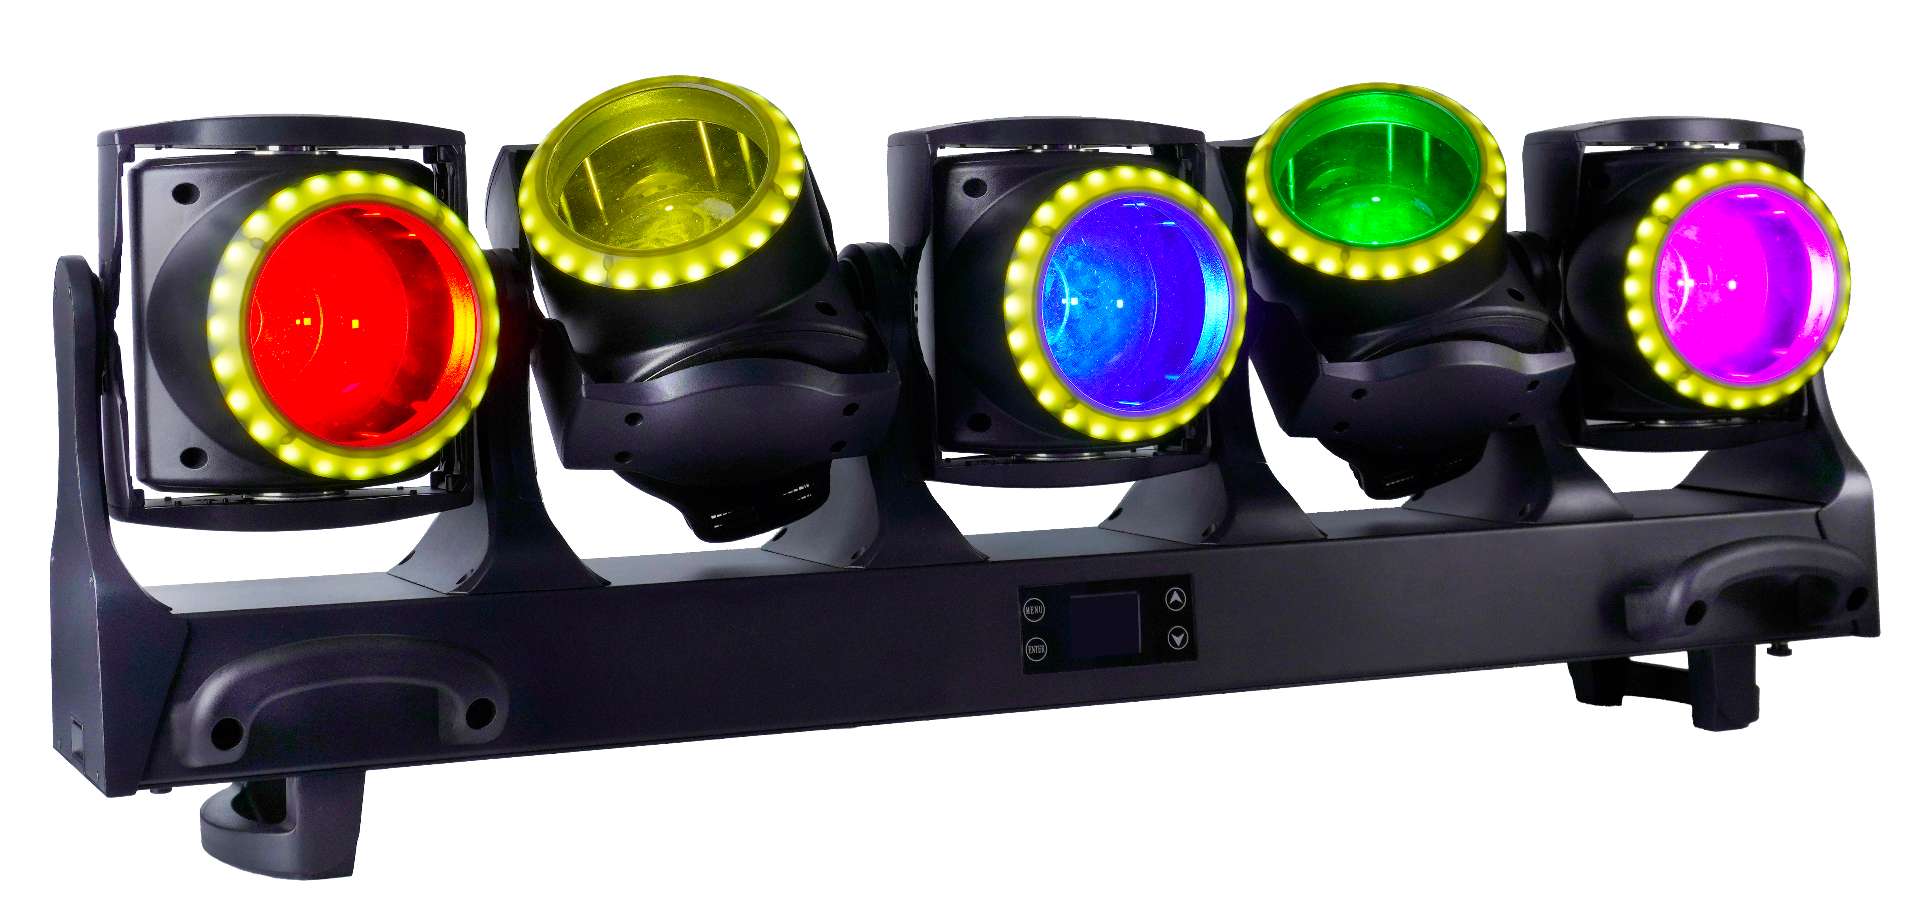
5 independent RGBL heads | 5 RGB pixel halos | Motorized zoom
Ingress Protection | Rated Power | Input | DMX Modes
IP20 | 750 W | AC 110-240 V, 50/60 Hz | 21 / 41 / 71 / 75 / 85 / 170 CH

IMPORTANT Read this manual completely before installing, powering, operating, or servicing the fixture. Retain it for future reference.

Contents
1 Product Information & Safety
2 Installation & DMX Connections
3 Display Menu & Operation
4 DMX512 Control & Channel Charts
5 Inspection, Maintenance & Cleaning
EDITORIAL NOTE Terminology, grammar, and control labels have been standardized for professional lighting use. Source specifications and DMX values are retained; ambiguous repeated channel structures are clarified with deterministic mapping tables.

1 Product Information & Safety

1.1 Intended Use
The AL5120T is a professional indoor moving-head effect fixture with five independently moving RGBL heads, motorized zoom, and five RGB pixel halos. It supports DMX512, automatic programs, sound-active operation, and standalone use. Typical applications include live productions, theatres, studios, clubs, and entertainment venues.
Inspect the fixture and accessories immediately after unpacking. Do not operate a product that appears damaged in transit.

1.2 Package Contents
Item | Quantity
AL5120T fixture | 1
Power cable | 1
3-pin DMX cable | 1
Safety cable | 1
Omega bracket | 2
User manual | 1

1.3 Safety Instructions
- This fixture is intended for professional use and must be installed and serviced by qualified personnel.
- Connect only to the rated AC supply and a properly grounded Protection Class I circuit.
- Disconnect the fixture from mains power before cleaning, servicing, or when it is not in use. Pull the plug, never the cable.
- Do not power the fixture immediately after a severe temperature change. Allow it to reach room temperature so condensation can evaporate.
- Do not use the fixture if the power cable, housing, lens, bracket, or safety attachment is damaged.
- Keep ventilation openings unobstructed and maintain at least 0.5 m clearance from walls or other objects that could restrict airflow.
- Keep illuminated objects at least 0.2 m from the light output, as indicated by the product marking.
- Do not project the beam onto combustible materials and do not install the fixture directly on combustible surfaces.
- Strobe lighting may trigger photosensitive seizures. Follow venue and local warning requirements.
- The external flexible cable may be replaced only by the manufacturer, its service agent, or similarly qualified personnel.
WARNING Never stand directly below the fixture during installation, removal, or service. Always use a correctly rated secondary safety attachment.

1.4 Technical Specifications
Parameter | Specification
Input voltage | AC 110-240 V, 50/60 Hz
Rated power | 750 W
Main light sources | 5 x 120 W RGBL LEDs (red, green, blue, lime)
Halo light sources | 120 x 0.5 W RGB LEDs; 24 LEDs per head
Rated LED life | Average 20,000 hours
Beam angle | 3 degrees-30 degrees
Beam divergence | 4 degrees-35 degrees
Pan / Tilt | Pan: 60 degrees; Tilt: 220 degrees
Dimming | 0-100% continuous; four selectable dimmer curves
Strobe | 1-25 Hz
Color functions | RGBL mixing, continuous CTO adjustment, LEE-referenced color macros
Control modes | DMX512, auto programs, sound-active, standalone
DMX personalities | 21 CH / 41 CH / 71 CH / 75 CH / 85 CH / 170 CH
Ingress protection | IP20 - indoor use only
Fixture dimensions | 1002 x 196 x 334 mm
Net / gross weight | 27.6 kg / 30.6 kg
Carton, 1 fixture | 1170 x 395 x 305 mm
Flight case, 2 fixtures | 1070 x 670 x 580 mm; case N.W. 38 kg; loaded G.W. 96 kg

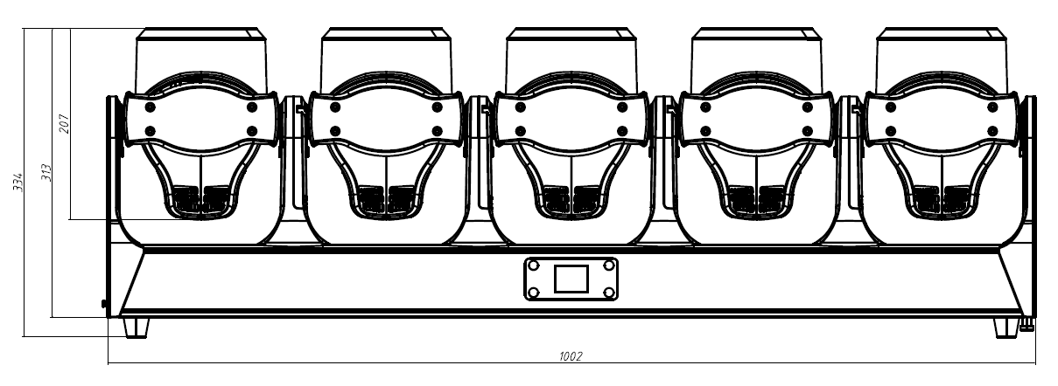
Front dimensions. All values are in millimetres.
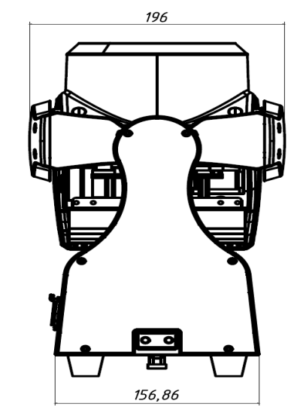
Side dimensions. All values are in millimetres.

2 Installation & DMX Connections

2.1 Rigging
Before mounting, verify that the supporting structure and all rigging hardware can support at least ten times the fixture weight. Fit appropriately rated clamps to the two omega brackets using M10 fasteners. Complete all rigging before connecting mains power.
- Use both omega brackets for overhead suspension.
- Attach at least one correctly rated safety cable to a designated safety attachment point on the fixture.
- Never attach the safety cable to a carrying handle.
- Inspect clamps, fasteners, brackets, safety cables, and the supporting structure before every use.
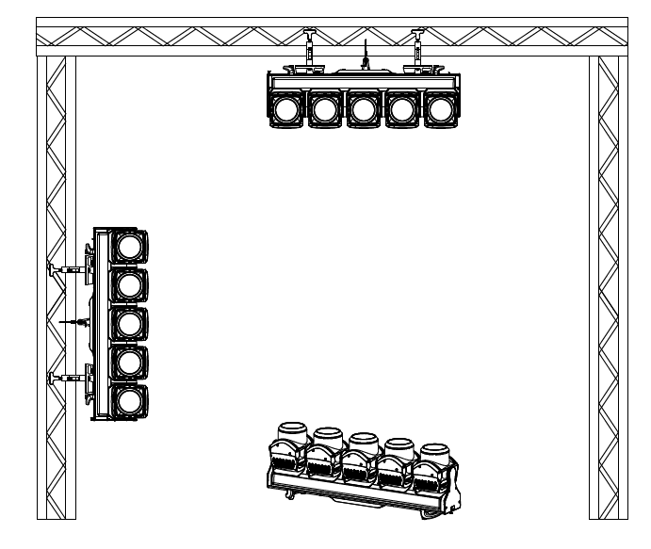
Permitted mounting orientations shown in the supplied manual.

2.2 DMX512 Data Connection
Connect the controller DMX output to the fixture DMX input with a shielded twisted-pair DMX cable. Connect each fixture output to the next fixture input. The source fixture provides 3-pin XLR connectors; 5-pin wiring follows the same DMX512 data principles when fitted.
3-pin XLR | Signal
Pin 1 | Ground / shield
Pin 2 | Data -
Pin 3 | Data +

TERMINATION For long cable runs or electrically noisy environments, install a 120 ohm resistor between pins 2 and 3 in a male XLR plug, then connect it to the DMX output of the final fixture.

3 Display Menu & Operation

3.1 Menu Map
Menu | Option | Range / Function
DMX Address | Address | 001-512
Fixture | Channel Mode | 21 / 41 / 71 / 75 / 85 / 170 CH
Fixture | Run Mode | DMX / Auto
Fixture | Pan Invert | Off / On
Fixture | Tilt Invert | Off / On
Fixture | Fan Mode | Normal / Low / Quiet / High
Fixture | Dimmer Curve | Linear / Square / Inverse Square / S-Curve
Fixture | Dimmer Response | Smooth / Fast
Fixture | On DMX Loss | Blackout / Hold last value
Fixture | LED PWM Frequency | 900, 1000, 1100, 1200, 1300, 1400, 1500, 2500, 4000, 5000, 6000, 10000, 15000, 20000, or 25000 Hz
Manual | Manual Control | Control each channel manually
Information | Time | Current operating time / total operating time / power-cycle count
Information | Sensors | Pan, tilt, zoom, temperature, and additional sensor status
Information | Temperature | Head 1-5 temperature
Information | Software Version | Display, motor, and dimmer firmware versions
Factory | Password | 000-255
Factory | Calibration | Pan, tilt, and zoom calibration for heads 1-5; 000-255
Reset | Reset All | Off / Run
Reset | Factory Reset | Off / Run
Display | Language | Chinese / English
Display | Display Reverse | Yes / No
Display | Display Mode | Screen off after 60 s / always on

FIRMWARE NOTE The feature list also identifies sound-active control. Menu labels and available items may vary with installed firmware.

4 DMX512 Control
Set a unique DMX start address for each independently controlled fixture. The highest usable start address depends on the selected personality. Function-channel commands must remain in the specified value range for at least 3 seconds before activation.
OUTPUT NOTE To produce light output, set the relevant dimmer above zero and set the applicable strobe channel to an open value.

4.1 21 CH Mode
Channel | DMX Value | Function
1 | 000-255 | Pan, 0-60 degrees
2 | 000-255 | Pan Fine
3 | 000-255 | Tilt, 0-220 degrees
4 | 000-255 | Tilt Fine
5 | 000-255 | Zoom, wide to narrow
6 | 000-255 | Main LED Red, 0-100%
7 | 000-255 | Main LED Green, 0-100%
8 | 000-255 | Main LED Blue, 0-100%
9 | 000-255 | Main LED Lime, 0-100%
10 | 000-255 | Main LED CTO; see 4.7
11 | 000-255 | Main LED color macro; see 4.7
12 | 000-255 | Halo Red, 0-100%
13 | 000-255 | Halo Green, 0-100%
14 | 000-255 | Halo Blue, 0-100%
15 | 000-255 | Halo macro and speed; see 4.7
16 | 000-255 | Master Dimmer, 0-100%
17 | 000-255 | Master Dimmer Fine
18 | 000-255 | Main LED Strobe; see 4.7
19 | 000-255 | Halo Strobe; see 4.7
20 | 000-255 | Pan/Tilt Speed, fast to slow
21 | 000-255 | Function; see 4.8

4.2 41 CH Mode
Channel | DMX Value | Function
1 | 000-255 | Head 1 Pan, 0-60 degrees
2 | 000-255 | Head 1 Pan Fine
3 | 000-255 | Head 1 Tilt, 0-220 degrees
4 | 000-255 | Head 1 Tilt Fine
5 | 000-255 | Head 1 Zoom, wide to narrow
6 | 000-255 | Head 2 Pan, 0-60 degrees
7 | 000-255 | Head 2 Pan Fine
8 | 000-255 | Head 2 Tilt, 0-220 degrees
9 | 000-255 | Head 2 Tilt Fine
10 | 000-255 | Head 2 Zoom, wide to narrow
11 | 000-255 | Head 3 Pan, 0-60 degrees
12 | 000-255 | Head 3 Pan Fine
13 | 000-255 | Head 3 Tilt, 0-220 degrees
14 | 000-255 | Head 3 Tilt Fine
15 | 000-255 | Head 3 Zoom, wide to narrow
16 | 000-255 | Head 4 Pan, 0-60 degrees
17 | 000-255 | Head 4 Pan Fine
18 | 000-255 | Head 4 Tilt, 0-220 degrees
19 | 000-255 | Head 4 Tilt Fine
20 | 000-255 | Head 4 Zoom, wide to narrow
21 | 000-255 | Head 5 Pan, 0-60 degrees
22 | 000-255 | Head 5 Pan Fine
23 | 000-255 | Head 5 Tilt, 0-220 degrees
24 | 000-255 | Head 5 Tilt Fine
25 | 000-255 | Head 5 Zoom, wide to narrow
26 | 000-255 | Main LEDs Red, 0-100%
27 | 000-255 | Main LEDs Green, 0-100%
28 | 000-255 | Main LEDs Blue, 0-100%
29 | 000-255 | Main LEDs Lime, 0-100%
30 | 000-255 | Main LED CTO; see 4.7
31 | 000-255 | Main LED color macro; see 4.7
32 | 000-255 | Halo Red, 0-100%
33 | 000-255 | Halo Green, 0-100%
34 | 000-255 | Halo Blue, 0-100%
35 | 000-255 | Halo macro and speed; see 4.7
36 | 000-255 | Master Dimmer, 0-100%
37 | 000-255 | Master Dimmer Fine
38 | 000-255 | Main LED Strobe; see 4.7
39 | 000-255 | Halo Strobe; see 4.7
40 | 000-255 | Pan/Tilt Speed, fast to slow
41 | 000-255 | Function; see 4.8

4.3 71 / 75 / 85 CH Modes
These three personalities use the same five-head sequence. The 75 CH mode adds an individual strobe channel to each head. The 85 CH mode adds individual dimmer, fine dimmer, and strobe channels to each head.
Head | 71 CH Range | 75 CH Range | 85 CH Range
Head 1 | 1-13 | 1-14 | 1-16
Head 2 | 14-26 | 15-28 | 17-32
Head 3 | 27-39 | 29-42 | 33-48
Head 4 | 40-52 | 43-56 | 49-64
Head 5 | 53-65 | 57-70 | 65-80

Relative Position | 71 CH Function | 75 CH Function | 85 CH Function
1 | Pan | Pan | Pan
2 | Pan Fine | Pan Fine | Pan Fine
3 | Tilt | Tilt | Tilt
4 | Tilt Fine | Tilt Fine | Tilt Fine
5 | Red | Red | Red
6 | Green | Green | Green
7 | Blue | Blue | Blue
8 | Lime | Lime | Lime
9 | Zoom | Head Strobe | Head Dimmer
10 | Halo Red | Zoom | Head Dimmer Fine
11 | Halo Green | Halo Red | Head Strobe
12 | Halo Blue | Halo Green | Zoom
13 | Halo Macro / Speed | Halo Blue | Halo Red
14 | - | Halo Macro / Speed | Halo Green
15 | - | - | Halo Blue
16 | - | - | Halo Macro / Speed

MAPPING RULE Within each head range, add the relative position minus 1 to that head range's first channel. All listed parameter channels use 000-255.
Function | 71 CH | 75 CH | 85 CH
Master Dimmer | 66 | 71 | 81
Master Dimmer Fine | 67 | 72 | 82
Global Main LED Strobe | 68 | - | -
Global Halo Strobe | 69 | 73 | 83
Pan/Tilt Speed | 70 | 74 | 84
Function | 71 | 75 | 85

4.4 170 CH Pixel Mode
The 170 CH personality provides individual RGB control of eight halo blocks on every head. Each head occupies 33 consecutive channels.
Head | Channel Range | Start Channel
Head 1 | 1-33 | 1
Head 2 | 34-66 | 34
Head 3 | 67-99 | 67
Head 4 | 100-132 | 100
Head 5 | 133-165 | 133

Relative Position | Function
1 | Pan
2 | Pan Fine
3 | Tilt
4 | Tilt Fine
5 | Main LED Red
6 | Main LED Green
7 | Main LED Blue
8 | Main LED Lime
9 | Zoom
10-12 | Halo Block 1 Red / Green / Blue
13-15 | Halo Block 2 Red / Green / Blue
16-18 | Halo Block 3 Red / Green / Blue
19-21 | Halo Block 4 Red / Green / Blue
22-24 | Halo Block 5 Red / Green / Blue
25-27 | Halo Block 6 Red / Green / Blue
28-30 | Halo Block 7 Red / Green / Blue
31-33 | Halo Block 8 Red / Green / Blue

MAPPING RULE Add the relative position minus 1 to the head start channel. Every parameter uses 000-255. For halo block n, RGB begins at head start + 9 + 3 x (n - 1).
Channel | DMX Value | Function
166 | 000-255 | Master Dimmer, 0-100%
167 | 000-255 | Master Dimmer Fine
168 | 000-255 | Main LED Strobe; see 4.7
169 | 000-255 | Pan/Tilt Speed, fast to slow
170 | 000-255 | Function; see 4.8

4.5 Personality Summary
Mode | Control Resolution
21 CH | All heads move together; shared RGBL, CTO, color macro, halo, dimmer, and strobe control.
41 CH | Independent pan, tilt, and zoom per head; shared RGBL, CTO, color macro, halo, dimmer, and strobe control.
71 CH | Independent pan, tilt, RGBL, zoom, and halo per head; global dimmer and main/halo strobe.
75 CH | As 71 CH, plus individual main-LED strobe per head; global dimmer and halo strobe.
85 CH | As 75 CH, plus individual dimmer and fine dimmer per head; global dimmer and halo strobe.
170 CH | Independent movement, RGBL, zoom, and eight RGB halo blocks per head; global dimmer and main-LED strobe.

4.6 Common Parameter Behavior
Parameter | DMX Behavior
Pan | 000-255: 0-60 degrees
Tilt | 000-255: 0-220 degrees
Zoom | 000-255: wide to narrow
Red / Green / Blue / Lime | 000-255: 0-100%
Dimmer | 000-255: 0-100%
Pan/Tilt Speed | 000-255: fast to slow

4.7 Shared Macro & Strobe Tables

CTO Channel
DMX Value | Nominal Color Temperature
000 | No CTO correction
001-004 | 8000 K
005-009 | 7900 K
010-013 | 7800 K
014-018 | 7700 K
019-022 | 7600 K
023-027 | 7500 K
028-225 | Continues in approximately 100 K steps
226-229 | 3000 K
230-234 | 2900 K
235-238 | 2800 K
239-243 | 2700 K
244-247 | 2600 K
248-255 | 2500 K

SOURCE NOTE The supplied chart omits the middle CTO bands with an ellipsis. Endpoint bands and the stated continuous 8000 K-to-2500 K progression are retained here without inventing omitted boundaries.

Color Macro Channel
DMX Value | Color Macro
000-009 | No color macro
010-016 | LEE 790 - Moroccan Pink
017-023 | LEE 157 - Pink
024-030 | LEE 332 - Special Rose Pink
031-037 | LEE 328 - Follies Pink
038-044 | LEE 345 - Fuchsia Pink
045-051 | LEE 194 - Surprise Pink
052-058 | LEE 181 - Congo Blue
059-065 | LEE 071 - Tokyo Blue
066-072 | LEE 120 - Deep Blue
073-079 | LEE 079 - Just Blue
080-086 | LEE 132 - Medium Blue
087-093 | LEE 200 - Double CT Blue
094-100 | LEE 161 - Slate Blue
101-107 | LEE 201 - Full CT Blue
108-114 | LEE 202 - Half CT Blue
115-121 | LEE 117 - Steel Blue
122-128 | LEE 353 - Lighter Blue
129-135 | LEE 118 - Light Blue
136-142 | LEE 116 - Medium Blue-Green
143-149 | LEE 124 - Dark Green
150-156 | LEE 139 - Primary Green
157-163 | LEE 089 - Moss Green
164-170 | LEE 122 - Fern Green
171-177 | LEE 738 - JAS Green
178-184 | LEE 088 - Lime Green
185-191 | LEE 100 - Spring Yellow
192-198 | LEE 104 - Deep Amber
199-205 | LEE 179 - Chrome Orange
206-212 | LEE 105 - Orange
213-219 | LEE 021 - Gold Amber
220-226 | LEE 778 - Millennium Gold
227-233 | LEE 135 - Deep Golden Amber
234-255 | LEE 164 - Flame Red

Halo Macro & Speed Channel
DMX Value | Function
000-015 | No halo macro
016-031 | Macro 1, fast to slow within the band
032-047 | Macro 2, fast to slow within the band
048-223 | Macros 3-13 in consecutive 16-value bands, fast to slow
224-239 | Macro 14, fast to slow within the band
240-255 | Macro 15, fast to slow within the band

Main LED / Halo Strobe Channel
DMX Value | Strobe Function
000-007 | Closed (blackout)
008-015 | Open
016-131 | Standard strobe, slow to fast
132-139 | Open
140-181 | Pulse: fast open / slow close, slow to fast
182-189 | Open
190-231 | Pulse: slow open / fast close, slow to fast
232-239 | Open
240-247 | Random strobe, slow to fast
248-255 | Open

4.8 Function Channel
ACTIVATION Hold the selected function value for at least 3 seconds. Reset commands may interrupt output and movement.
DMX Value | Function
000-029 | No function
030-039 | Dimmer curve: Linear
040-049 | Dimmer curve: Square
050-059 | Dimmer curve: Inverse Square
060-069 | Dimmer curve: S-Curve
070-079 | Fan mode: Standard
080-089 | Fan mode: Quiet
090-099 | No function
100-109 | Enable LED PWM-frequency setting
110-119 | Disable LED PWM-frequency setting
120-122 | No function
123 | LED PWM frequency: 900 Hz
124 | LED PWM frequency: 1000 Hz
125 | LED PWM frequency: 1100 Hz
126 | LED PWM frequency: 1200 Hz
127 | LED PWM frequency: 1300 Hz
128 | LED PWM frequency: 1400 Hz
129 | LED PWM frequency: 1500 Hz
130 | LED PWM frequency: 2500 Hz
131 | LED PWM frequency: 4000 Hz
132 | LED PWM frequency: 5000 Hz
133 | LED PWM frequency: 6000 Hz
134 | LED PWM frequency: 10 kHz
135 | LED PWM frequency: 15 kHz
136 | LED PWM frequency: 20 kHz
137 | LED PWM frequency: 25 kHz
138-139 | No function
140-149 | Pan/Tilt reset
150-159 | Effect reset
160-169 | Head inversion: On
170-179 | Head inversion: Off
180-189 | CCI calibration: On
190-199 | CCI calibration: Off
200-209 | Reset all
210-219 | Dimmer response: Fast
220-229 | Dimmer response: Smooth
230 | Dimming start mode: High
231 | Dimming start mode: Low
232-255 | No function

5 Inspection, Maintenance & Cleaning
Disconnect mains power and allow the fixture to cool before inspection or cleaning. There are no user-serviceable parts inside the fixture. Internal service must be performed by qualified personnel using genuine replacement parts.

5.1 Inspection
- Confirm that all installation screws and fasteners are tight and free from corrosion.
- Check the housing, lenses, brackets, suspension points, and rigging hardware for deformation, cracks, or other damage.
- Check all moving parts for excessive wear, imbalance, abnormal noise, or restricted travel.
- Inspect power and data cables for cuts, crushing, heat damage, material fatigue, or contamination.
- Correct every safety issue before returning the fixture to service.

5.2 Cleaning
- Clean the inner and outer lens surfaces regularly to prevent output loss caused by dust accumulation.
- Remove dust from fans and ventilation openings regularly. Cleaning frequency depends on the operating environment.
- Use a soft, lint-free cloth lightly moistened with water. Do not use alcohol, solvents, abrasives, or pressurized liquid.
- Arrange a detailed electrical inspection by a qualified technician at least every three months, or more often in demanding environments.
END OF MANUAL Retain this manual with the fixture. Before operation, verify the product label, local electrical code, rigging requirements, and venue safety procedures.

