AL640WX

6 x 40 W Laser Bee Eye
Moving Head
RGBW PIXELS · RGB HALO · ANIMATION LASER — USER MANUAL
Beam, wash, vortex, kaleidoscope and animated-laser fixture
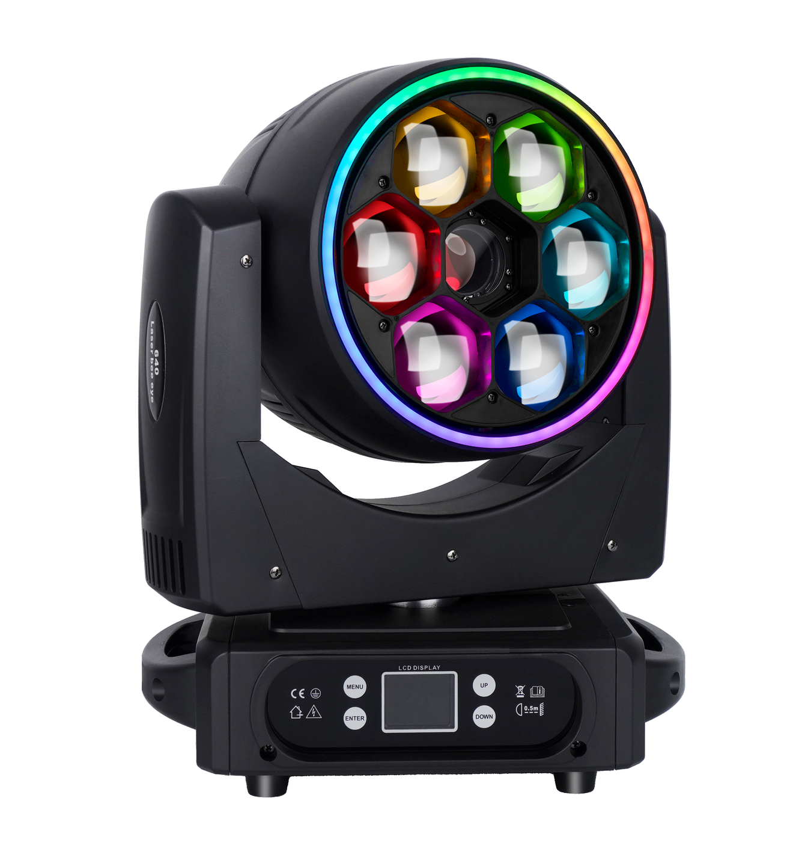
LASER SAFETY Avoid direct eye or skin exposure to laser radiation. Never aim the beam at people, aircraft or vehicles. Operate only where applicable laser-safety requirements are satisfied.
English Edition — Specifications subject to change without notice

Contents
Section | Topic
1 | Safety Information
2 | Product Overview
3 | Setup and Installation
4 | Control Panel and Menu
5 | DMX Channel Reference
6 | Routine Maintenance
7 | Troubleshooting and Service

MODEL IDENTIFICATION This manual is organized for model AL640WX. Confirm the model, voltage rating, laser labeling and firmware shown on the actual fixture before installation or programming.
The source document identifies the product as a six-emitter 40 W laser bee-eye fixture. This edition uses the complete model designation AL640WX supplied with the product files.

1 Safety Information
DANGER Disconnect AC power and allow the fixture to cool completely before opening the housing, cleaning, inspection or service.
- Use the fixture only with the voltage and frequency marked on its product label. Connect it to a properly grounded supply.
- This is a Class I electrical appliance. Never defeat the protective earth connection.
- Protect power and data cables from crushing, sharp edges, heat and other damage. Replace damaged cables before use.
- Use the fixture indoors in a dry, well-ventilated location. Keep ventilation openings clear and protect the product from moisture and condensation.
- Do not look into the LED or laser output. Do not use optical instruments to view the beam and do not expose people to the output path.
- Never aim laser output at people, animals, aircraft, vehicles, reflective surfaces or public areas where exposure cannot be controlled.
- Installation, operation, calibration and service must be performed by trained personnel. Do not modify the fixture.
- For suspended installation, use suitable clamps and an independently rated safety cable. Keep the area below the fixture clear during installation and service.
CONDENSATION If the fixture is moved between environments with a large temperature difference, leave it disconnected until it reaches room temperature and all condensation has evaporated.
LASER COMPLIANCE The source manual does not state a laser class, wavelength, divergence or accessible-emission limit. Check the product label and comply with all local licensing, operator, audience-scanning and controlled-area requirements before use.

2 Product Overview
The AL640WX combines six 40 W RGBW bee-eye emitters, an RGB animation laser and an RGB halo ring in a moving-head platform. Its continuously rotating front lens supports beam, wash, vortex and kaleidoscope looks, while independent pixel and laser controls provide layered effects.

2.1 Package Contents
Item | Quantity
AL640WX fixture | 1
User manual | 1
Power cable | 1
DMX signal cable | 1

2.2 Technical Specifications
Parameter | Specification
Input voltage | AC 100–240 V, 50/60 Hz
Rated power | 350 W
Main light source | 6 × 40 W OSRAM RGBW 4-in-1 LEDs
Laser source | 8 W RGB laser
Rated LED life | 50,000 hours
Color system | RGBW color mixing; linear CTO
Zoom range | 4.5°–45°
Pan / tilt | 540° / 270°, 16-bit control
DMX personalities | 49CH / 73CH
Control modes | DMX512 / RDM / Sound / Auto 1 / Auto 2
Connections | 3-pin DMX in/out; optional 5-pin; power input/output daisy chain
Display | 1.77-inch LCD; Chinese/English menu; error and temperature display
Ingress protection | IP20 — indoor use

SOURCE NORMALIZATION The specification states 270° tilt, while the source DMX table describes Channel 3 as 0–205°. This edition preserves both values and flags the channel-table entry for firmware verification. Use the actual fixture behavior when creating a console profile.

2.3 Main Functions
- Beam, wash, vortex and kaleidoscope effects from a continuously rotating front lens.
- Six independently controllable RGBW pixels in the 73-channel personality.
- Animated RGB laser with pattern, color, scan, rotation, movement, zoom and wave controls.
- RGB halo dimming, strobe, built-in color/effect selection and effect speed.
- DMX512 and RDM support with sound-active and automatic programs.

3 Setup and Installation

3.1 AC Power
Before connecting power, check that the product-label rating matches the local supply. Connect the fixture to protective earth. When linking power between fixtures, do not exceed the connector, cable or circuit rating.

3.2 DMX Data Connection
Use shielded, two-conductor twisted-pair cable intended for RS-485/DMX512. Connect the controller to DMX IN, then link DMX OUT to the next fixture. Keep data wiring separate from mains wiring where practical.
3-pin XLR | Signal
Pin 1 | Shield / signal common
Pin 2 | Data −
Pin 3 | Data +

TERMINATION At the last fixture in a long or unstable DMX chain, connect a 120 Ω, 1 W resistor between pins 2 and 3 of a male XLR plug and insert it into DMX OUT.

3.3 DMX Addressing
Set each fixture's start address so that its channel range does not overlap another fixture unless synchronized control is intended. The next start address equals the current address plus the selected channel count.
49CH fixture | Start address
Fixture 1 | A001
Fixture 2 | A050
Fixture 3 | A099

3.4 Rigging
- Inspect the fixture, mounting hardware and support structure before installation.
- Attach an appropriately rated clamp to the fixture's mounting point and secure it to the structure.
- Attach an independently rated safety cable through the designated safety point; do not use handles or cables as safety anchors.
- Confirm that the moving head and laser output have adequate clearance throughout the programmed pan and tilt range.
- After installation, recheck every fastener and establish a periodic inspection schedule.

4 Control Panel and Menu
Use ENTER to open or save the selected item, UP and DOWN to change a value, and MENU/EXIT to return without saving. The display can rotate automatically to match the fixture orientation. Menu wording may vary with firmware revision.
Menu | Options | Operation
Address | 001–512 | Set the DMX start address.
Run Mode | DMX / Sound / Auto 1 / Auto 2 | Select console control, sound-active or an automatic program.
Channel Mode | 49CH / 73CH | Select the DMX personality used by the controller profile.
Pan / Tilt Invert | Off / On | Reverse movement direction to suit the installation.
Hall / Optical Correction | Off / On | Enable sensor-based position correction.
Signal Hold | Off / On | Choose whether the last DMX state is retained after signal loss.
Screen Saver | Off / On | Control automatic display blanking.
Screen Flip | Off / On / Auto | Set normal, inverted or automatic display orientation.
Synchronized Update | Off / On | Apply supported output changes synchronously.
Language | 中文 / English | Choose the display language.
Factory Reset | Confirm | Restore default settings.

4.1 Manual Control and Calibration
In Manual Control, select a channel, press ENTER to edit, use UP/DOWN to set 0–255, and press ENTER again to save. EXIT cancels the unsaved change.
Calibration item | Range | Meaning
Pan / Tilt / Zoom home | 0–255 | Home-position offset; 127 = no offset
Pan / Tilt / Zoom travel | 0–255 | Movement-range calibration; factory reference 127
Pan / Tilt motor strength | 0–255 | Motor drive strength; factory reference 127
Other motor strength | 0–255 | Effect-motor drive strength; factory reference 127
Microphone sensitivity | Firmware value | Sound-active input sensitivity
Change password | Protected | Update access password for calibration settings

CALIBRATION Record original values before adjustment. Incorrect home, travel or motor-strength values can cause abnormal positioning or mechanical stress.

4.2 Reset and Information
Item | Action
Effect motor reset | Reset effect motors without resetting pan/tilt.
Movement motor reset | Reset pan and tilt motors.
Reset all | Perform a complete fixture reset.
Reset errors | Clear stored error information after the cause has been corrected.
DMX monitor | View received channel values.
Sensor status | View Hall, X-axis and Y-axis sensor state.
Hardware / software | View hardware and firmware versions.

5 DMX Channel Reference
Select 49CH or 73CH on the fixture and use the matching controller personality. The first 29 channels are common to both modes. The 49CH personality then adds 20 laser channels; the 73CH personality adds 24 RGBW pixel channels followed by 20 laser channels.
Mode | Channel map
49CH | 1–29 common fixture/halo + 30–49 laser
73CH | 1–29 common fixture/halo + 30–53 six RGBW pixels + 54–73 laser

PROFILE VERIFICATION The source laser table contains an overlapping halo-strobe range and misaligned scan rows. This edition normalizes halo strobe to 4–250 and reconstructs laser scan as 0–127 line scan / 128–255 point scan. Verify both behaviors on the installed firmware before show programming.

5.1 Common Channels 1–29 — 49CH and 73CH
Channel | Function | DMX Value | Description
1 | Pan | 0-255 | 0–540°
2 | Pan Fine | 0-255 | 16-bit fine adjustment
3 | Tilt | 0-255 | 0–205° (source channel table)
4 | Tilt Fine | 0-255 | 16-bit fine adjustment
5 | Pan/Tilt Speed | 0-255 | Fast to slow
6 | Zoom | 0-255 | Narrow to wide (4.5°–45° nominal)
7 | Rotating Lens | 0-255 | 0–127: 0–60° position; 128–188: CCW fast→slow; 189–193: stop; 194–255: CW slow→fast
8 | Master Dimmer | 0-255 | Linear dimming, dark to full
9 | Strobe | 0-255 | 0–19 blackout; 20–24 open; 25–69 standard; 70–89 fast-open/slow-close; 90–109 slow-open/fast-close; 110–129 random; 130–149 random fast-open/slow-close; 150–169 random slow-open/fast-close; 170–189 pulse; 190–209 random pulse; 210–229 fade; 230–244 pulse 2; 245–255 open
10 | Red | 0-255 | Main red dimmer
11 | Green | 0-255 | Main green dimmer
12 | Blue | 0-255 | Main blue dimmer
13 | White | 0-255 | Main white dimmer
14 | Linear CTO | 0-255 | Linear color-temperature control
15 | Color Macro | 0-255 | Built-in color macros
16 | Built-in Effect | 0-255 | 0–19 dimmer mode; 20–255 effects 1–13, allocated in 20-value steps
17 | Effect Speed / Direction | 0-255 | 0–127 forward fast→slow; 128 stop; 129–255 reverse slow→fast
18 | Background Red | 0-255 | Background red dimmer
19 | Background Green | 0-255 | Background green dimmer
20 | Background Blue | 0-255 | Background blue dimmer
21 | Background White | 0-255 | Background white dimmer
22 | Reset | 0-255 | 0–25 none; 26–76 effect-motor reset (hold 5 s); 77–127 pan/tilt reset (hold 5 s); 128–255 full reset (hold 5 s)
23 | Halo Dimmer | 0-255 | Halo-ring master dimmer
24 | Halo Strobe | 0-255 | 0–3 blackout; 4–250 synchronized strobe; 251–255 open
25 | Halo Red | 0-255 | Halo red dimmer
26 | Halo Green | 0-255 | Halo green dimmer
27 | Halo Blue | 0-255 | Halo blue dimmer
28 | Halo Effect | 0-255 | 0–51 built-in colors; 52–55 effect 1; 56–59 effect 2; 60–251 effects 3–50 (four values each); 252–255 effect 51
29 | Halo Effect Speed | 0-255 | Slow to fast

5.2 49CH Laser Extension — Channels 30–49
Channel | Function | DMX Value | Description
30 | Laser Dimmer | 0-255 | 0 off; 1–255 intensity 1–100%
31 | Laser Strobe | 0-255 | 1–255 strobe-speed selection
32 | Horizontal Position | 0-255 | 0–255 position; 128 center; effective with laser output enabled
33 | Vertical Position | 0-255 | 0–255 position; 128 center; effective with laser output enabled
34 | Pattern File | 0-255 | Select a pattern from the fixture library
35 | Laser Color | 0-255 | 0–63 fixed colors; 64–95 fixed-color/change speed; 96–127 color-change speed; 128–159 color-change/water-flow speed; 160–223 water-flow speed; 224–255 gradient speed
36 | Scan Speed | 0-255 | 0–127 line-scan speed; 128–255 point-scan speed (reconstructed from source table)
37 | Pattern Effect | 0-255 | Select pattern/effect library in 8-value steps
38 | Trigger | 0-255 | 0–26 default auto speed; 27–127 auto speed; 128–255 sound sensitivity
39 | Z Rotation | 0-255 | 1–127 angle; 128–255 rotation speed
40 | X Rotation | 0-255 | 1–127 angle; 128–255 rotation speed
41 | Y Rotation | 0-255 | 1–127 angle; 128–255 rotation speed
42 | Horizontal Move | 0-255 | 1–127 position; 128–255 movement speed
43 | Vertical Move | 0-255 | 1–127 position; 128–255 movement speed
44 | Laser Zoom | 0-255 | 1–127 size; 128–255 zoom speed
45 | Gradual Draw | 0-255 | 1–255 gradient/drawing speed
46 | XY Wave | 0-255 | 1–127 X-wave speed; 128–255 Y-wave speed
47 | Laser Red | 0-255 | Red laser intensity
48 | Laser Green | 0-255 | Green laser intensity
49 | Laser Blue | 0-255 | Blue laser intensity

5.3 73CH Pixel Extension — Channels 30–53
Channel | Function | DMX Value | Description
30 | Pixel 1 Red | 0-255 | Pixel 1 red dimmer
31 | Pixel 1 Green | 0-255 | Pixel 1 green dimmer
32 | Pixel 1 Blue | 0-255 | Pixel 1 blue dimmer
33 | Pixel 1 White | 0-255 | Pixel 1 white dimmer
34 | Pixel 2 Red | 0-255 | Pixel 2 red dimmer
35 | Pixel 2 Green | 0-255 | Pixel 2 green dimmer
36 | Pixel 2 Blue | 0-255 | Pixel 2 blue dimmer
37 | Pixel 2 White | 0-255 | Pixel 2 white dimmer
38 | Pixel 3 Red | 0-255 | Pixel 3 red dimmer
39 | Pixel 3 Green | 0-255 | Pixel 3 green dimmer
40 | Pixel 3 Blue | 0-255 | Pixel 3 blue dimmer
41 | Pixel 3 White | 0-255 | Pixel 3 white dimmer
42 | Pixel 4 Red | 0-255 | Pixel 4 red dimmer
43 | Pixel 4 Green | 0-255 | Pixel 4 green dimmer
44 | Pixel 4 Blue | 0-255 | Pixel 4 blue dimmer
45 | Pixel 4 White | 0-255 | Pixel 4 white dimmer
46 | Pixel 5 Red | 0-255 | Pixel 5 red dimmer
47 | Pixel 5 Green | 0-255 | Pixel 5 green dimmer
48 | Pixel 5 Blue | 0-255 | Pixel 5 blue dimmer
49 | Pixel 5 White | 0-255 | Pixel 5 white dimmer
50 | Pixel 6 Red | 0-255 | Pixel 6 red dimmer
51 | Pixel 6 Green | 0-255 | Pixel 6 green dimmer
52 | Pixel 6 Blue | 0-255 | Pixel 6 blue dimmer
53 | Pixel 6 White | 0-255 | Pixel 6 white dimmer

5.4 73CH Laser Extension — Channels 54–73
Channel | Function | DMX Value | Description
54 | Laser Dimmer | 0-255 | 0 off; 1–255 intensity 1–100%
55 | Laser Strobe | 0-255 | 1–255 strobe-speed selection
56 | Horizontal Position | 0-255 | 0–255 position; 128 center; effective with laser output enabled
57 | Vertical Position | 0-255 | 0–255 position; 128 center; effective with laser output enabled
58 | Pattern File | 0-255 | Select a pattern from the fixture library
59 | Laser Color | 0-255 | 0–63 fixed colors; 64–95 fixed-color/change speed; 96–127 color-change speed; 128–159 color-change/water-flow speed; 160–223 water-flow speed; 224–255 gradient speed
60 | Scan Speed | 0-255 | 0–127 line-scan speed; 128–255 point-scan speed (reconstructed from source table)
61 | Pattern Effect | 0-255 | Select pattern/effect library in 8-value steps
62 | Trigger | 0-255 | 0–26 default auto speed; 27–127 auto speed; 128–255 sound sensitivity
63 | Z Rotation | 0-255 | 1–127 angle; 128–255 rotation speed
64 | X Rotation | 0-255 | 1–127 angle; 128–255 rotation speed
65 | Y Rotation | 0-255 | 1–127 angle; 128–255 rotation speed
66 | Horizontal Move | 0-255 | 1–127 position; 128–255 movement speed
67 | Vertical Move | 0-255 | 1–127 position; 128–255 movement speed
68 | Laser Zoom | 0-255 | 1–127 size; 128–255 zoom speed
69 | Gradual Draw | 0-255 | 1–255 gradient/drawing speed
70 | XY Wave | 0-255 | 1–127 X-wave speed; 128–255 Y-wave speed
71 | Laser Red | 0-255 | Red laser intensity
72 | Laser Green | 0-255 | Green laser intensity
73 | Laser Blue | 0-255 | Blue laser intensity

6 Routine Maintenance
ATTENTION Disconnect AC power, allow the fixture to cool and ensure the laser cannot emit before inspection or cleaning.
- Inspect the housing, mounting points, safety cable, power cable, connectors and ventilation openings.
- Remove loose dust with a soft brush, lint-free cloth, vacuum cleaner or clean dry compressed air.
- Clean optical surfaces with lint-free optical tissue lightly moistened with purified water or a cleaner suitable for the surface coating. Do not scratch lenses or coatings.
- Check that fans turn freely and that vents are not obstructed. Do not force debris deeper into the fixture.
- After service, refit all covers and safety devices before reconnecting power.
Cleaning frequency depends on dust, fog-fluid residue, airflow and operating hours. Establish a recurring interval based on inspection results and the installation environment.

7 Troubleshooting and Service
Symptom | Check
Fixture does not power on | Verify the supply, protective earth, circuit protection, cable, connector and product-label rating.
No DMX response | Confirm DMX mode, start address, selected 49CH/73CH personality, controller patch, cable polarity and termination.
Unexpected channel behavior | Confirm that the controller profile matches the selected personality and verify the installed firmware.
Movement error | Remove obstructions, run the appropriate reset and inspect the Hall/X/Y sensor status.
Laser effect differs from profile | Verify the pattern library and firmware; test the reconstructed scan ranges before programming a show.
Output is reduced or unstable | Check temperature, ventilation, fan operation, optical cleanliness and power quality.
Red ERR indicator | Open the information/error page, record the message, correct the cause and then clear the stored error.

SERVICE There are no user-serviceable laser or high-voltage parts inside. Refer internal repair, optical alignment, laser service and calibration to qualified personnel.

7.1 Warranty and Support
Damage caused by misuse, unauthorized modification, incorrect installation or operation outside the specified conditions may be excluded from warranty coverage. Keep the purchase record and warranty documentation, and include the model, serial number, firmware version and a clear fault description when requesting service.
End of manual

