AL740WZ

7 x 40 W LED Wash
Moving Head
PIXEL & HALO RING - USER MANUAL
RGBW wash, zoom and pixel-effect moving-head fixture
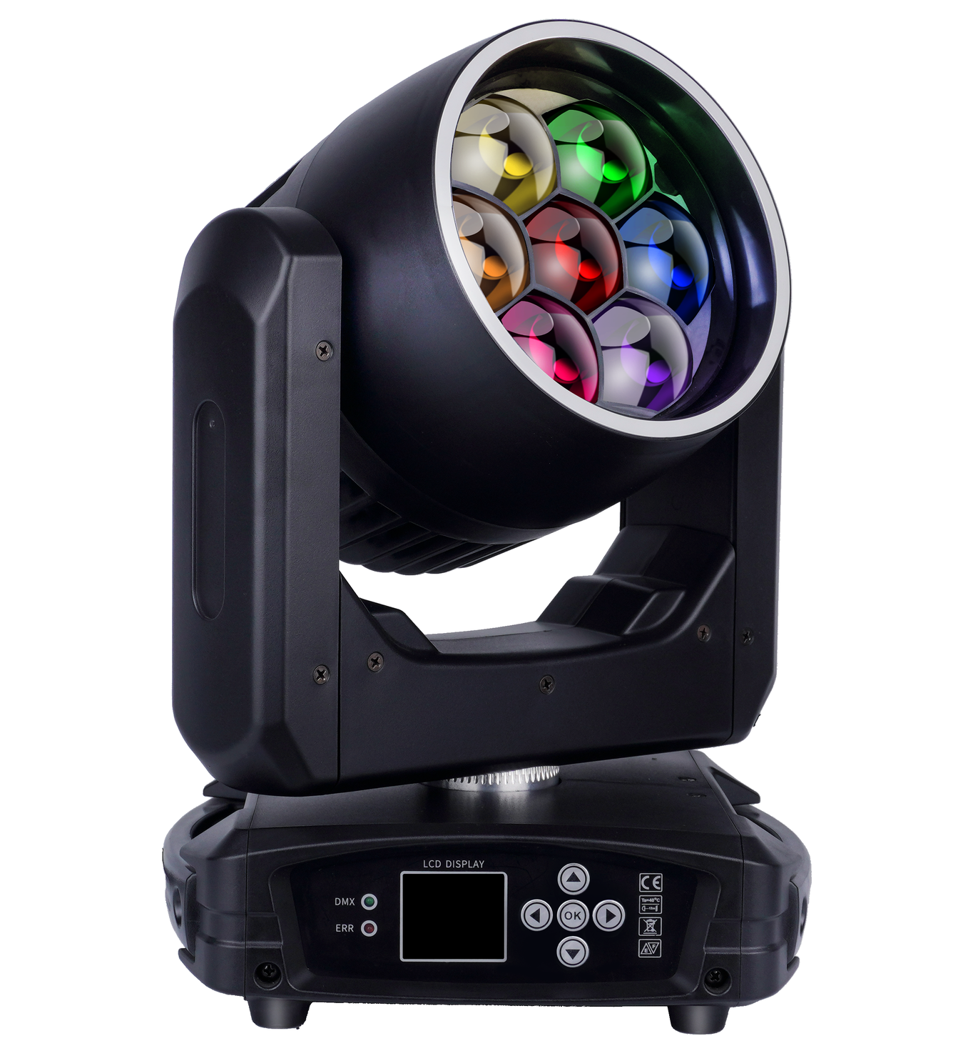
READ BEFORE USE Keep this manual with the fixture. Installation, operation and service must be performed by qualified personnel.
English Edition - Specifications subject to change without notice

Contents
Section | Topic
1 | Safety Information
2 | Product Overview
3 | Control Panel and Menu
4 | DMX Channel Reference
5 | Routine Maintenance
6 | Troubleshooting and Service

MODEL IDENTIFICATION This manual is organized for model AL740WZ. Confirm the model, voltage rating and firmware shown on the actual fixture before use.
The source manual identifies the product as 740WZ. This edition uses the complete model designation AL740WZ supplied with the product files.

1 Safety Information
DANGER Disconnect AC power and allow the fixture to cool completely before opening the housing, cleaning, inspection or service.
- Use the fixture only with the voltage and frequency marked on its product label.
- Connect the fixture to a properly grounded supply and keep power and data cables protected from damage.
- Keep ventilation openings clear. Do not operate the fixture where airflow is restricted or dust accumulation is excessive.
- Do not look directly into the light output at close range. The LEDs can produce intense visible light.
- Do not modify the fixture. Internal repair and calibration must be performed by qualified personnel.
- Use suitable clamps, fasteners and an independently rated safety cable for suspended installation.
OPTICAL SURFACES The optical coating is fragile and easily scratched. Work in a clean, bright area and do not use cleaners that can damage plastic, coatings or colored surfaces.

2 Product Overview
The AL740WZ is a compact LED wash moving head with seven individually controllable 40 W RGBW emitters, motorized zoom and an RGB halo ring. It supports DMX512, master/slave, sound-active, automatic and manual operation.

2.1 Technical Specifications
Parameter | Specification
Input voltage | AC 90-240 V, 50/60 Hz
Rated power | 350 W
Main light source | 7 x 40 W RGBW 4-in-1 LEDs
Halo ring | RGB ring LEDs
Zoom angle | 3-60 degrees
DMX personalities | 18CH / 29CH / 41CH / 57CH
Control modes | DMX512 / Master-Slave / Sound / Auto / Manual
Pan movement | 540 degrees
Tilt movement | 270 degrees nominal
Strobe | 1-25 Hz or random strobe
Display | LCD
Net weight | 6.5 kg
Dimensions | 266 x 207 x 258 mm

SOURCE NORMALIZATION The detailed source tables define 18CH, 29CH, 41CH and 57CH modes; these values are used in this edition. The source dimension unit has been normalized from cm to mm. The source channel tables describe a 205-degree tilt range, while the specification states 270 degrees; verify the active firmware before profile programming.

2.2 Main Functions
- RGBW color mixing with coarse and fine control in the 41-channel personality.
- Motorized zoom from narrow beam to wide wash.
- Built-in static, dynamic, foreground and background effects.
- Independent RGBW pixel control in the 57-channel personality.
- RGB halo-ring strobe, color and dynamic-effect controls.

3 Control Panel and Menu
Use ENTER to open or confirm a menu item, UP and DOWN to change the selected option or value, and the return/menu key to leave the current screen. Menu names may vary slightly with firmware revision.
Menu | Options | Operation
DMX Settings | Address and channel mode | Set the DMX start address and select 18CH, 29CH, 41CH or 57CH. Press ENTER to save.
Run Mode | DMX512 / Slow / Fast / Sound / Manual | Select console control, slow auto, fast auto, sound-active or manual scene operation.
Invert Pan/Tilt | Yes / No | Reverse pan and/or tilt direction as required by the installation.
Display Set | Invert / English-Chinese / Backlight | Rotate the display, choose the interface language and set the backlight behavior.
Manual Set | Channel values | Create and save a local scene. RUN MODE must be set to Manual.
Sound Sense | 0-100 | Adjust sound-active sensitivity.
System Set | Version / Defaults / Code Settings | View system data, restore defaults and access protected calibration parameters.
Reset | Fixture reset | Select Reset and wait approximately 3 seconds for initialization.

3.1 Run Modes
Mode | Description
DMX512 | Control from a compatible DMX512 console.
Slow | Slow automatic program.
Fast | Fast automatic program.
Sound | Sound-active automatic program.
Manual | Manual scene mode; saved values can be restored after power cycling.

3.2 Display Settings
When LCD Backlight is set to ON, the display remains illuminated. When set to OFF, it turns off after approximately 20 seconds without key input and lights again when a key is pressed.

3.3 Protected Calibration
Code Settings protects pan, tilt and zoom home-position adjustment and RGBW balance parameters. The factory key sequence in the source manual is DOWN, DOWN, UP, UP.
Parameter | Purpose
PAN_INIT | Pan home-position adjustment
TILT_INIT | Tilt home-position adjustment
ZOOM_INIT | Zoom home-position adjustment
SET_Red / Green / Blue / White | LED white-balance calibration

CALIBRATION Record the original values before adjustment. Incorrect settings can cause uneven color or abnormal mechanical positioning.

4 DMX Channel Reference
Select the personality in DMX Settings and configure the controller with the matching channel layout. Channel functions can vary with firmware; compare the fixture display and controller profile before programming.
Mode | Use
18CH | Compact movement, main RGBW and halo-ring control
29CH | Movement, main effects, background color and halo-ring control
41CH | 16-bit RGBW, movement, shape effects and halo-ring control
57CH | 29CH-style core plus seven-pixel RGBW control and halo ring

4.1 18-Channel Personality
Channel | Function | DMX Value | Description
1 | Pan | 0-255 | 0-540 degrees
2 | Tilt | 0-255 | 0-205 degrees (source table)
3 | Pan/Tilt Speed | 0-255 | Fast to slow
4 | Zoom | 0-255 | Narrow to wide
5 | Rotating Lens | 0-255 | Lens rotation
6 | Master Dimmer | 0-255 | Main output linear dimming, dark to full
7 | Strobe | 0-255 | Main-light strobe
8 | Red | 0-255 | Linear dimming, dark to full
9 | Green | 0-255 | Linear dimming, dark to full
10 | Blue | 0-255 | Linear dimming, dark to full
11 | White | 0-255 | Linear dimming, dark to full
12 | Reset | 0-255 | 0-250: No function; 251-255: Fixture reset after value is held for 5 seconds
13 | Halo Strobe | 0-255 | Halo-ring strobe
14 | Halo Red | 0-255 | Halo-ring red dimmer
15 | Halo Green | 0-255 | Halo-ring green dimmer
16 | Halo Blue | 0-255 | Halo-ring blue dimmer
17 | Halo Dynamic Effect | 0-255 | Halo-ring dynamic effect
18 | Halo Effect Speed | 0-255 | Halo-ring dynamic-effect speed

4.2 29-Channel Personality
Channel | Function | DMX Value | Description
1 | Pan | 0-255 | 0-540 degrees
2 | Pan Fine | 0-255 | 16-bit fine adjustment
3 | Tilt | 0-255 | 0-205 degrees (source table)
4 | Tilt Fine | 0-255 | 16-bit fine adjustment
5 | Pan/Tilt Speed | 0-255 | Fast to slow
6 | Zoom | 0-255 | Narrow to wide
7 | Rotating Lens | 0-255 | Lens rotation
8 | Master Dimmer | 0-255 | Linear dimming, dark to full
9 | Strobe | 0-255 | Main-light strobe
10 | Red | 0-255 | Linear dimming, dark to full
11 | Green | 0-255 | Linear dimming, dark to full
12 | Blue | 0-255 | Linear dimming, dark to full
13 | White | 0-255 | Linear dimming, dark to full
14 | Color Temperature | 0-255 | Linear color-temperature adjustment
15 | Color Macro | 0-255 | Built-in color gradient
16 | Static Effect | 0-255 | Built-in static effect selection
17 | Dynamic Effect | 0-255 | Built-in dynamic effect selection
18 | Dynamic Effect Speed | 0-255 | Slow to fast
19 | Background Red | 0-255 | Linear dimming, dark to full
20 | Background Green | 0-255 | Linear dimming, dark to full
21 | Background Blue | 0-255 | Linear dimming, dark to full
22 | Background White | 0-255 | Linear dimming, dark to full
23 | Reset | 0-255 | 0-250: No function; 251-255: Fixture reset after value is held for 5 seconds
24 | Halo Strobe | 0-255 | Halo-ring strobe
25 | Halo Red | 0-255 | Halo-ring red dimmer
26 | Halo Green | 0-255 | Halo-ring green dimmer
27 | Halo Blue | 0-255 | Halo-ring blue dimmer
28 | Halo Dynamic Effect | 0-255 | Halo-ring dynamic effect
29 | Halo Effect Speed | 0-255 | Halo-ring dynamic-effect speed

4.3 41-Channel Personality
Channel | Function | DMX Value | Description
1 | Red | 0-255 | Red dimmer
2 | Red Fine | 0-255 | Red fine adjustment
3 | Green | 0-255 | Green dimmer
4 | Green Fine | 0-255 | Green fine adjustment
5 | Blue | 0-255 | Blue dimmer
6 | Blue Fine | 0-255 | Blue fine adjustment
7 | White | 0-255 | White dimmer
8 | White Fine | 0-255 | White fine adjustment
9 | Linear CTO | 0-255 | Linear color-temperature adjustment
10 | Color Macro | 0-255 | Built-in color macros
11 | Strobe | 0-255 | Main-light strobe
12 | Master Dimmer | 0-255 | Main-light master dimmer
13 | Master Dimmer Fine | 0-255 | Fine master-dimmer adjustment
14 | Pan | 0-255 | Pan movement
15 | Pan Fine | 0-255 | Pan fine adjustment
16 | Tilt | 0-255 | Tilt movement
17 | Tilt Fine | 0-255 | Tilt fine adjustment
18 | Function | 0-255 | Fixture function channel
19 | Reset | 0-255 | Fixture reset
20 | Zoom | 0-255 | Motorized zoom
21 | Rotating Lens | 0-255 | Lens rotation
22 | Shape Selection | 0-255 | Built-in effect selection
23 | Shape Speed | 0-255 | Built-in effect speed
24 | Shape Fade | 0-255 | Built-in effect fade
25 | Shape Red | 0-255 | Foreground red dimmer
26 | Shape Green | 0-255 | Foreground green dimmer
27 | Shape Blue | 0-255 | Foreground blue dimmer
28 | Shape White | 0-255 | Foreground white dimmer
29 | Shape Dimmer | 0-255 | Foreground master dimmer
30 | Background Dimmer | 0-255 | Background master dimmer
31 | Shape Transition | 0-255 | Built-in effect transformation
32 | Shape Offset | 0-255 | Built-in effect offset / disable
33 | Foreground Strobe | 0-255 | Foreground strobe
34 | Background Strobe | 0-255 | Background strobe
35 | Background Select | 0-255 | Background selection
36 | Halo Strobe | 0-255 | Halo-ring strobe
37 | Halo Red | 0-255 | Halo-ring red dimmer
38 | Halo Green | 0-255 | Halo-ring green dimmer
39 | Halo Blue | 0-255 | Halo-ring blue dimmer
40 | Halo Dynamic Effect | 0-255 | Halo-ring dynamic effect
41 | Halo Effect Speed | 0-255 | Halo-ring dynamic-effect speed

4.4 57-Channel Personality
Channel | Function | DMX Value | Description
1 | Pan | 0-255 | 0-540 degrees
2 | Pan Fine | 0-255 | 16-bit fine adjustment
3 | Tilt | 0-255 | 0-205 degrees (source table)
4 | Tilt Fine | 0-255 | 16-bit fine adjustment
5 | Pan/Tilt Speed | 0-255 | Fast to slow
6 | Zoom | 0-255 | Narrow to wide
7 | Rotating Lens | 0-255 | Lens rotation
8 | Master Dimmer | 0-255 | Linear dimming, dark to full
9 | Strobe | 0-255 | Main-light strobe
10 | Red | 0-255 | Linear dimming, dark to full
11 | Green | 0-255 | Linear dimming, dark to full
12 | Blue | 0-255 | Linear dimming, dark to full
13 | White | 0-255 | Linear dimming, dark to full
14 | Color Temperature | 0-255 | Linear color-temperature adjustment
15 | Color Macro | 0-255 | Built-in color gradient
16 | Static Effect | 0-255 | Built-in static effect selection
17 | Dynamic Effect | 0-255 | Built-in dynamic effect selection
18 | Dynamic Effect Speed | 0-255 | Slow to fast
19 | Background Red | 0-255 | Linear dimming, dark to full
20 | Background Green | 0-255 | Linear dimming, dark to full
21 | Background Blue | 0-255 | Linear dimming, dark to full
22 | Background White | 0-255 | Linear dimming, dark to full
23 | Reset | 0-255 | 0-250: No function; 251-255: Fixture reset after value is held for 5 seconds
24 | Pixel 1 Red | 0-255 | Pixel 1 red dimmer
25 | Pixel 1 Green | 0-255 | Pixel 1 green dimmer
26 | Pixel 1 Blue | 0-255 | Pixel 1 blue dimmer
27 | Pixel 1 White | 0-255 | Pixel 1 white dimmer
28 | Pixel 2 Red | 0-255 | Pixel 2 red dimmer
29 | Pixel 2 Green | 0-255 | Pixel 2 green dimmer
30 | Pixel 2 Blue | 0-255 | Pixel 2 blue dimmer
31 | Pixel 2 White | 0-255 | Pixel 2 white dimmer
32 | Pixel 3 Red | 0-255 | Pixel 3 red dimmer
33 | Pixel 3 Green | 0-255 | Pixel 3 green dimmer
34 | Pixel 3 Blue | 0-255 | Pixel 3 blue dimmer
35 | Pixel 3 White | 0-255 | Pixel 3 white dimmer
36 | Pixel 4 Red | 0-255 | Pixel 4 red dimmer
37 | Pixel 4 Green | 0-255 | Pixel 4 green dimmer
38 | Pixel 4 Blue | 0-255 | Pixel 4 blue dimmer
39 | Pixel 4 White | 0-255 | Pixel 4 white dimmer
40 | Pixel 5 Red | 0-255 | Pixel 5 red dimmer
41 | Pixel 5 Green | 0-255 | Pixel 5 green dimmer
42 | Pixel 5 Blue | 0-255 | Pixel 5 blue dimmer
43 | Pixel 5 White | 0-255 | Pixel 5 white dimmer
44 | Pixel 6 Red | 0-255 | Pixel 6 red dimmer
45 | Pixel 6 Green | 0-255 | Pixel 6 green dimmer
46 | Pixel 6 Blue | 0-255 | Pixel 6 blue dimmer
47 | Pixel 6 White | 0-255 | Pixel 6 white dimmer
48 | Pixel 7 Red | 0-255 | Pixel 7 red dimmer
49 | Pixel 7 Green | 0-255 | Pixel 7 green dimmer
50 | Pixel 7 Blue | 0-255 | Pixel 7 blue dimmer
51 | Pixel 7 White | 0-255 | Pixel 7 white dimmer
52 | Halo Strobe | 0-255 | Halo-ring strobe
53 | Halo Red | 0-255 | Halo-ring red dimmer
54 | Halo Green | 0-255 | Halo-ring green dimmer
55 | Halo Blue | 0-255 | Halo-ring blue dimmer
56 | Halo Dynamic Effect | 0-255 | Halo-ring dynamic effect
57 | Halo Effect Speed | 0-255 | Halo-ring dynamic-effect speed

5 Routine Maintenance
Cleaning frequency depends on operating conditions. Inspect the fixture after approximately 100 hours when any of the following factors are present, then establish a suitable recurring interval.
- Frequent use of smoke or fog machines.
- High airflow, such as operation near an air inlet or outlet.
- Dust from stage effects, building structures or simulated outdoor environments.
ATTENTION Disconnect AC power and allow the fixture to cool completely before opening the housing or cleaning any component.

5.1 Cleaning Optical Components
- Disconnect power, allow the fixture to cool completely and open the housing only if qualified to do so.
- Use clean, dry compressed air to remove loose dust.
- For stubborn marks, use lint-free optical tissue lightly moistened with purified water or a suitable glass cleaner. Wipe gently without scratching.
- For oily residue, use an alcohol-moistened lint-free cloth. Remove any cleaner residue with purified water, working slowly in circular motions from the center outward.
- Dry with a clean, soft cloth or clean compressed air.

5.2 Cleaning Fans and Vents
Remove dust from fans and ventilation openings with a soft brush, lint-free cloth, vacuum cleaner or clean compressed air. Do not force debris deeper into the fixture.

6 Troubleshooting and Service
Symptom | Check
Fixture does not power on | Verify the supply, power cable, plug and fixture rating.
Fixture does not respond to DMX | Confirm DMX mode, start address, controller profile and data-cable connections.
Unexpected channel behavior | Verify that the controller personality matches 18CH, 29CH, 41CH or 57CH and confirm the fixture firmware.
Pan or tilt is reversed | Change the Pan/Tilt Invert setting.
Sound mode is unresponsive | Increase Sound Sense and confirm that RUN MODE is set to Sound.
Reduced output or overheating | Allow the fixture to cool, then clean fans, vents and optical components.

SERVICE All repairs not described in this manual must be referred to a qualified technician. Do not operate a fixture that has damaged wiring, abnormal movement, persistent errors or signs of overheating.
END OF MANUAL Retain this manual with the fixture and verify the product label, controller profile, local electrical requirements and rigging procedures before each installation.

