W09

19 × 40 W LED Bee Eye
Moving Head Eco
USER MANUAL
Professional LED moving-head wash, beam and effect fixture
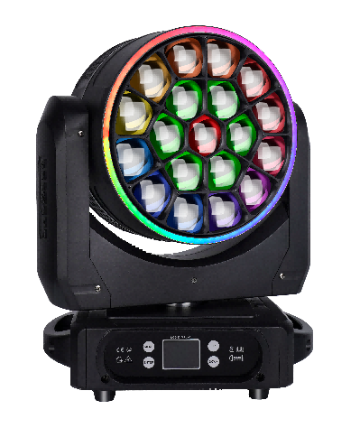
READ BEFORE USE Keep this manual with the fixture. Installation, operation and service must be performed by qualified personnel.
English Edition · Specifications subject to change without notice

Contents
Section | Topic
1 | Safety Information
2 | Product Overview
3 | Setup and Installation
4 | Control Panel and Menu
5 | DMX Channel Reference
6 | Maintenance
7 | Troubleshooting and Service

MODEL IDENTIFICATION This manual is organized for model W09. Before connecting power or selecting a DMX personality, verify the model, electrical rating and firmware shown on the actual fixture.
Thank you for choosing the W09. Read this manual completely before installation or operation. Follow all safety instructions and retain the manual for future reference.

1 Safety Information
DANGER Disconnect the fixture from AC power before cleaning, inspection, installation or service. The fixture contains no user-serviceable internal parts.
• Use the fixture indoors in a dry location unless the product label explicitly states a different environmental rating.
• Connect only to a grounded Class I supply. The protective earth conductor must never be interrupted.
• Use only the voltage and frequency marked on the fixture. The technical rating in this manual is AC 100–240 V, 50/60 Hz.
• Allow the fixture to reach room temperature after transport or exposure to a large temperature change. Condensation can damage internal components.
• Inspect the power cable regularly. Do not use a cable that is pinched, cut, abraded or otherwise damaged.
• Do not modify the fixture. Installation, maintenance and repair must be performed by qualified personnel.
• Do not stare into the light output. Do not operate the fixture if a lens, guard or enclosure is missing or damaged.
• Keep children and unauthorized persons away from the fixture. Do not apply excessive force during installation or operation.
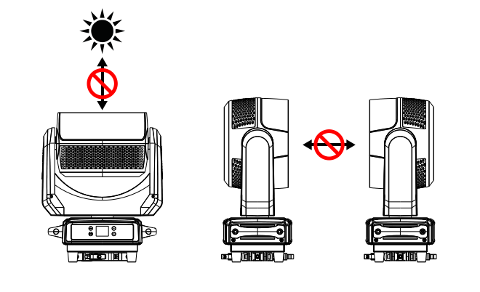
Figure 1. Protect the front lens from concentrated external light.
OPTICAL HAZARD Direct sunlight or another powerful beam entering the front lens can cause severe internal damage. Never expose the lens to direct sunlight during unpacking, installation, operation, transport or storage. Never aim one fixture directly into another.

2 Product Overview
The W09 combines a 19-pixel RGBW LED array with motorized pan, tilt, zoom and a continuously rotating front lens. It supports DMX512, sound-active and automatic operation for concerts, theaters, studios, clubs, bars and similar entertainment venues.

2.1 Package Contents
Item | Quantity
W09 fixture | 1
User manual | 1
Power cable | 1
DMX signal cable | 1

Unpack carefully and inspect the fixture and accessories for shipping damage. If anything is missing or damaged, stop and contact the supplier before use.

2.2 Technical Specifications
Parameter | Specification
Input power | AC 100–240 V, 50/60 Hz
Maximum power | 800 W
Light source | 19 × 40 W RGBW 4-in-1 LEDs
Color temperature | 2,800–8,500 K
Rated LED life | 50,000 hours (nominal)
Beam angle | 3.5°–50°
Control | DMX512, sound-active, Auto 1, Auto 2
DMX personalities | 21 / 30 / 35 / 78 / 92 / 97 / 99 channels
Effects | CTO, wash, beam, vortex, kaleidoscope, pixel control
Front lens | Bidirectional continuous rotation
Dimensions | 390 × 223 × 531 mm (W × D × H)

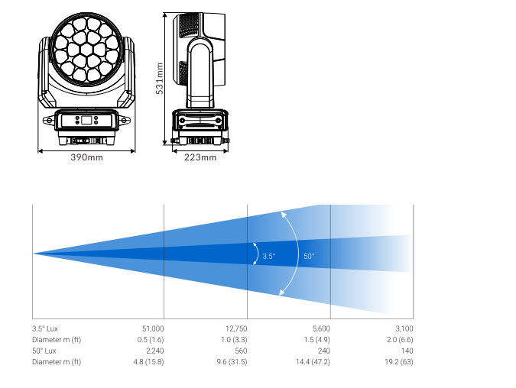
Figure 2. Dimensions and beam-angle reference. Photometric values are nominal.

3 Setup and Installation

3.1 DMX512 Data Connection
Connect fixtures in a daisy chain using shielded twisted-pair DMX cable. Connect the controller to DMX IN on the first fixture, then connect each DMX OUT to the next DMX IN. Do not use a star connection without a suitable DMX splitter.
3-pin XLR | Signal
Pin 1 | Shield / Ground
Pin 2 | Data –
Pin 3 | Data +

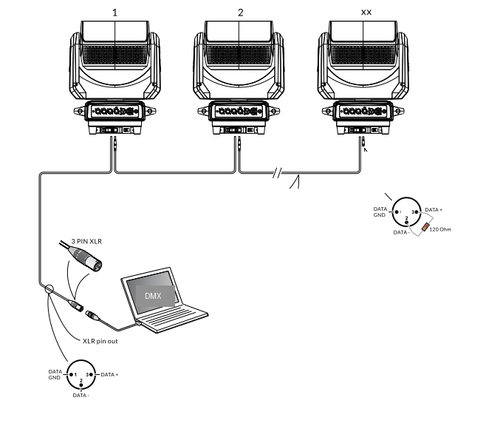
Figure 3. DMX512 daisy-chain wiring and termination.
TERMINATION Install a 120 Ω, 1 W resistor between pins 2 and 3 of a 3-pin XLR plug and connect it to DMX OUT on the final fixture.

3.2 DMX Start Address
Assign each fixture a unique start address. The next non-overlapping address equals the current start address plus the channel count of the selected personality.
Example: 21-channel mode | Start address
Fixture 1 | A001
Fixture 2 | A022
Fixture 3 | A043

CONTROLLER CAPACITY The controller must provide enough channels for every addressed fixture. Addressing rules can vary with the console and fixture profile.

3.3 Rigging
The fixture may be placed upright, mounted at an angle or suspended upside down. The supporting structure, clamps, fasteners and safety cable must be rated for the installation and installed according to local regulations.
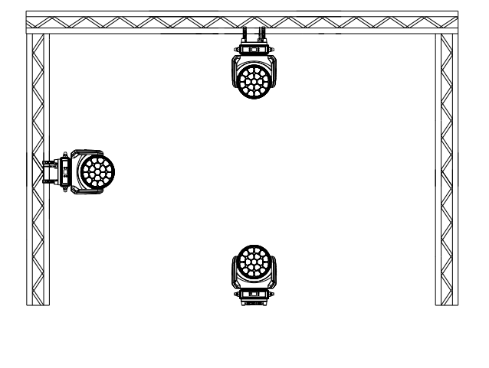
Figure 4. Typical mounting orientations.
• Verify that the mounting point and support structure are stable before installation.
• For suspended installation, attach an independently rated safety cable through a designated safety point.
• Keep the area below the fixture clear during installation and adjustment.
• Inspect the safety cable, clamps and fasteners regularly for wear, deformation and loosening.

4 Control Panel and Menu
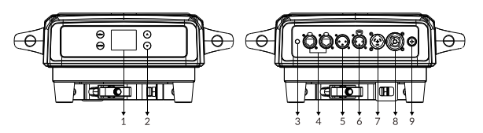
Figure 5. Display and connection panel layout. Follow the markings on the actual fixture.

4.1 Display Status and Keys
Indicator / Key | Operation
DMX indicator | Blue when a valid controller signal is present; off in normal stand-alone operation.
Error indicator | Red when the fixture reports a fault; off in normal operation.
Temperature | Shows LED-board temperature. “--- °C” may indicate an open sensor circuit; “*** °C” or an implausible value may indicate a short circuit.
Address | Displays the DMX start address from 001 to 512.
UP / DOWN | Move through menu items or change the selected value.
ENTER | Open a menu, enter edit mode or confirm and save a value.
MENU | Return to the previous screen or leave edit mode without saving.

DISPLAY CARE Do not press the display with a sharp or pointed object.

4.2 Main Menu
Main Menu | Item | Options / Notes
Address | DMX address | 001–512
Settings | Run mode | DMX / Sound / Auto 1 / Auto 2
Settings | Channel mode | 21CH / 35CH / 78CH / 92CH / 97CH / 30CH / 99CH
Settings | Pan invert | On / Off
Settings | Tilt invert | On / Off
Settings | Hall correction | On / Off
Settings | Optical correction | On / Off
Settings | Signal hold | On / Off
Settings | Screen saver | On / Off
Settings | Screen orientation | On / Off / Auto
Settings | Synchronized update | On / Off
Settings | Language | Chinese / English
Settings | Factory reset | Restore factory defaults
Manual | Channel control | Set the current channel value from 0–255
Calibration | Password | Enter the protected fixture-calibration menu
Reset | Effect motors | Reset effect motors except pan/tilt
Reset | Movement motors | Reset pan and tilt
Reset | All motors | Reset the complete fixture
Information | Diagnostics | Reset errors, DMX monitor, Hall sensor, X/Y optical sensor
Information | Versions | Hardware and software versions

4.3 Manual Control
Select a channel and press ENTER to edit. Use UP or DOWN to change the value. Press ENTER again to save, or press MENU to leave edit mode without saving.

4.4 Calibration
Calibration Group | Parameter | Range / Reference
Home position | Pan / Tilt / Zoom | 0–255; 127 = no offset
Travel | Pan / Tilt / Zoom | 0–255; 127 = no offset
Drive strength | Pan / Tilt and other motors | 0–255; 127 = nominal
Other | Microphone sensitivity | Adjust to suit the environment
Security | Password | Restricted to qualified service personnel

CALIBRATION Incorrect calibration can cause abnormal movement or mechanical stress. Record original values before adjustment and restrict this menu to qualified personnel.

4.5 Reset and Information
Use RESET to initialize the effect motors, pan/tilt motors or the entire fixture. The INFORMATION menu provides reset-error records, live DMX data, sensor status and hardware/software version data. A red ERR indication means that the corresponding subsystem requires inspection.

5 DMX Channel Reference
The W09 provides seven DMX personalities. To reduce repetition, the charts below show two common channel cores followed by the extensions used by each personality. Pixel channels are expanded in full for direct fixture-profile programming.
Mode | Common Core | Extension
21CH | Channels 1–21 · Core A | None
35CH | Channels 1–21 · Core A | Built-in effects, Channels 22–35
78CH | Channels 1–21 · Core A | 19-pixel RGB, Channels 22–78
92CH | Channels 1–21 · Core A | Effects 22–35 + 19-pixel RGB 36–92
97CH | Channels 1–21 · Core A | 19-pixel RGBW, Channels 22–97
30CH | Channels 1–23 · Core B | Auxiliary strip, Channels 24–30
99CH | Channels 1–23 · Core B | 19-pixel RGBW, Channels 24–99

FIRMWARE Channel functions can change with firmware revision. Compare this chart with the fixture display and controller personality before programming.

5.1 Core A · Channels 1–21
Used by 21CH, 35CH, 78CH, 92CH and 97CH personalities.
Channel | Function | DMX Value | Description
1 | Red | 0–255 | Red linear dimming from dark to full
2 | Red Fine | 0–255 | Red fine dimming
3 | Green | 0–255 | Green linear dimming from dark to full
4 | Green Fine | 0–255 | Green fine dimming
5 | Blue | 0–255 | Blue linear dimming from dark to full
6 | Blue Fine | 0–255 | Blue fine dimming
7 | White | 0–255 | White linear dimming from dark to full
8 | White Fine | 0–255 | White fine dimming
9 | Color Temperature | 0–255 | Linear color-temperature adjustment
10 | Color Macro | 0–255 | Built-in color macros
11 | Strobe | 0–3 | Blackout
11 | Strobe | 4–103 | Synchronized strobe, slow to fast (1–25 Hz)
11 | Strobe | 104–107 | Open
11 | Strobe | 108–207 | Pulse strobe, slow to fast (1–25 Hz)
11 | Strobe | 208–212 | Open
11 | Strobe | 213–225 | Slow random strobe
11 | Strobe | 226–238 | Medium random strobe
11 | Strobe | 239–251 | Fast random strobe
11 | Strobe | 252–255 | Open
12 | Master Dimmer | 0–255 | Linear dimming from dark to full
13 | Master Dimmer Fine | 0–255 | Fine master-dimmer control
14 | Pan | 0–255 | 0–540°
15 | Pan Fine | 0–255 | 16-bit fine adjustment
16 | Tilt | 0–255 | 0–205°
17 | Tilt Fine | 0–255 | 16-bit fine adjustment
18 | Macro Function | 0–255 | Reserved
19 | Reset | 0–25 | No function
19 | Reset | 26–76 | Head reset; hold value for 5 s
19 | Reset | 77–127 | Pan/tilt reset; hold value for 5 s
19 | Reset | 128–255 | Full reset; hold value for 5 s
20 | Zoom | 0–255 | Linear zoom from narrow to wide
21 | Rotating Lens | 0–127 | 0–60°
21 | Rotating Lens | 128–188 | Counterclockwise rotation, fast to slow
21 | Rotating Lens | 189–193 | Stop
21 | Rotating Lens | 194–255 | Clockwise rotation, slow to fast

5.2 Effect Extension · Channels 22–35
Used by 35CH and 92CH personalities. In 35CH mode this extension completes the personality. In 92CH mode, pixel RGB channels follow at Channel 36.
Channel | Function | DMX Value | Description
22 | Built-in Effect (with Effect Color) | 0–7 | None
22 | Built-in Effect (with Effect Color) | 8 | Static Effect 1
22 | Built-in Effect (with Effect Color) | 9 | Static Effect 2
22 | Built-in Effect (with Effect Color) | 10 | Static Effect 3
22 | Built-in Effect (with Effect Color) | 11 | None
22 | Built-in Effect (with Effect Color) | 12 | Static Effect 4
22 | Built-in Effect (with Effect Color) | 13 | Static Effect 5
22 | Built-in Effect (with Effect Color) | 14 | None
22 | Built-in Effect (with Effect Color) | 15 | Dynamic Effect 1
22 | Built-in Effect (with Effect Color) | 16 | Dynamic Effect 2
22 | Built-in Effect (with Effect Color) | 17 | Dynamic Effect 3
22 | Built-in Effect (with Effect Color) | 18 | Dynamic Effect 4
22 | Built-in Effect (with Effect Color) | 19 | Single-color random effect
22 | Built-in Effect (with Effect Color) | 20 | Full-color random effect
22 | Built-in Effect (with Effect Color) | 21 | Rainbow Effect 1
22 | Built-in Effect (with Effect Color) | 22 | Rainbow Effect 2
22 | Built-in Effect (with Effect Color) | 23 | Dynamic Effect 5
22 | Built-in Effect (with Effect Color) | 24 | Dynamic Effect 6
22 | Built-in Effect (with Effect Color) | 25 | Dynamic Effect 7
22 | Built-in Effect (with Effect Color) | 26 | Dynamic Effect 8
22 | Built-in Effect (with Effect Color) | 27 | Dynamic Effect 9
22 | Built-in Effect (with Effect Color) | 28 | Dynamic Effect 10
22 | Built-in Effect (with Effect Color) | 29 | Dynamic Effect 11
22 | Built-in Effect (with Effect Color) | 30 | Dynamic Effect 12
22 | Built-in Effect (with Effect Color) | 31 | Dynamic Effect 13
22 | Built-in Effect (with Effect Color) | 32 | Dynamic Effect 14
22 | Built-in Effect (with Effect Color) | 33 | None
22 | Built-in Effect (with Effect Color) | 34 | None
22 | Built-in Effect (with Effect Color) | 35 | Dynamic Effect 15
22 | Built-in Effect (with Effect Color) | 36 | Dynamic Effect 16
22 | Built-in Effect (with Effect Color) | 37 | Dynamic Effect 17
22 | Built-in Effect (with Effect Color) | 38 | Dynamic Effect 18
22 | Built-in Effect (with Effect Color) | 39 | Dynamic Effect 19
22 | Built-in Effect (with Effect Color) | 40 | Dynamic Effect 20
22 | Built-in Effect (with Effect Color) | 41 | None
22 | Built-in Effect (with Effect Color) | 42 | Dynamic Effect 21
22 | Built-in Effect (with Effect Color) | 43 | None
22 | Built-in Effect (with Effect Color) | 44 | Dynamic Effect 22
22 | Built-in Effect (with Effect Color) | 45 | Dynamic Effect 23
22 | Built-in Effect (with Effect Color) | 46 | Dynamic Effect 24
22 | Built-in Effect (with Effect Color) | 47 | Dynamic Effect 25
22 | Built-in Effect (with Effect Color) | 48 | Dynamic Effect 26
22 | Built-in Effect (with Effect Color) | 49 | Dynamic Effect 27
22 | Built-in Effect (with Effect Color) | 50 | Dynamic Effect 28
22 | Built-in Effect (with Effect Color) | 51 | Dynamic Effect 29
22 | Built-in Effect (with Effect Color) | 52 | Dynamic Effect 30
22 | Built-in Effect (with Effect Color) | 53 | Dynamic Effect 31
22 | Built-in Effect (with Effect Color) | 54 | Dynamic Effect 32
22 | Built-in Effect (with Effect Color) | 55 | Dynamic Effect 33
22 | Built-in Effect (with Effect Color) | 56 | Dynamic Effect 34
22 | Built-in Effect (with Effect Color) | 57 | Dynamic Effect 35
22 | Built-in Effect (with Effect Color) | 58 | Dynamic Effect 36
22 | Built-in Effect (with Effect Color) | 59 | Dynamic Effect 37
22 | Built-in Effect (with Effect Color) | 60 | Dynamic Effect 38
22 | Built-in Effect (with Effect Color) | 61 | Random Position 1
22 | Built-in Effect (with Effect Color) | 62 | Random Position 2
22 | Built-in Effect (with Effect Color) | 63 | Random Position 3
22 | Built-in Effect (with Effect Color) | 64 | None
22 | Built-in Effect (with Effect Color) | 65 | Random Position 4
22 | Built-in Effect (with Effect Color) | 66 | Random Position 5
22 | Built-in Effect (with Effect Color) | 67 | Dynamic Effect 39
22 | Built-in Effect (with Effect Color) | 68 | Dynamic Effect 40
22 | Built-in Effect (with Effect Color) | 69 | None
22 | Built-in Effect (with Effect Color) | 70 | Dynamic Effect 41
22 | Built-in Effect (with Effect Color) | 71–255 | None
23 | Effect Speed | 0–63 | Static effect
23 | Effect Speed | 64–158 | Forward, fast to slow
23 | Effect Speed | 159–160 | Stop
23 | Effect Speed | 161–255 | Reverse, slow to fast
24 | Effect Fade | 0–255 | Dynamic-effect fade
25 | Effect Red | 0–255 | Dynamic-effect red
26 | Effect Green | 0–255 | Dynamic-effect green
27 | Effect Blue | 0–255 | Dynamic-effect blue
28 | Effect White | 0–255 | Dynamic-effect white
29 | Effect Dimmer | 0–255 | Pattern dimmer, 0–100%
30 | Background Dimmer | 0–255 | Background dimmer, 0–100%
31 | Effect Transition | 0–255 | Pattern transition control
32 | Effect Translation | 0–255 | Pattern translation
33 | Foreground Strobe | 0–255 | Foreground strobe; behavior follows Channel 11
34 | Background Strobe | 0–255 | Background strobe; behavior follows Channel 11
35 | Background Selection | 0–255 | Background selection

5.3 78CH Pixel Extension · Channels 22–78
Channel | Pixel | Color | DMX Value / Description
22 | 1 | Red | 0–255 · Linear dimming from dark to full
23 | 1 | Green | 0–255 · Linear dimming from dark to full
24 | 1 | Blue | 0–255 · Linear dimming from dark to full
25 | 2 | Red | 0–255 · Linear dimming from dark to full
26 | 2 | Green | 0–255 · Linear dimming from dark to full
27 | 2 | Blue | 0–255 · Linear dimming from dark to full
28 | 3 | Red | 0–255 · Linear dimming from dark to full
29 | 3 | Green | 0–255 · Linear dimming from dark to full
30 | 3 | Blue | 0–255 · Linear dimming from dark to full
31 | 4 | Red | 0–255 · Linear dimming from dark to full
32 | 4 | Green | 0–255 · Linear dimming from dark to full
33 | 4 | Blue | 0–255 · Linear dimming from dark to full
34 | 5 | Red | 0–255 · Linear dimming from dark to full
35 | 5 | Green | 0–255 · Linear dimming from dark to full
36 | 5 | Blue | 0–255 · Linear dimming from dark to full
37 | 6 | Red | 0–255 · Linear dimming from dark to full
38 | 6 | Green | 0–255 · Linear dimming from dark to full
39 | 6 | Blue | 0–255 · Linear dimming from dark to full
40 | 7 | Red | 0–255 · Linear dimming from dark to full
41 | 7 | Green | 0–255 · Linear dimming from dark to full
42 | 7 | Blue | 0–255 · Linear dimming from dark to full
43 | 8 | Red | 0–255 · Linear dimming from dark to full
44 | 8 | Green | 0–255 · Linear dimming from dark to full
45 | 8 | Blue | 0–255 · Linear dimming from dark to full
46 | 9 | Red | 0–255 · Linear dimming from dark to full
47 | 9 | Green | 0–255 · Linear dimming from dark to full
48 | 9 | Blue | 0–255 · Linear dimming from dark to full
49 | 10 | Red | 0–255 · Linear dimming from dark to full
50 | 10 | Green | 0–255 · Linear dimming from dark to full
51 | 10 | Blue | 0–255 · Linear dimming from dark to full
52 | 11 | Red | 0–255 · Linear dimming from dark to full
53 | 11 | Green | 0–255 · Linear dimming from dark to full
54 | 11 | Blue | 0–255 · Linear dimming from dark to full
55 | 12 | Red | 0–255 · Linear dimming from dark to full
56 | 12 | Green | 0–255 · Linear dimming from dark to full
57 | 12 | Blue | 0–255 · Linear dimming from dark to full
58 | 13 | Red | 0–255 · Linear dimming from dark to full
59 | 13 | Green | 0–255 · Linear dimming from dark to full
60 | 13 | Blue | 0–255 · Linear dimming from dark to full
61 | 14 | Red | 0–255 · Linear dimming from dark to full
62 | 14 | Green | 0–255 · Linear dimming from dark to full
63 | 14 | Blue | 0–255 · Linear dimming from dark to full
64 | 15 | Red | 0–255 · Linear dimming from dark to full
65 | 15 | Green | 0–255 · Linear dimming from dark to full
66 | 15 | Blue | 0–255 · Linear dimming from dark to full
67 | 16 | Red | 0–255 · Linear dimming from dark to full
68 | 16 | Green | 0–255 · Linear dimming from dark to full
69 | 16 | Blue | 0–255 · Linear dimming from dark to full
70 | 17 | Red | 0–255 · Linear dimming from dark to full
71 | 17 | Green | 0–255 · Linear dimming from dark to full
72 | 17 | Blue | 0–255 · Linear dimming from dark to full
73 | 18 | Red | 0–255 · Linear dimming from dark to full
74 | 18 | Green | 0–255 · Linear dimming from dark to full
75 | 18 | Blue | 0–255 · Linear dimming from dark to full
76 | 19 | Red | 0–255 · Linear dimming from dark to full
77 | 19 | Green | 0–255 · Linear dimming from dark to full
78 | 19 | Blue | 0–255 · Linear dimming from dark to full

5.4 92CH Pixel Extension · Channels 36–92
Channel | Pixel | Color | DMX Value / Description
36 | 1 | Red | 0–255 · Linear dimming from dark to full
37 | 1 | Green | 0–255 · Linear dimming from dark to full
38 | 1 | Blue | 0–255 · Linear dimming from dark to full
39 | 2 | Red | 0–255 · Linear dimming from dark to full
40 | 2 | Green | 0–255 · Linear dimming from dark to full
41 | 2 | Blue | 0–255 · Linear dimming from dark to full
42 | 3 | Red | 0–255 · Linear dimming from dark to full
43 | 3 | Green | 0–255 · Linear dimming from dark to full
44 | 3 | Blue | 0–255 · Linear dimming from dark to full
45 | 4 | Red | 0–255 · Linear dimming from dark to full
46 | 4 | Green | 0–255 · Linear dimming from dark to full
47 | 4 | Blue | 0–255 · Linear dimming from dark to full
48 | 5 | Red | 0–255 · Linear dimming from dark to full
49 | 5 | Green | 0–255 · Linear dimming from dark to full
50 | 5 | Blue | 0–255 · Linear dimming from dark to full
51 | 6 | Red | 0–255 · Linear dimming from dark to full
52 | 6 | Green | 0–255 · Linear dimming from dark to full
53 | 6 | Blue | 0–255 · Linear dimming from dark to full
54 | 7 | Red | 0–255 · Linear dimming from dark to full
55 | 7 | Green | 0–255 · Linear dimming from dark to full
56 | 7 | Blue | 0–255 · Linear dimming from dark to full
57 | 8 | Red | 0–255 · Linear dimming from dark to full
58 | 8 | Green | 0–255 · Linear dimming from dark to full
59 | 8 | Blue | 0–255 · Linear dimming from dark to full
60 | 9 | Red | 0–255 · Linear dimming from dark to full
61 | 9 | Green | 0–255 · Linear dimming from dark to full
62 | 9 | Blue | 0–255 · Linear dimming from dark to full
63 | 10 | Red | 0–255 · Linear dimming from dark to full
64 | 10 | Green | 0–255 · Linear dimming from dark to full
65 | 10 | Blue | 0–255 · Linear dimming from dark to full
66 | 11 | Red | 0–255 · Linear dimming from dark to full
67 | 11 | Green | 0–255 · Linear dimming from dark to full
68 | 11 | Blue | 0–255 · Linear dimming from dark to full
69 | 12 | Red | 0–255 · Linear dimming from dark to full
70 | 12 | Green | 0–255 · Linear dimming from dark to full
71 | 12 | Blue | 0–255 · Linear dimming from dark to full
72 | 13 | Red | 0–255 · Linear dimming from dark to full
73 | 13 | Green | 0–255 · Linear dimming from dark to full
74 | 13 | Blue | 0–255 · Linear dimming from dark to full
75 | 14 | Red | 0–255 · Linear dimming from dark to full
76 | 14 | Green | 0–255 · Linear dimming from dark to full
77 | 14 | Blue | 0–255 · Linear dimming from dark to full
78 | 15 | Red | 0–255 · Linear dimming from dark to full
79 | 15 | Green | 0–255 · Linear dimming from dark to full
80 | 15 | Blue | 0–255 · Linear dimming from dark to full
81 | 16 | Red | 0–255 · Linear dimming from dark to full
82 | 16 | Green | 0–255 · Linear dimming from dark to full
83 | 16 | Blue | 0–255 · Linear dimming from dark to full
84 | 17 | Red | 0–255 · Linear dimming from dark to full
85 | 17 | Green | 0–255 · Linear dimming from dark to full
86 | 17 | Blue | 0–255 · Linear dimming from dark to full
87 | 18 | Red | 0–255 · Linear dimming from dark to full
88 | 18 | Green | 0–255 · Linear dimming from dark to full
89 | 18 | Blue | 0–255 · Linear dimming from dark to full
90 | 19 | Red | 0–255 · Linear dimming from dark to full
91 | 19 | Green | 0–255 · Linear dimming from dark to full
92 | 19 | Blue | 0–255 · Linear dimming from dark to full

5.5 97CH Pixel Extension · Channels 22–97
Channel | Pixel | Color | DMX Value / Description
22 | 1 | Red | 0–255 · Linear dimming from dark to full
23 | 1 | Green | 0–255 · Linear dimming from dark to full
24 | 1 | Blue | 0–255 · Linear dimming from dark to full
25 | 1 | White | 0–255 · Linear dimming from dark to full
26 | 2 | Red | 0–255 · Linear dimming from dark to full
27 | 2 | Green | 0–255 · Linear dimming from dark to full
28 | 2 | Blue | 0–255 · Linear dimming from dark to full
29 | 2 | White | 0–255 · Linear dimming from dark to full
30 | 3 | Red | 0–255 · Linear dimming from dark to full
31 | 3 | Green | 0–255 · Linear dimming from dark to full
32 | 3 | Blue | 0–255 · Linear dimming from dark to full
33 | 3 | White | 0–255 · Linear dimming from dark to full
34 | 4 | Red | 0–255 · Linear dimming from dark to full
35 | 4 | Green | 0–255 · Linear dimming from dark to full
36 | 4 | Blue | 0–255 · Linear dimming from dark to full
37 | 4 | White | 0–255 · Linear dimming from dark to full
38 | 5 | Red | 0–255 · Linear dimming from dark to full
39 | 5 | Green | 0–255 · Linear dimming from dark to full
40 | 5 | Blue | 0–255 · Linear dimming from dark to full
41 | 5 | White | 0–255 · Linear dimming from dark to full
42 | 6 | Red | 0–255 · Linear dimming from dark to full
43 | 6 | Green | 0–255 · Linear dimming from dark to full
44 | 6 | Blue | 0–255 · Linear dimming from dark to full
45 | 6 | White | 0–255 · Linear dimming from dark to full
46 | 7 | Red | 0–255 · Linear dimming from dark to full
47 | 7 | Green | 0–255 · Linear dimming from dark to full
48 | 7 | Blue | 0–255 · Linear dimming from dark to full
49 | 7 | White | 0–255 · Linear dimming from dark to full
50 | 8 | Red | 0–255 · Linear dimming from dark to full
51 | 8 | Green | 0–255 · Linear dimming from dark to full
52 | 8 | Blue | 0–255 · Linear dimming from dark to full
53 | 8 | White | 0–255 · Linear dimming from dark to full
54 | 9 | Red | 0–255 · Linear dimming from dark to full
55 | 9 | Green | 0–255 · Linear dimming from dark to full
56 | 9 | Blue | 0–255 · Linear dimming from dark to full
57 | 9 | White | 0–255 · Linear dimming from dark to full
58 | 10 | Red | 0–255 · Linear dimming from dark to full
59 | 10 | Green | 0–255 · Linear dimming from dark to full
60 | 10 | Blue | 0–255 · Linear dimming from dark to full
61 | 10 | White | 0–255 · Linear dimming from dark to full
62 | 11 | Red | 0–255 · Linear dimming from dark to full
63 | 11 | Green | 0–255 · Linear dimming from dark to full
64 | 11 | Blue | 0–255 · Linear dimming from dark to full
65 | 11 | White | 0–255 · Linear dimming from dark to full
66 | 12 | Red | 0–255 · Linear dimming from dark to full
67 | 12 | Green | 0–255 · Linear dimming from dark to full
68 | 12 | Blue | 0–255 · Linear dimming from dark to full
69 | 12 | White | 0–255 · Linear dimming from dark to full
70 | 13 | Red | 0–255 · Linear dimming from dark to full
71 | 13 | Green | 0–255 · Linear dimming from dark to full
72 | 13 | Blue | 0–255 · Linear dimming from dark to full
73 | 13 | White | 0–255 · Linear dimming from dark to full
74 | 14 | Red | 0–255 · Linear dimming from dark to full
75 | 14 | Green | 0–255 · Linear dimming from dark to full
76 | 14 | Blue | 0–255 · Linear dimming from dark to full
77 | 14 | White | 0–255 · Linear dimming from dark to full
78 | 15 | Red | 0–255 · Linear dimming from dark to full
79 | 15 | Green | 0–255 · Linear dimming from dark to full
80 | 15 | Blue | 0–255 · Linear dimming from dark to full
81 | 15 | White | 0–255 · Linear dimming from dark to full
82 | 16 | Red | 0–255 · Linear dimming from dark to full
83 | 16 | Green | 0–255 · Linear dimming from dark to full
84 | 16 | Blue | 0–255 · Linear dimming from dark to full
85 | 16 | White | 0–255 · Linear dimming from dark to full
86 | 17 | Red | 0–255 · Linear dimming from dark to full
87 | 17 | Green | 0–255 · Linear dimming from dark to full
88 | 17 | Blue | 0–255 · Linear dimming from dark to full
89 | 17 | White | 0–255 · Linear dimming from dark to full
90 | 18 | Red | 0–255 · Linear dimming from dark to full
91 | 18 | Green | 0–255 · Linear dimming from dark to full
92 | 18 | Blue | 0–255 · Linear dimming from dark to full
93 | 18 | White | 0–255 · Linear dimming from dark to full
94 | 19 | Red | 0–255 · Linear dimming from dark to full
95 | 19 | Green | 0–255 · Linear dimming from dark to full
96 | 19 | Blue | 0–255 · Linear dimming from dark to full
97 | 19 | White | 0–255 · Linear dimming from dark to full

5.6 Core B · Channels 1–23
Used by 30CH and 99CH personalities.
Channel | Function | DMX Value | Description
1 | Pan | 0–255 | 0–540°
2 | Pan Fine | 0–255 | 16-bit fine adjustment
3 | Tilt | 0–255 | 0–205°
4 | Tilt Fine | 0–255 | 16-bit fine adjustment
5 | Pan/Tilt Speed | 0–255 | Pan/tilt speed, fast to slow
6 | Zoom | 0–255 | Linear zoom from narrow to wide
7 | Rotating Lens | 0–127 | 0–60°
7 | Rotating Lens | 128–188 | Counterclockwise rotation, fast to slow
7 | Rotating Lens | 189–193 | Stop
7 | Rotating Lens | 194–255 | Clockwise rotation, slow to fast
8 | Dimmer | 0–255 | Linear dimming from dark to full
9 | Strobe | 0–3 | Open
9 | Strobe | 4–200 | Synchronized strobe, slow to fast (1–25 Hz)
9 | Strobe | 201–215 | Slow random strobe
9 | Strobe | 216–234 | Medium random strobe
9 | Strobe | 235–255 | Fast random strobe
10 | Red | 0–255 | Red linear dimming from dark to full
11 | Green | 0–255 | Green linear dimming from dark to full
12 | Blue | 0–255 | Blue linear dimming from dark to full
13 | White | 0–255 | White linear dimming from dark to full
14 | Color Temperature | 0–255 | Linear color-temperature adjustment
15 | Color Macro | 0–255 | Built-in color macros
16 | Static Effect | 0–9 | None
16 | Static Effect | 10–14 | Static Effect 1
16 | Static Effect | 15–19 | Static Effect 2
16 | Static Effect | 20–24 | Static Effect 3
16 | Static Effect | 25–29 | Static Effect 4
16 | Static Effect | 30–34 | Static Effect 5
16 | Static Effect | 35–39 | Static Effect 6
16 | Static Effect | 40–44 | Static Effect 7
16 | Static Effect | 45–49 | Static Effect 8
16 | Static Effect | 50–54 | Static Effect 9
16 | Static Effect | 55–59 | Static Effect 10
16 | Static Effect | 60–64 | Static Effect 11
16 | Static Effect | 65–69 | Static Effect 12
16 | Static Effect | 70–74 | Static Effect 13
16 | Static Effect | 75–79 | Static Effect 14
16 | Static Effect | 80–84 | Static Effect 15
16 | Static Effect | 85–89 | Static Effect 16
16 | Static Effect | 90–94 | Static Effect 17
16 | Static Effect | 95–99 | Static Effect 18
16 | Static Effect | 100–104 | Static Effect 19
16 | Static Effect | 105–109 | Static Effect 20
16 | Static Effect | 110–114 | Static Effect 21
16 | Static Effect | 115–119 | Static Effect 22
16 | Static Effect | 120–124 | Static Effect 23
16 | Static Effect | 125–129 | Static Effect 24
16 | Static Effect | 130–134 | Static Effect 25
16 | Static Effect | 135–139 | Static Effect 26
16 | Static Effect | 140–144 | Static Effect 27
16 | Static Effect | 145–149 | Static Effect 28
16 | Static Effect | 150–154 | Static Effect 29
16 | Static Effect | 155–159 | Static Effect 30
16 | Static Effect | 160–164 | Static Effect 31
16 | Static Effect | 165–169 | Static Effect 32
16 | Static Effect | 170–174 | Static Effect 33
16 | Static Effect | 175–179 | Static Effect 34
16 | Static Effect | 180–184 | Static Effect 35
16 | Static Effect | 185–255 | Static Effect 36
17 | Dynamic Effect | 0–9 | None
17 | Dynamic Effect | 10–14 | Foreground and background colors adjustable
17 | Dynamic Effect | 15–19 | Foreground and background colors adjustable
17 | Dynamic Effect | 20–24 | Foreground and background colors adjustable
17 | Dynamic Effect | 25–29 | Foreground and background colors adjustable
17 | Dynamic Effect | 30–34 | Foreground and background colors adjustable
17 | Dynamic Effect | 35–39 | Foreground and background colors adjustable
17 | Dynamic Effect | 40–44 | Foreground and background colors adjustable
17 | Dynamic Effect | 45–49 | Foreground and background colors adjustable
17 | Dynamic Effect | 50–54 | Foreground and background colors adjustable
17 | Dynamic Effect | 55–59 | Foreground and background colors adjustable
17 | Dynamic Effect | 60–64 | Foreground and background colors adjustable
17 | Dynamic Effect | 65–69 | Foreground and background colors adjustable
17 | Dynamic Effect | 70–74 | Foreground and background colors adjustable
17 | Dynamic Effect | 75–79 | Foreground and background colors adjustable
17 | Dynamic Effect | 80–84 | Single-pixel, single-color random effect
17 | Dynamic Effect | 85–89 | Foreground and background colors adjustable
17 | Dynamic Effect | 90–94 | Foreground and background colors adjustable
17 | Dynamic Effect | 95–99 | Foreground and background colors adjustable
17 | Dynamic Effect | 100–104 | Foreground and background colors adjustable
17 | Dynamic Effect | 105–109 | Foreground and background colors adjustable
17 | Dynamic Effect | 110–114 | Foreground and background colors adjustable
17 | Dynamic Effect | 115–119 | Foreground and background colors adjustable
17 | Dynamic Effect | 120–124 | Foreground and background colors adjustable
17 | Dynamic Effect | 125–129 | Foreground and background colors adjustable
17 | Dynamic Effect | 130–134 | Foreground and background colors adjustable
17 | Dynamic Effect | 135–139 | Foreground and background colors adjustable
17 | Dynamic Effect | 140–144 | Foreground and background colors adjustable
17 | Dynamic Effect | 145–149 | Foreground and background colors adjustable
17 | Dynamic Effect | 150–154 | Multicolor dynamic effect
17 | Dynamic Effect | 155–159 | Multicolor dynamic effect
17 | Dynamic Effect | 160–164 | Multicolor dynamic effect
17 | Dynamic Effect | 165–169 | Multicolor dynamic effect
17 | Dynamic Effect | 170–174 | Multicolor dynamic effect
17 | Dynamic Effect | 175–179 | Multicolor dynamic effect
17 | Dynamic Effect | 180–184 | Multicolor dynamic effect
17 | Dynamic Effect | 185–189 | Multicolor dynamic effect
17 | Dynamic Effect | 190–194 | Multicolor dynamic effect
17 | Dynamic Effect | 195–199 | Multicolor dynamic effect
17 | Dynamic Effect | 200–204 | Multicolor dynamic effect
17 | Dynamic Effect | 205–209 | Multicolor dynamic effect
17 | Dynamic Effect | 210–214 | Multicolor dynamic effect
17 | Dynamic Effect | 215–219 | Multicolor dynamic effect
17 | Dynamic Effect | 220–224 | Multicolor dynamic effect
17 | Dynamic Effect | 225–229 | Multicolor dynamic effect
17 | Dynamic Effect | 230–255 | Multicolor dynamic effect
18 | Effect Speed | 0–126 | Forward, fast to slow
18 | Effect Speed | 127–128 | Stop
18 | Effect Speed | 129–255 | Reverse, slow to fast
19 | Background Red | 0–255 | Effect background red
20 | Background Green | 0–255 | Effect background green
21 | Background Blue | 0–255 | Effect background blue
22 | Background White | 0–255 | Effect background white
23 | Reset | 0–26 | None
23 | Reset | 27–76 | Head reset; hold value for 5 s
23 | Reset | 77–127 | Pan/tilt reset; hold value for 5 s
23 | Reset | 128–255 | Full reset; hold value for 5 s

5.7 30CH Strip Extension · Channels 24–30
Channel | Function | DMX Value | Description
24 | Strip Dimmer | 0–255 | Strip dimmer, 0–100%
25 | Strip Strobe | 0–4 | None
25 | Strip Strobe | 5–250 | Synchronized strobe
25 | Strip Strobe | 251–255 | None
26 | Strip Red | 0–255 | Strip red dimmer, 0–100%
27 | Strip Green | 0–255 | Strip green dimmer, 0–100%
28 | Strip Blue | 0–255 | Strip blue dimmer, 0–100%
29 | Strip Macro | 0–13 | None
29 | Strip Macro | 14–51 | Static colors
29 | Strip Macro | 52–255 | Dynamic effects
30 | Effect Speed | 0–255 | Strip effect speed, slow to fast

5.8 99CH Pixel Extension · Channels 24–99
Channel | Pixel | Color | DMX Value / Description
24 | 1 | Red | 0–255 · Linear dimming from dark to full
25 | 1 | Green | 0–255 · Linear dimming from dark to full
26 | 1 | Blue | 0–255 · Linear dimming from dark to full
27 | 1 | White | 0–255 · Linear dimming from dark to full
28 | 2 | Red | 0–255 · Linear dimming from dark to full
29 | 2 | Green | 0–255 · Linear dimming from dark to full
30 | 2 | Blue | 0–255 · Linear dimming from dark to full
31 | 2 | White | 0–255 · Linear dimming from dark to full
32 | 3 | Red | 0–255 · Linear dimming from dark to full
33 | 3 | Green | 0–255 · Linear dimming from dark to full
34 | 3 | Blue | 0–255 · Linear dimming from dark to full
35 | 3 | White | 0–255 · Linear dimming from dark to full
36 | 4 | Red | 0–255 · Linear dimming from dark to full
37 | 4 | Green | 0–255 · Linear dimming from dark to full
38 | 4 | Blue | 0–255 · Linear dimming from dark to full
39 | 4 | White | 0–255 · Linear dimming from dark to full
40 | 5 | Red | 0–255 · Linear dimming from dark to full
41 | 5 | Green | 0–255 · Linear dimming from dark to full
42 | 5 | Blue | 0–255 · Linear dimming from dark to full
43 | 5 | White | 0–255 · Linear dimming from dark to full
44 | 6 | Red | 0–255 · Linear dimming from dark to full
45 | 6 | Green | 0–255 · Linear dimming from dark to full
46 | 6 | Blue | 0–255 · Linear dimming from dark to full
47 | 6 | White | 0–255 · Linear dimming from dark to full
48 | 7 | Red | 0–255 · Linear dimming from dark to full
49 | 7 | Green | 0–255 · Linear dimming from dark to full
50 | 7 | Blue | 0–255 · Linear dimming from dark to full
51 | 7 | White | 0–255 · Linear dimming from dark to full
52 | 8 | Red | 0–255 · Linear dimming from dark to full
53 | 8 | Green | 0–255 · Linear dimming from dark to full
54 | 8 | Blue | 0–255 · Linear dimming from dark to full
55 | 8 | White | 0–255 · Linear dimming from dark to full
56 | 9 | Red | 0–255 · Linear dimming from dark to full
57 | 9 | Green | 0–255 · Linear dimming from dark to full
58 | 9 | Blue | 0–255 · Linear dimming from dark to full
59 | 9 | White | 0–255 · Linear dimming from dark to full
60 | 10 | Red | 0–255 · Linear dimming from dark to full
61 | 10 | Green | 0–255 · Linear dimming from dark to full
62 | 10 | Blue | 0–255 · Linear dimming from dark to full
63 | 10 | White | 0–255 · Linear dimming from dark to full
64 | 11 | Red | 0–255 · Linear dimming from dark to full
65 | 11 | Green | 0–255 · Linear dimming from dark to full
66 | 11 | Blue | 0–255 · Linear dimming from dark to full
67 | 11 | White | 0–255 · Linear dimming from dark to full
68 | 12 | Red | 0–255 · Linear dimming from dark to full
69 | 12 | Green | 0–255 · Linear dimming from dark to full
70 | 12 | Blue | 0–255 · Linear dimming from dark to full
71 | 12 | White | 0–255 · Linear dimming from dark to full
72 | 13 | Red | 0–255 · Linear dimming from dark to full
73 | 13 | Green | 0–255 · Linear dimming from dark to full
74 | 13 | Blue | 0–255 · Linear dimming from dark to full
75 | 13 | White | 0–255 · Linear dimming from dark to full
76 | 14 | Red | 0–255 · Linear dimming from dark to full
77 | 14 | Green | 0–255 · Linear dimming from dark to full
78 | 14 | Blue | 0–255 · Linear dimming from dark to full
79 | 14 | White | 0–255 · Linear dimming from dark to full
80 | 15 | Red | 0–255 · Linear dimming from dark to full
81 | 15 | Green | 0–255 · Linear dimming from dark to full
82 | 15 | Blue | 0–255 · Linear dimming from dark to full
83 | 15 | White | 0–255 · Linear dimming from dark to full
84 | 16 | Red | 0–255 · Linear dimming from dark to full
85 | 16 | Green | 0–255 · Linear dimming from dark to full
86 | 16 | Blue | 0–255 · Linear dimming from dark to full
87 | 16 | White | 0–255 · Linear dimming from dark to full
88 | 17 | Red | 0–255 · Linear dimming from dark to full
89 | 17 | Green | 0–255 · Linear dimming from dark to full
90 | 17 | Blue | 0–255 · Linear dimming from dark to full
91 | 17 | White | 0–255 · Linear dimming from dark to full
92 | 18 | Red | 0–255 · Linear dimming from dark to full
93 | 18 | Green | 0–255 · Linear dimming from dark to full
94 | 18 | Blue | 0–255 · Linear dimming from dark to full
95 | 18 | White | 0–255 · Linear dimming from dark to full
96 | 19 | Red | 0–255 · Linear dimming from dark to full
97 | 19 | Green | 0–255 · Linear dimming from dark to full
98 | 19 | Blue | 0–255 · Linear dimming from dark to full
99 | 19 | White | 0–255 · Linear dimming from dark to full

6 Maintenance
Regular inspection and cleaning preserve optical performance and reduce overheating risk. The required interval depends on dust, haze fluid, ventilation and operating conditions.
• Disconnect AC power and allow the fixture to cool before cleaning or inspection.
• Clean the front lens with a soft, lint-free cloth and a suitable optical cleaner. Do not use abrasive materials.
• Remove dust from ventilation openings without forcing debris into the fixture.
• Inspect the power cable, data connectors, mounting hardware, clamps and safety cable.
• Do not open the fixture unless you are qualified and authorized to service it.
SERVICE If the display reports a temperature-sensor fault, persistent reset error or abnormal motion, stop using the fixture until it has been inspected by qualified personnel.

7 Troubleshooting and Service
Symptom | Possible Cause | Corrective Action
Fixture does not respond | No AC power; damaged plug or cable; defective power switch | Verify the supply, plug and cable. Replace a defective switch through qualified service.
Fixture switches off suddenly | Protection device or circuit breaker tripped | Remove the cause of the overload, then reset or replace the protection device as specified.
Light output is interrupted | Fixture overheating | Read the error information, allow the fixture to cool, clean ventilation paths and reduce ambient temperature.
Fixture stops responding | DMX signal disconnected | Inspect the DMX cable and connections.
Abnormal DMX operation | Incorrect address or personality | Set the correct start address and DMX mode.
Abnormal DMX operation | Missing termination | Install a 120 Ω terminator at the final DMX OUT.
Abnormal DMX operation | Weak or damaged data signal | Inspect and replace damaged data cable; use a proper splitter or amplifier for long runs.
Abnormal DMX operation | A faulty fixture disrupts the daisy chain | Bypass fixtures one at a time to locate the fault; have the faulty unit repaired.
Pan/tilt movement is abnormal | Obstruction in the movement path | Disconnect power and remove the obstruction.
Pan/tilt movement is abnormal | Deformed mechanical part or displaced sensor magnet | Stop operation and have the affected part repaired or replaced by qualified personnel.

7.1 After-Sales Service
Damage caused by incorrect installation, misuse, unauthorized modification or failure to follow this manual is not covered by warranty. Technical consultation is available for the service life of the product. For warranty repair, provide the warranty card and an accurate description of the fault.
END OF MANUAL Retain this manual with the fixture. Before each installation, verify the product label, local electrical code, rigging requirements and venue safety procedures.

